Course:**Learning Chef DevOps Deployment**

**Introduction To Chef**

In this lesson we are going to go through an overview of the Learning Chef course. We'll talk about what you will accomplish through this course and how to follow along as we learn how to automate our infrastructure using Chef.

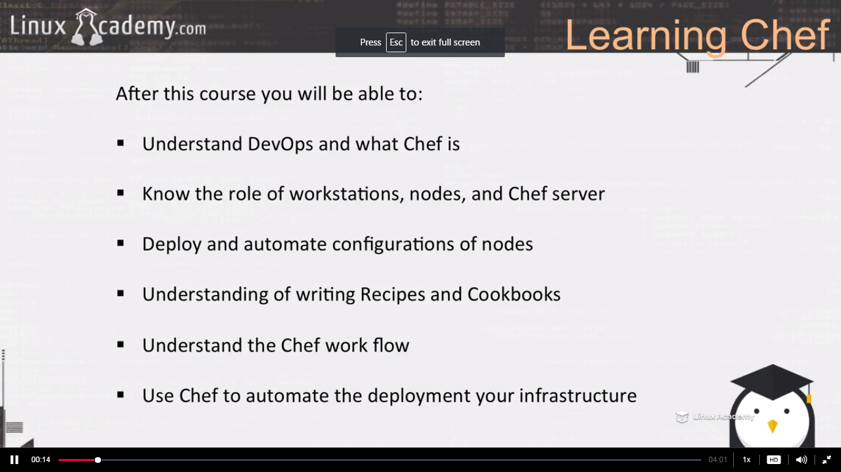

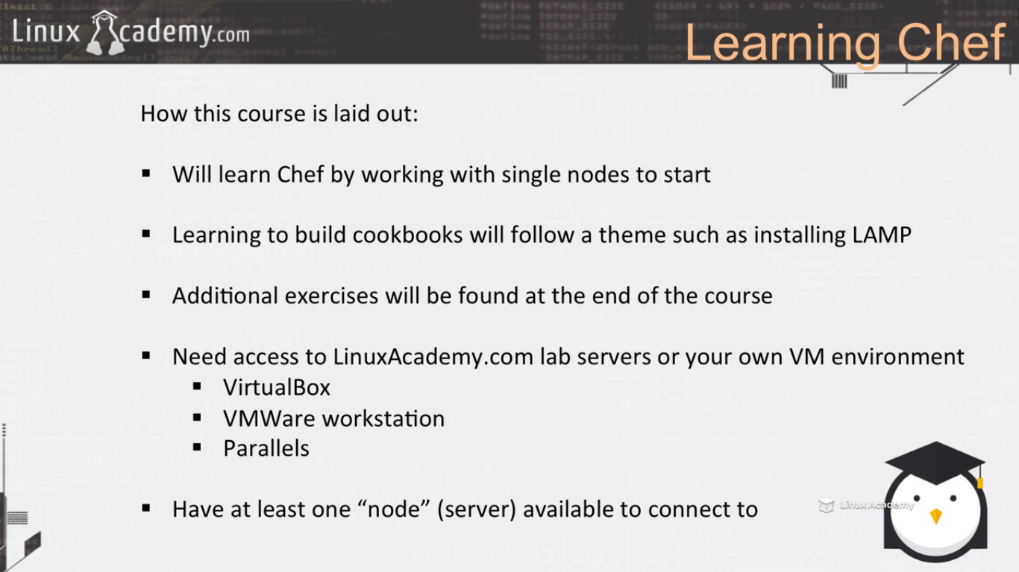

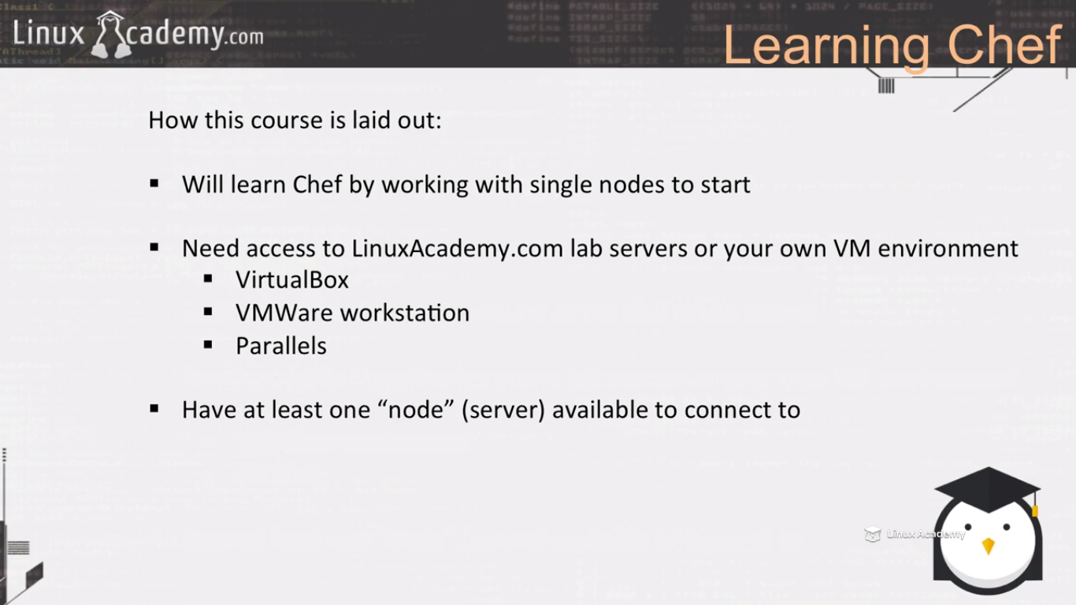

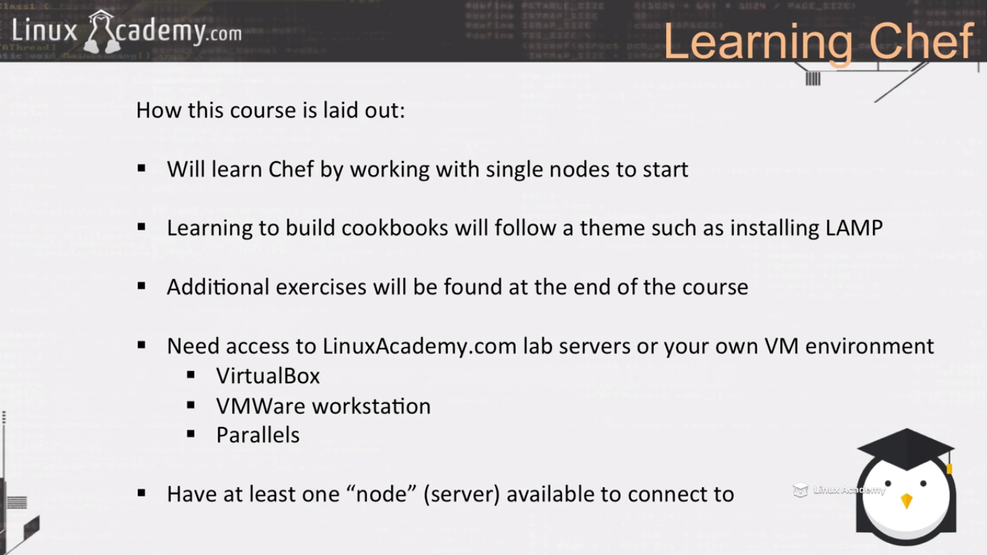

**Lecture: Chef Head First! (Build And Deploy An MOTD Recipe)**

In this lesson we are going to dive head first into Chef. We are going to set up our lab servers, enterprise chef account, and nodes. We will build a simple MOTD cookbook and deploy it to our node for our very first Chef run!

Workstation—is where our sysadmin or devops people write the recipes and uploads the recipes to the chef server.

Your workstation machine can be your windows, linux or osx machine.

Use centos6.5

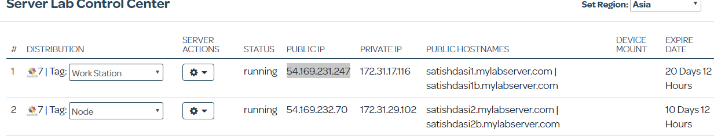

Change the hostname to workstation

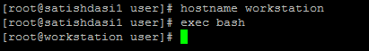

Now we can see our hostname is changed to workstation.

Connect to the node server as well by opening a new terminal.

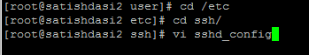

Uncomment the permitroot login.

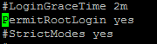





The workstation uploads the policies we write to the chef server and the nodes then checkin and authenticate with the chef server to receive instruction what they should be.

So we would be using enterprise chef, we could use open source chef but that we have to install in a different server. So let’s use enterprise server which gives us the possibility of using 5 nodes.

So go to [www.getcheff.com](http://www.getcheff.com)

Then browse to management console on the top.

Sign in as an individual.

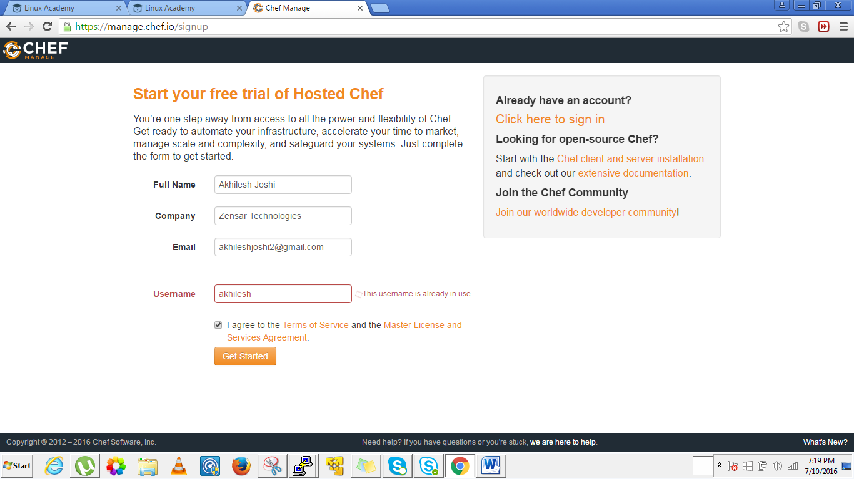

After filling your data and sign in again you will be in the management console as

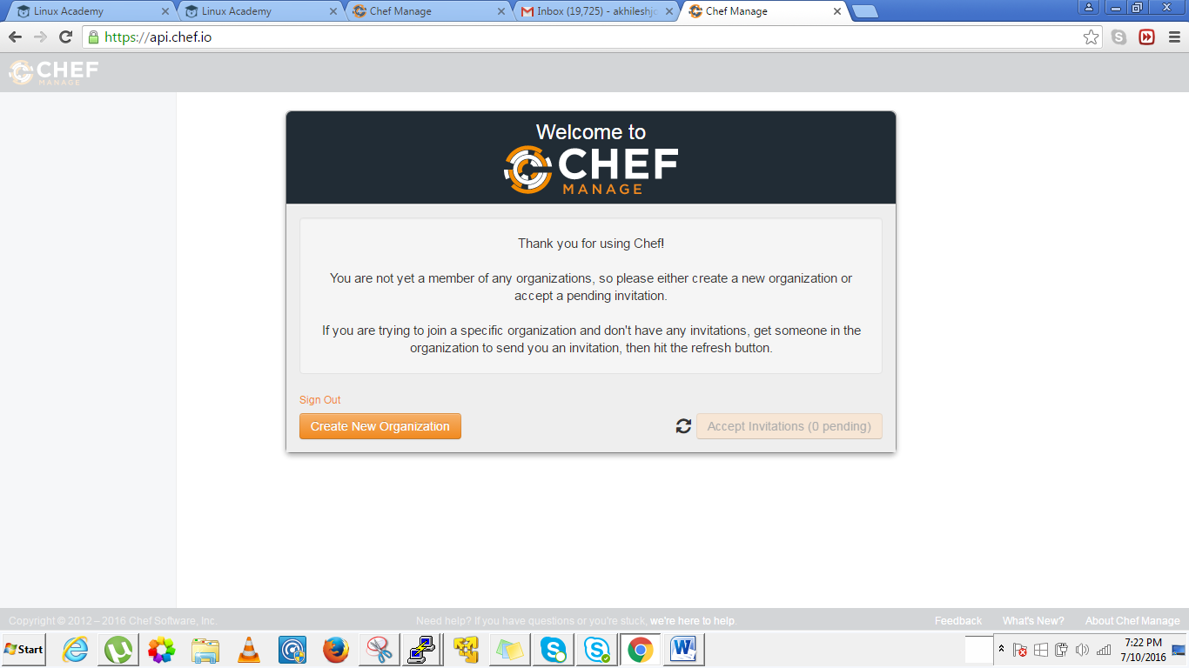

Click on create new organization.

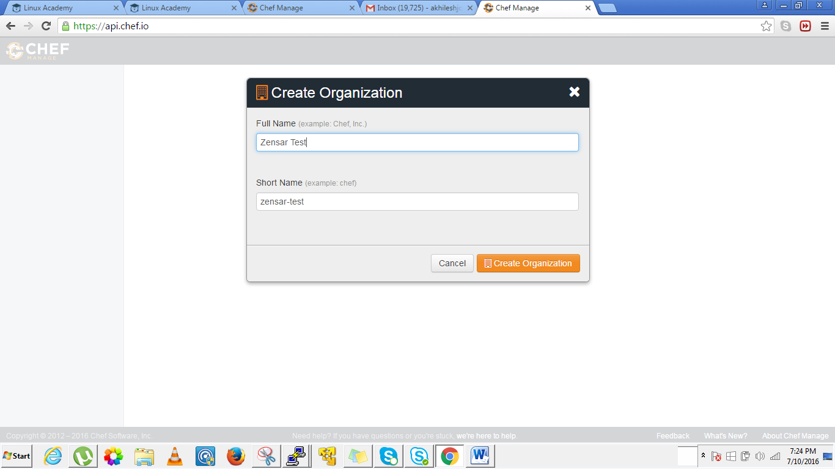

Organizations are unique around the enterprise chef framework.

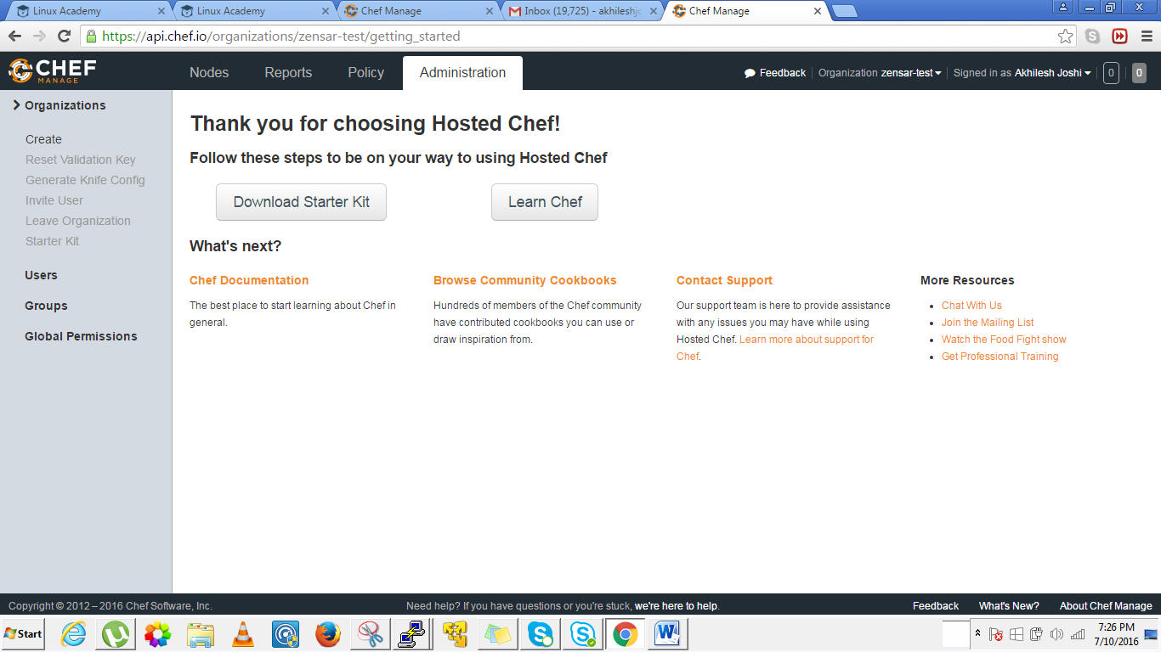

The download starter kit allows us to download the chef repo and has our pem certificates or security certificates which allows our nodes to communicate with our chef server securely and allow our workstation to communicate with our chef server securely.

Now click on download starter kit.

Since we have downloaded we have to bring it to our workstation somehow. We need to upload the server starter kit to the workstation . For that I have to download a ftp program called firezilla.

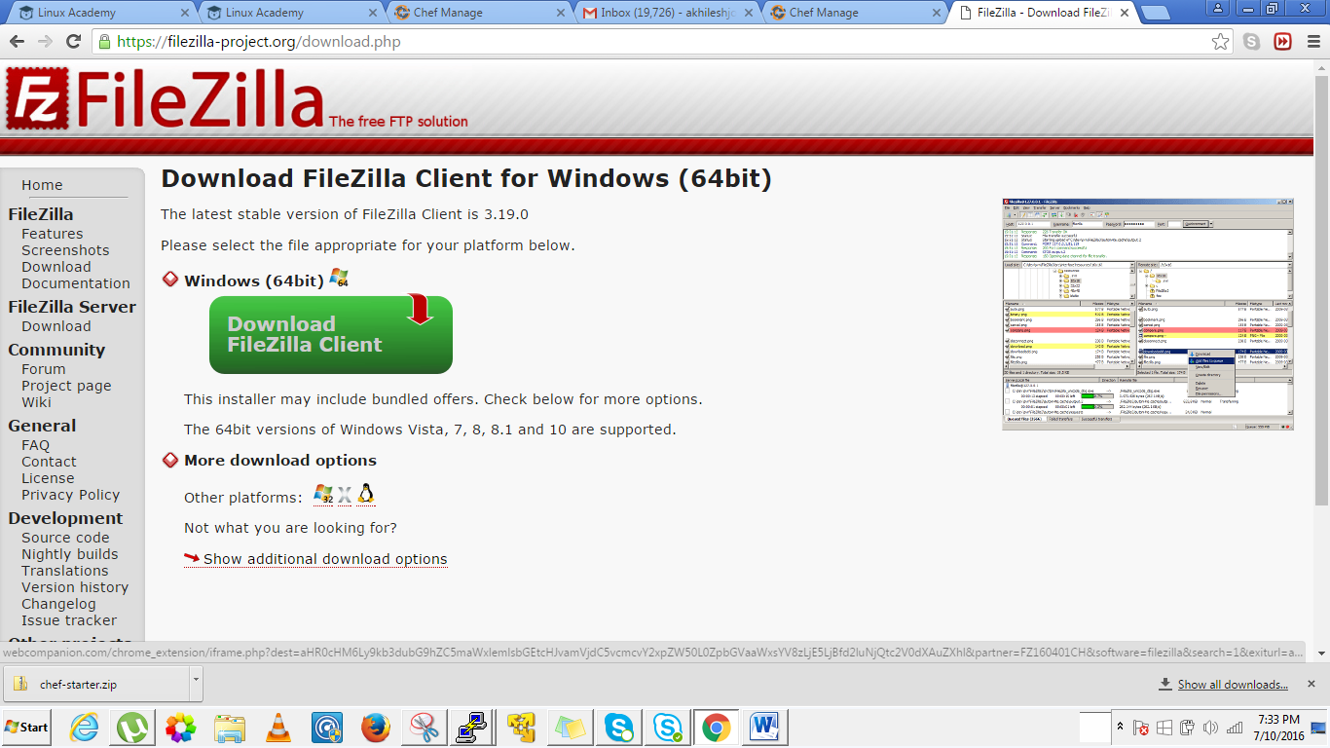

Download and install it.

We need to upload the starter kit to the workstation

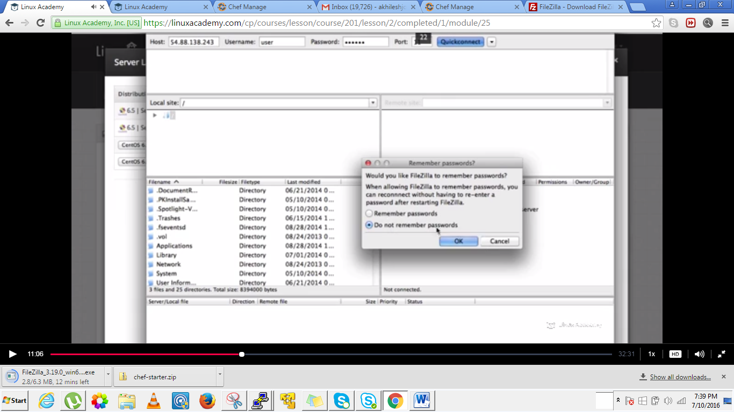

Give public ip of workstation and the username as user and password and port 22 and click quick connect.

Upload it.

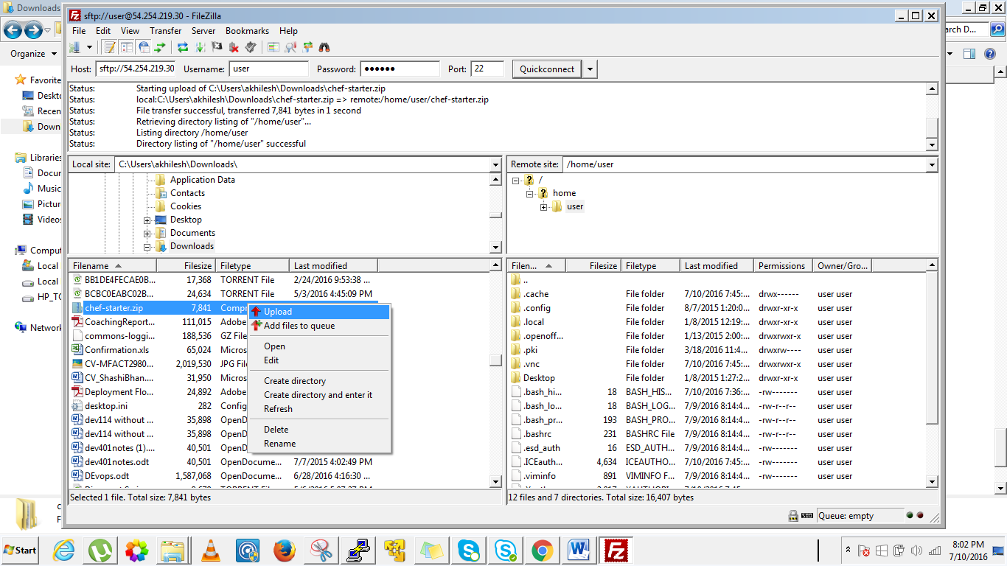

Go to workstation terminal and ls , you will see the chef starter.zip

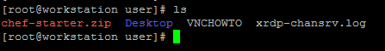

Move it to the root directory as: ***mv chef starter.zip ~/***

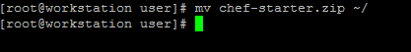

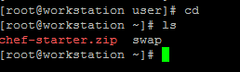



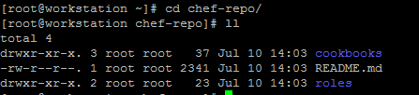

Now install the chef software to the workstation. It would install the ruby language, etc which is required to manage our chef environment.



We have chef repo installed , chef software install now let’s bootstrap a node.

Go to chef management console and we see there are no nodes so far

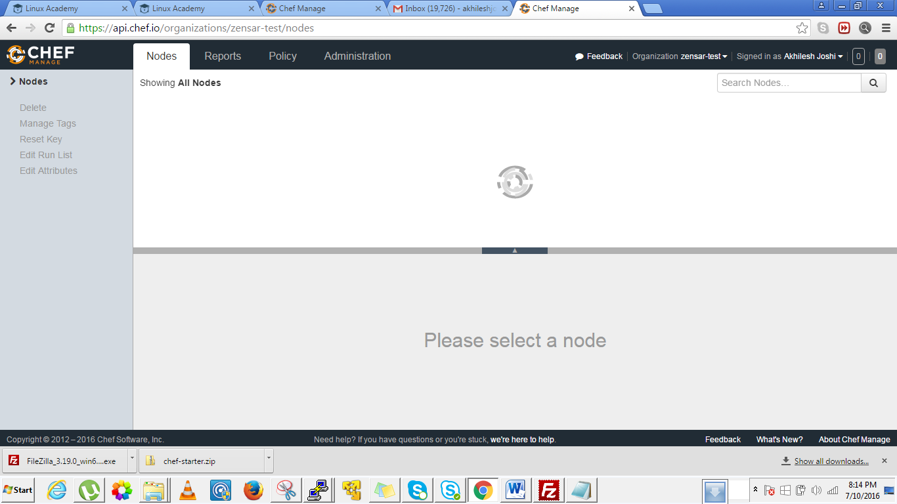

So we will bootstrap our first node.

We use knife to configure nodes, set recipe runlist, manage anything on our enterprise chef server. Its a tool we use to create cookbooks.

While using bootstrapping use hostname here not public ip as these would change whenever we stop start.(as these are EC2 machines)



The command to bootstrap a node is : **knife bootstrap hostname –x root(user) –P password –N nodename(anything you want to identify the node)**

**Why we enabled root login is to bootstrap a node. After bootstrap you may disable the root login in the etc/sshd_config file.**

**Run the above command only from inside the chef-repo folder else it will through an error.**

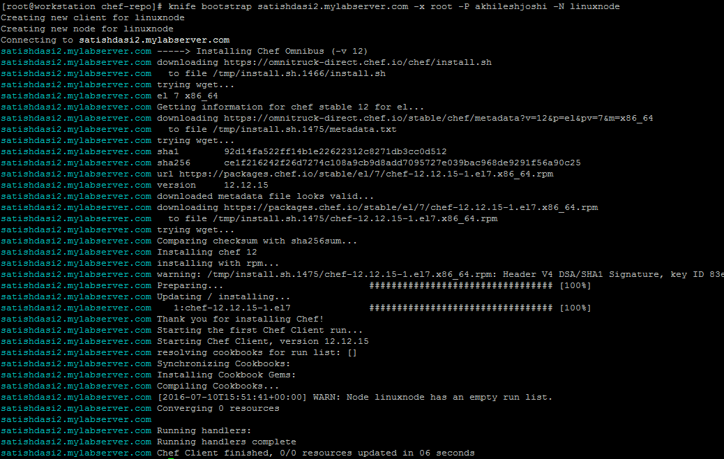

A node can be a linux node or windows node etc. It could be an anroid device, a cisco router anything which can run a chef client.

To verify lets go to the management console and refresh.

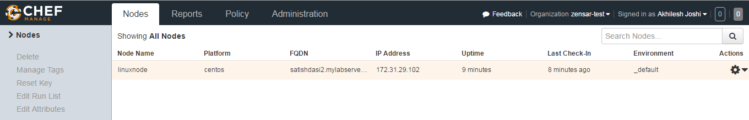

WE see a node as linuxnode here.

We can now disable the root login in the node as it’s the best practise in the prod environment.

We know our node doesn’t communicate with the workstation, our workstation uploads the recipes, configurations to the chef server and the chef node will communicate with the chef server.

Let’s now go to our node and type chef client and what it does is that it does conversions. It is going to check in the chef-enterprise server and would make sure it has the recent configuration policies that it needs.



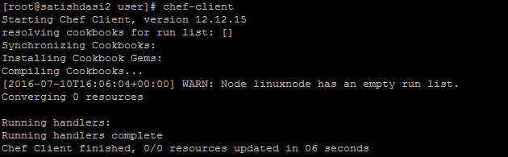

We are ready to write a policy . Let’s write a policy.

For writing a policy you should be in your chef-repo on the workstation.

In order to write a policy we need to write a cookbook. Since we are writing a MOTD cookbook we would write :

[root@workstation chef-repo]# knife cookbook create motd

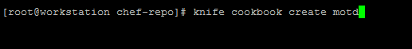

Motd is the cookbook name.

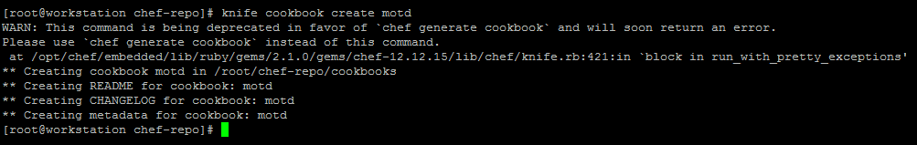

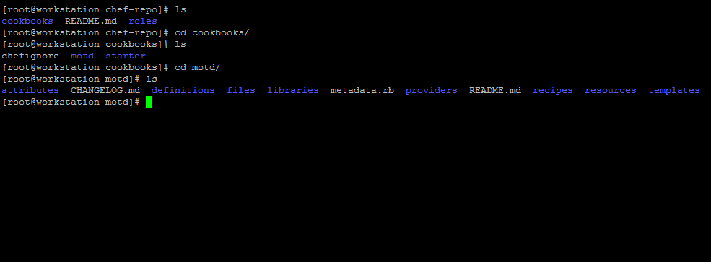

Since we have a cookbook if we navigate in the motd cookbook we have recipes, attributes and templates over there.We would be using these areas to configure our cookbook.



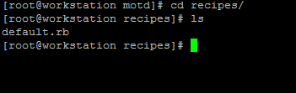

We will edit default.rb file. Chef relies on ruby and when we write recipes we write them in ruby language.

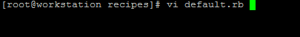

First inside there we need to define a resource which in our case would be a template.

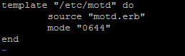

The recipe is completed. Save it.

Now go to template directory

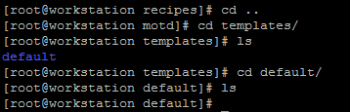

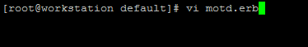

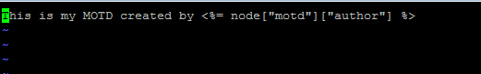

Save it.

Now if we do a convergent means the node should check for new updates it would give an error as we haven’t specified the author. For that we need to go to the attributes directory as

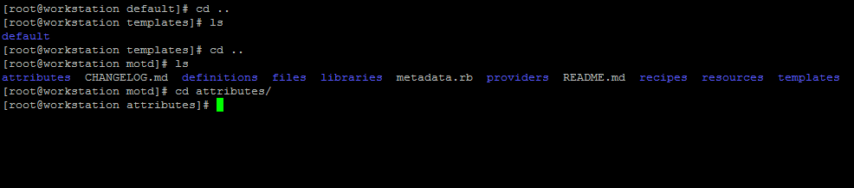

Let ‘s create a file default.rb and define an attribute as



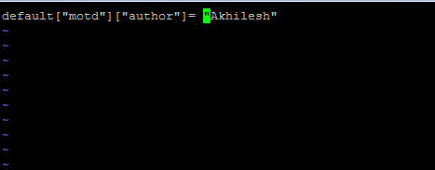

Save it.

That’s completes our motd cookbook.

Now we need to upload it to the chef enterprise server .

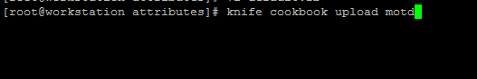

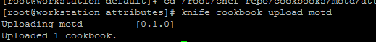

Now if we go to our manager console and check the policy we would see we have a motd as

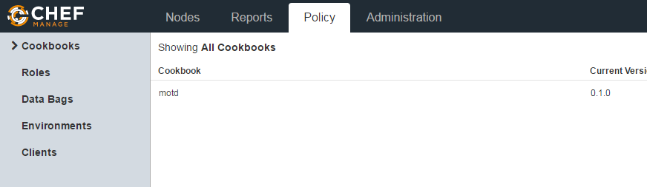

Go to content below as

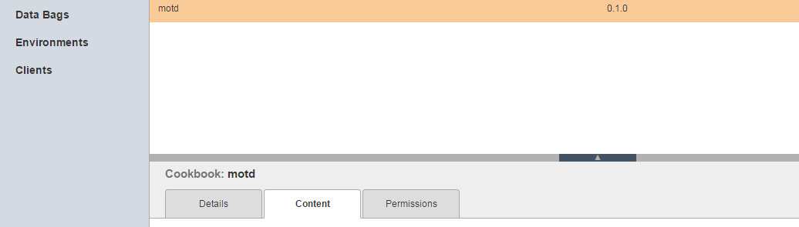

Go to recipes

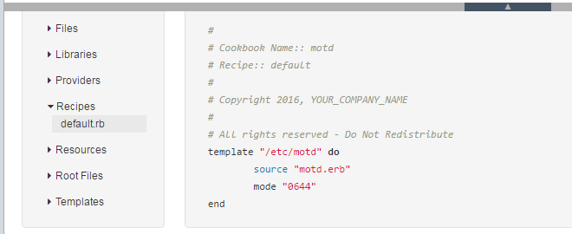

Now if we go to our node and run chef-client which is a convergence

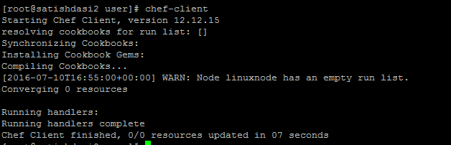

We see nothing happened because we haven’t said that this node has to run a recipe. We can have a number of recipes and a number of nodes and node doesn’t have to run every recipe. For eg If we have a database node then this must run the recipes which consist of database related configurations.



Here we are running a recipe motd not the complete cookbook motd because there may be many recipes inside a cookbook. We have defined the motd recipe inside the default.rb file.

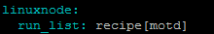

means

For the linux node during the next convergent its job is to run the motd recipe which means it gone take the template file, create the template file based on our attributes over there. Based on our author name it’s gone to put it inside our /etc/motd file. Let’s check if it is going to happen.

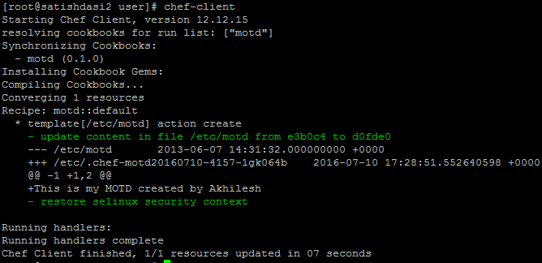

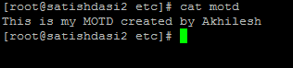

If there exists a motd already it creates a back of it. We will look that part in detail later.

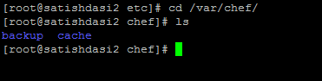

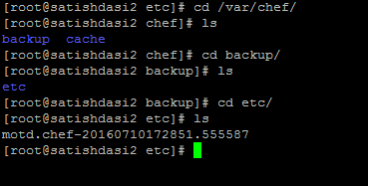

**Lecture: Introduction To DevOps**

In this lesson we are going to discuss what DevOps is. We'll give a brief overview of how it is viewed by startups and companies and what it means for SysAdmins. We will also look at how DevOps relates to Chef and automation of the data center.

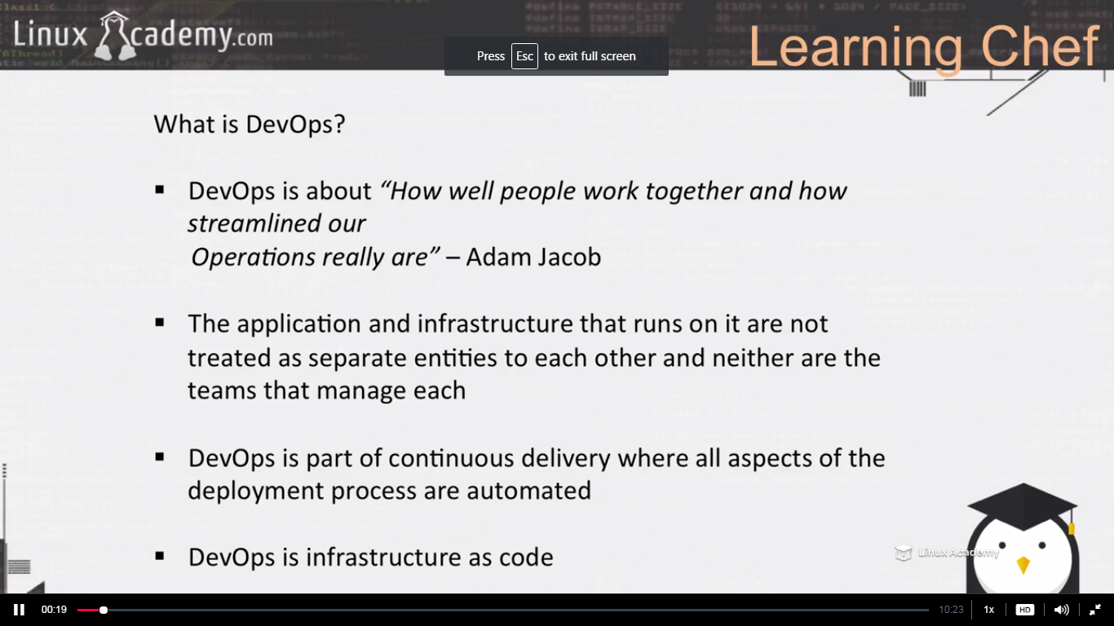

**Lecture: What is Chef?**

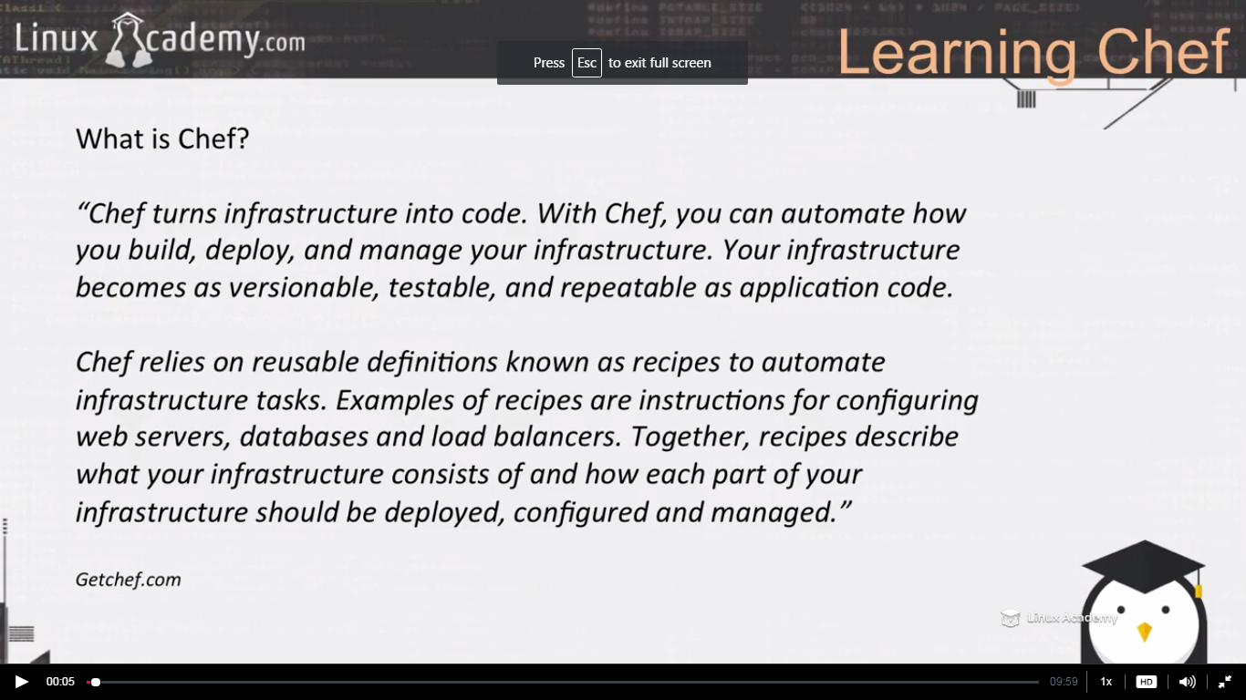

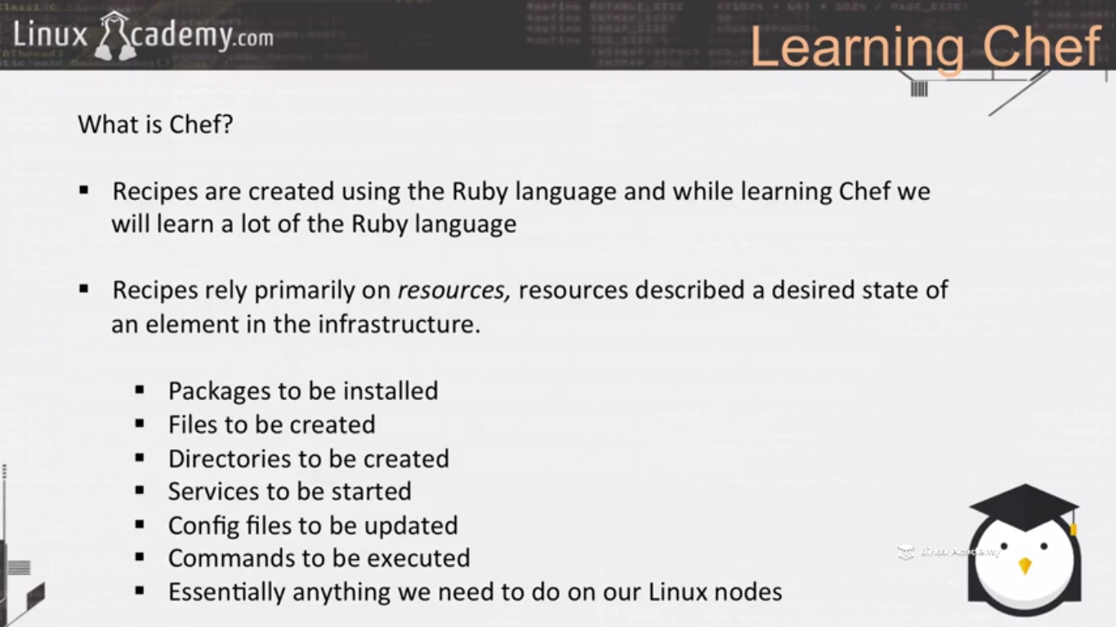

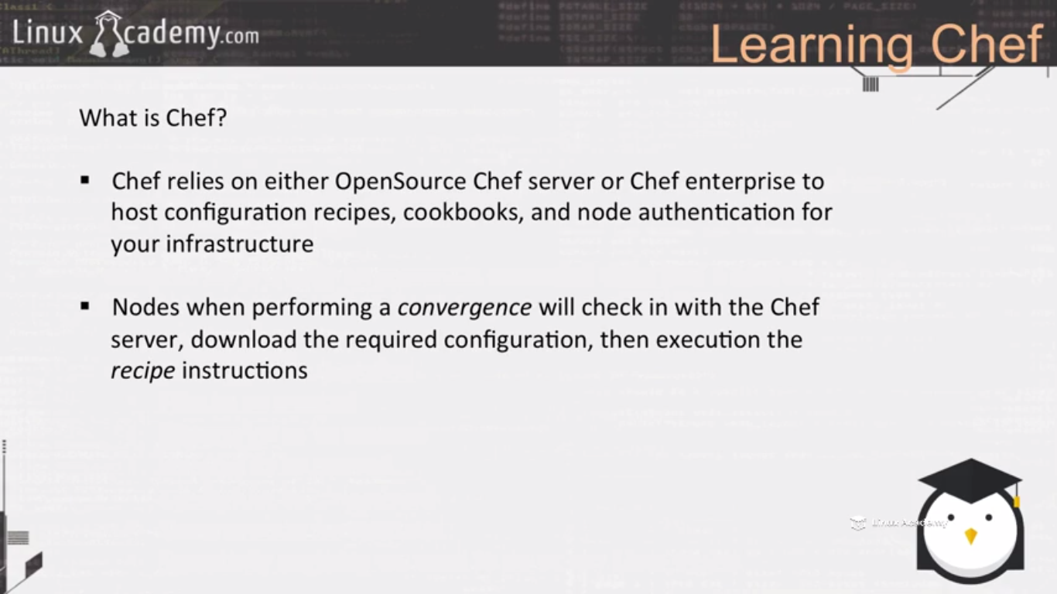

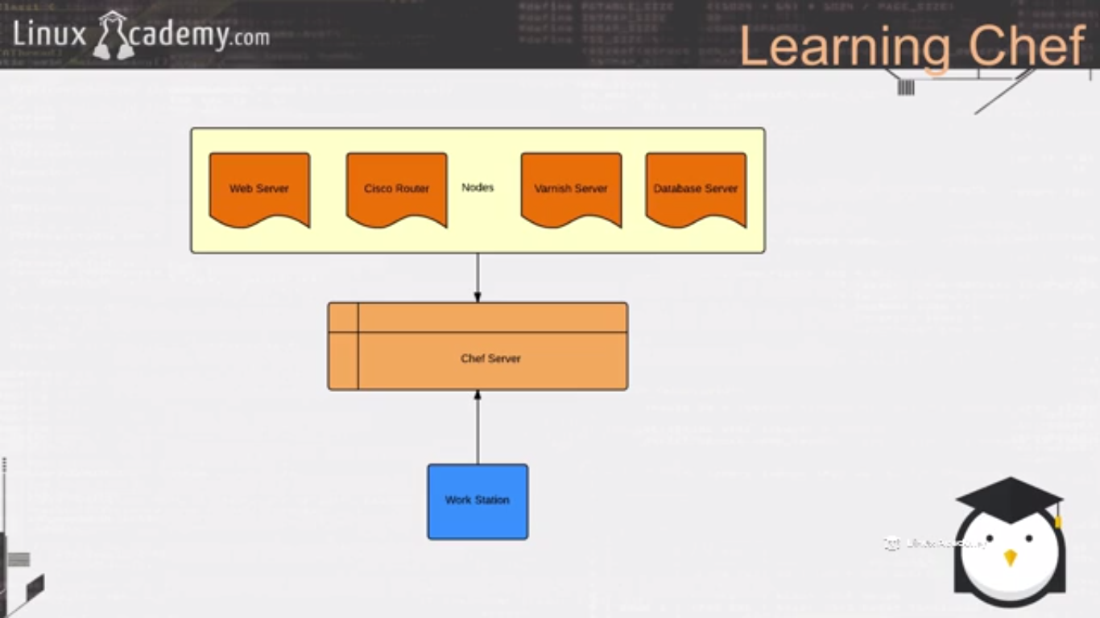

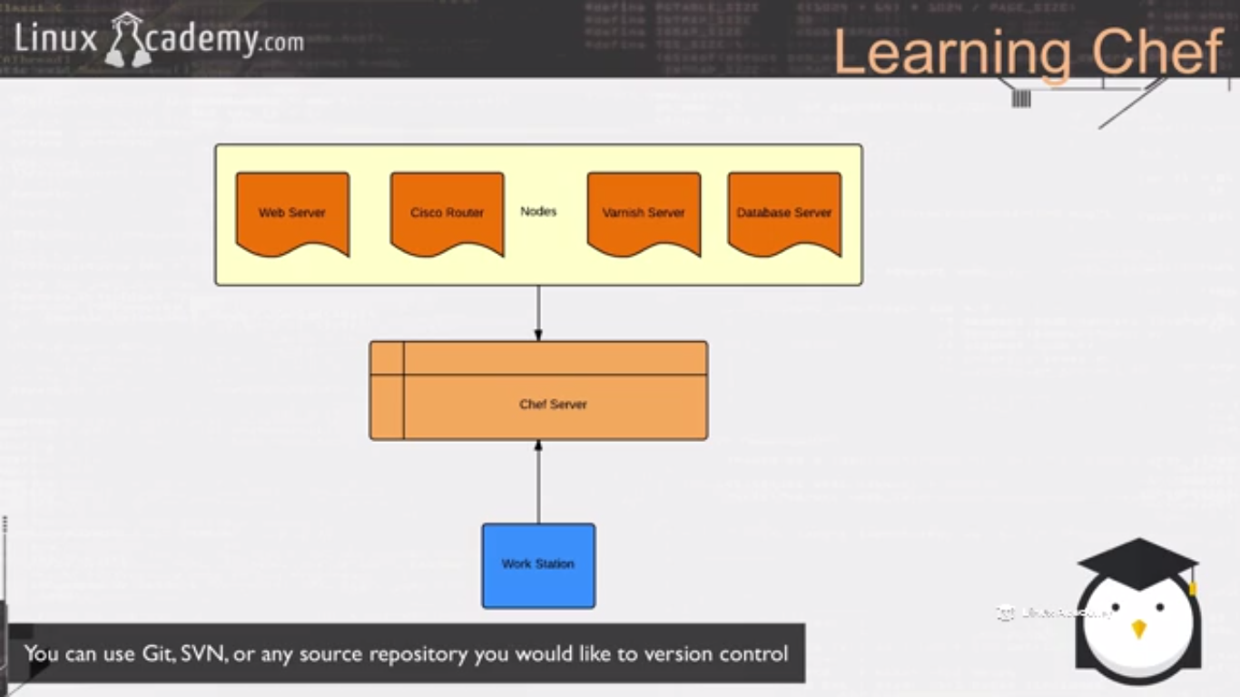

**Lecture: Common Chef Terminology**

In this lesson we are going to cover common Chef terminology. Being familiar with some of these terms as we move forward will make learning these concepts easier.

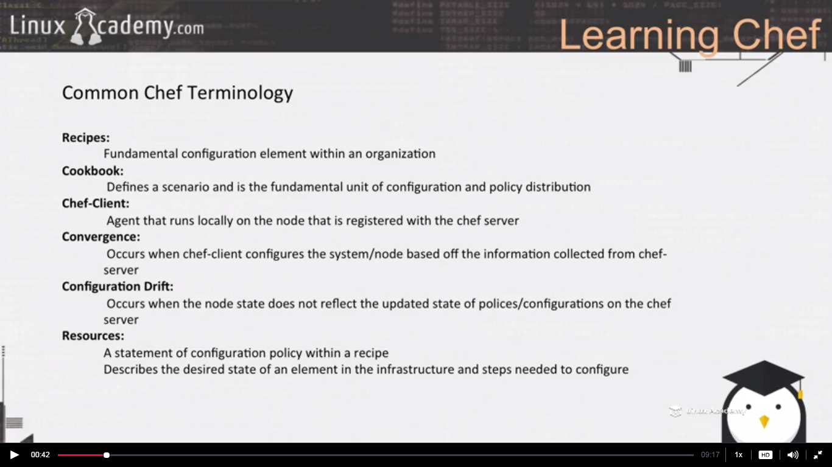

Recipes are created using the ruby language. A recipe must find everything that is required to configure part of a system. Recipes are stored in cookbooks. Recipes can include other recipes. Recipes can have dependencies on other recipes. Recipes must be added to a run list before our node run it. Recipes run in the same order as defined in our run list.

Cookbook is made up of recipes. Inside the cookbooks we have attributes, definitions which allows us to create re-usable collections of resources. We are going to built libraries that extend chef clients and provide helpers using the ruby code. Inside cookbooks we have recipes that specifies which resources to manage and the order in which these resources are applied. We are able to specify the versions of our recipes, templates inside of our recipes, metadata about our recipes , so cookbooks houses all of this information.

Chef client authenticates itself against the chef server, synchronize the cookbooks, takes appropriate steps to configure itself based of the cookbooks and the recipes it is supposed to run .

Recipes consist of resources.

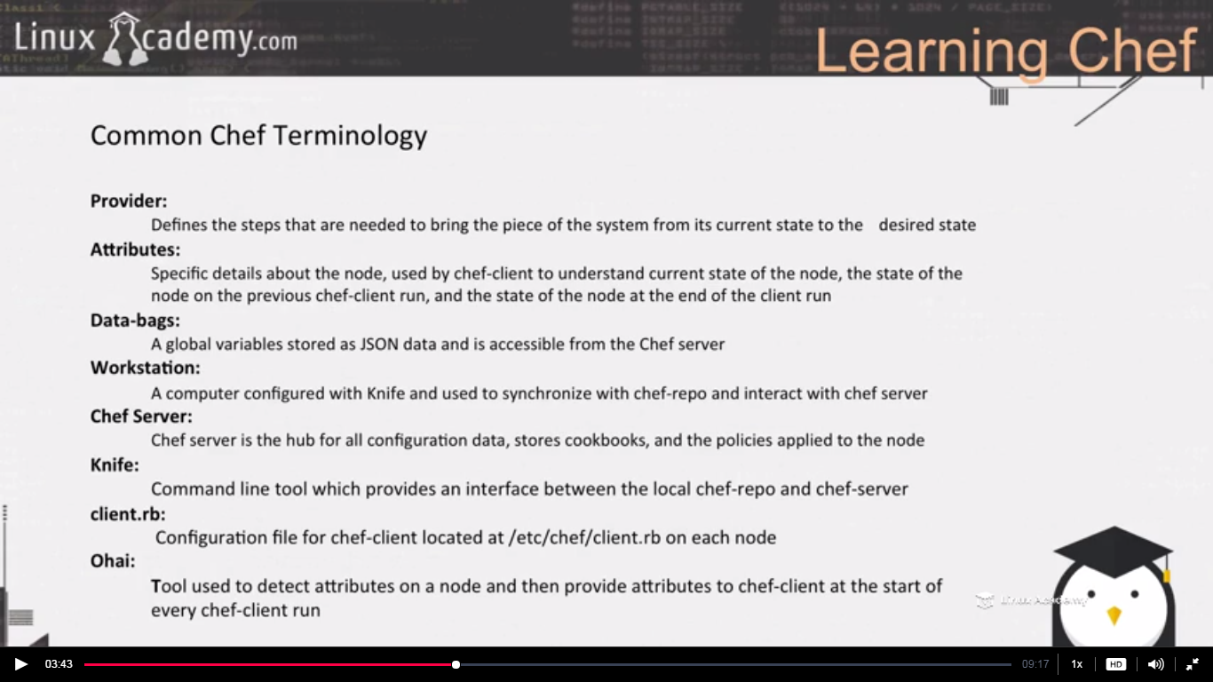

Providers work with the resources. Resources communicate with the providers and then performs the specific task to bring the piece of the system to a desired state from the current state.

We will use data bags when we will do something as defining local users in our system.

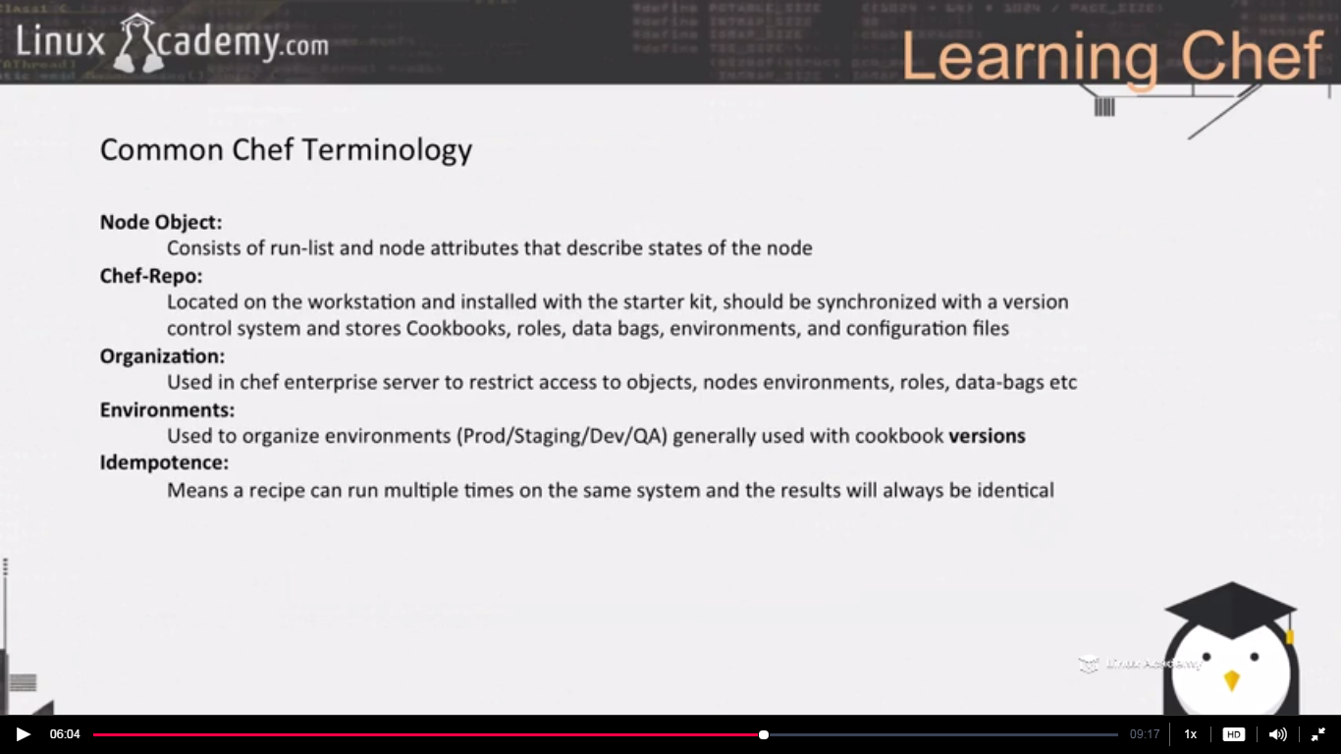

**Lecture: Chef Server**

In this lesson we are going to take a look at differences between Chef Enterprise and OpenSource Chef. We are also going to look at the role of the server as it relates to our Chef environment.

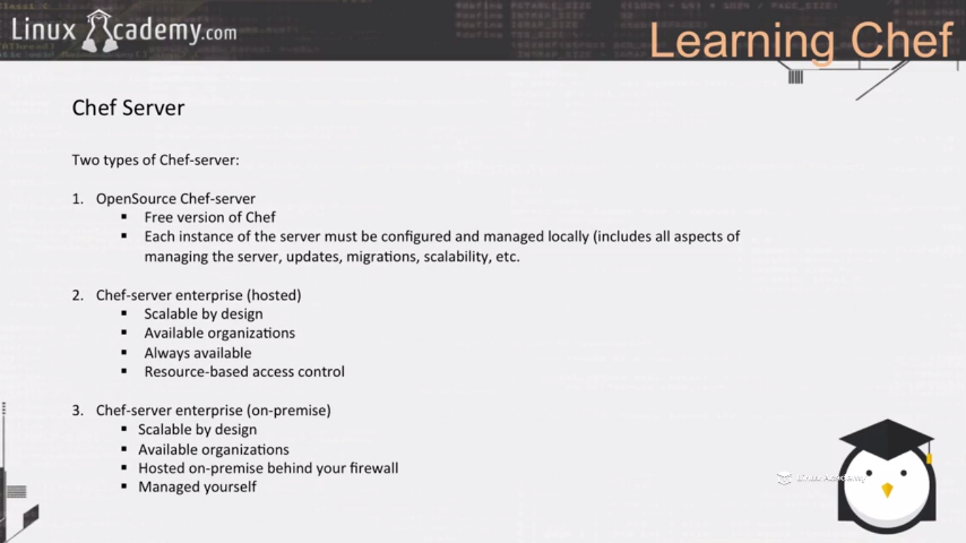

There is no organization for the open source chef server. Organization allows us to have different parts of our infrastructure completely separate from each other. Organizations can’t communicate with each other.

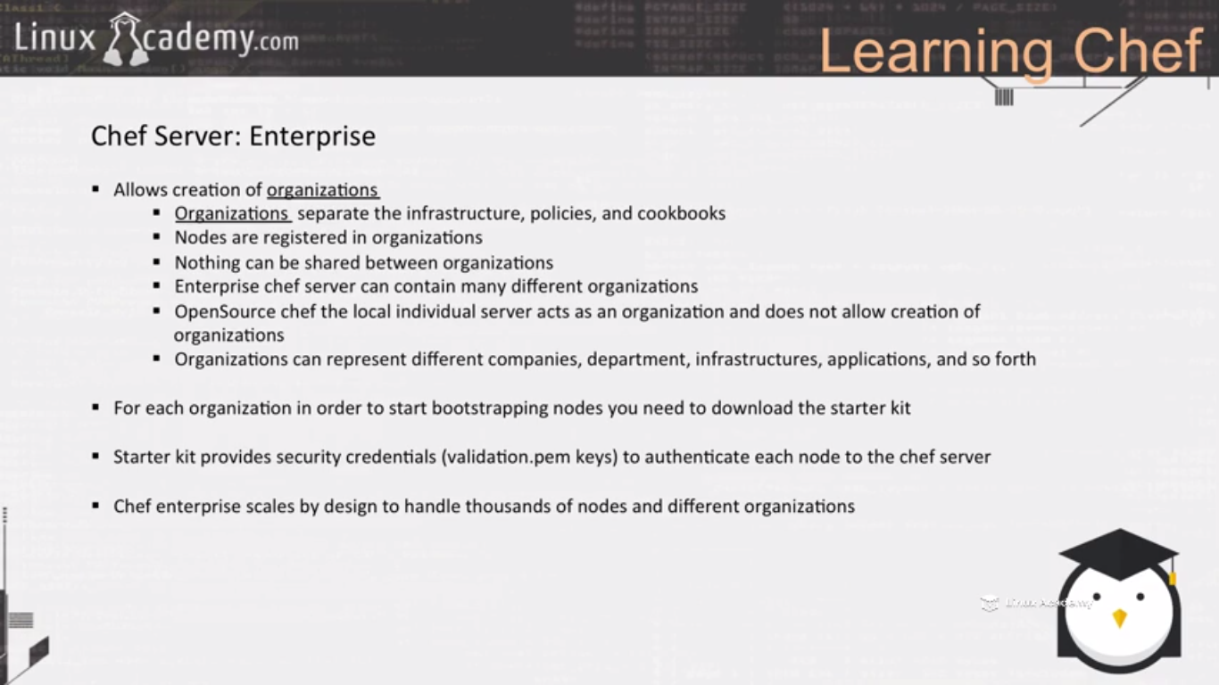

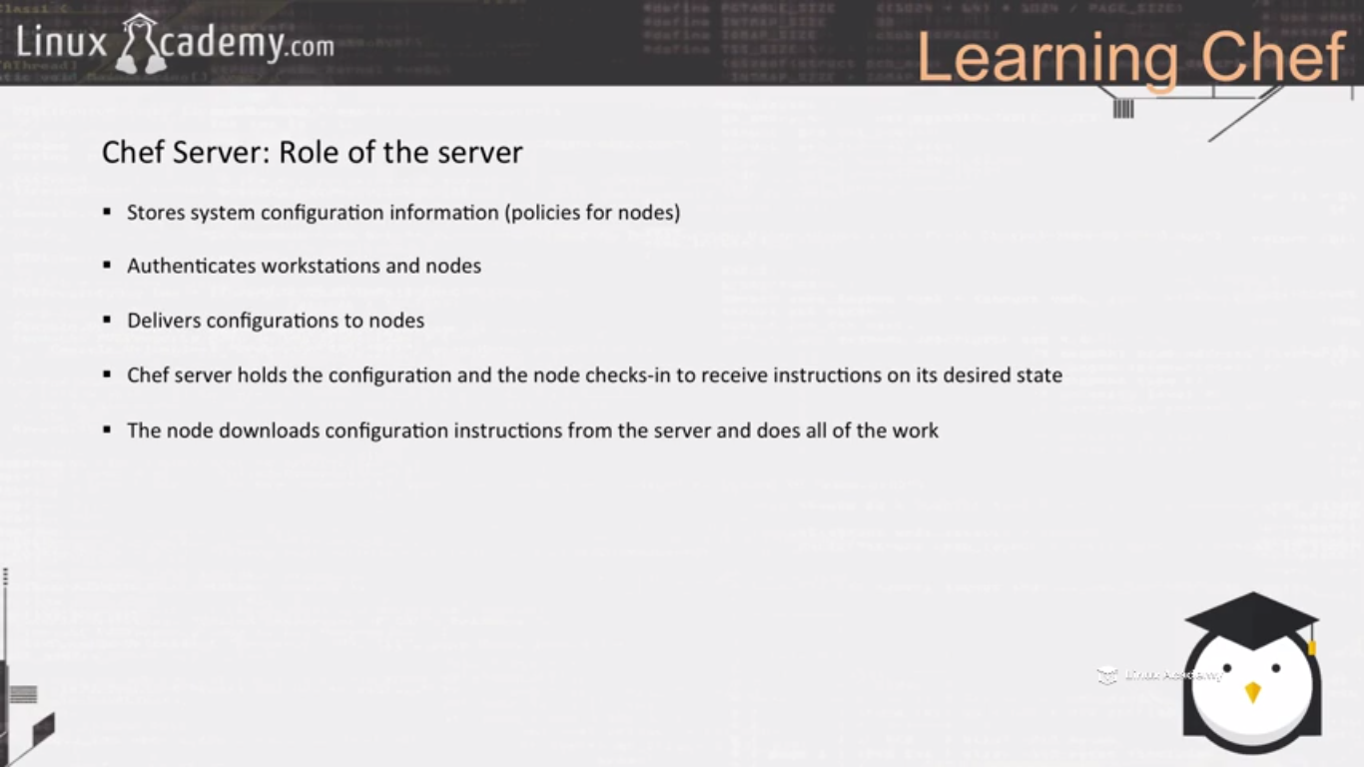

**Lecture: Chef Workstation**

In this lesson we are going to look at Chef workstation concepts. We'll look at how to set up our Chef workstation, security and configuration concepts, and bootstrapping concepts of a node.

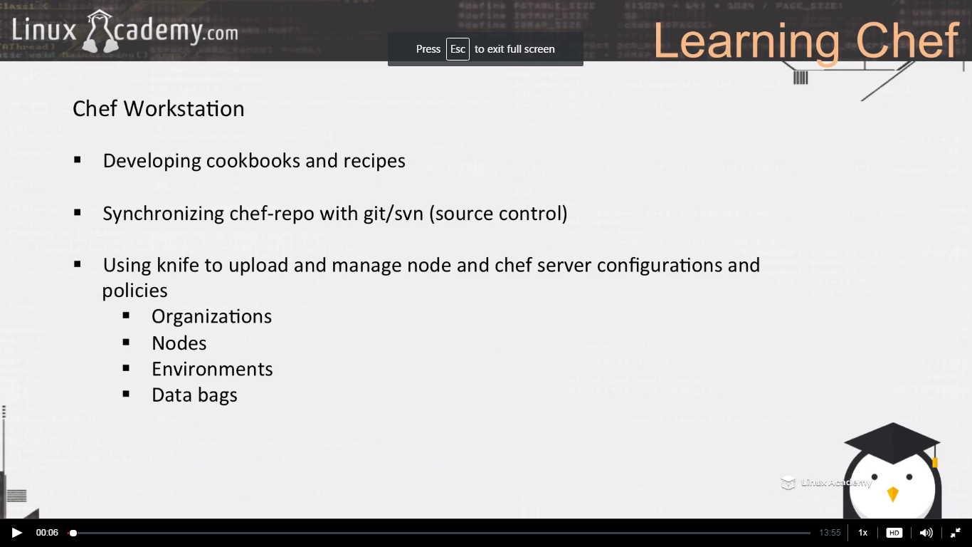

**Lecture: Chef-Repo**

In this lesson we are going to talk a little about the Chef-repo and what it is used for. It's important to get the real concepts down on how Chef works in order to understand the entire Chef workflow and system.

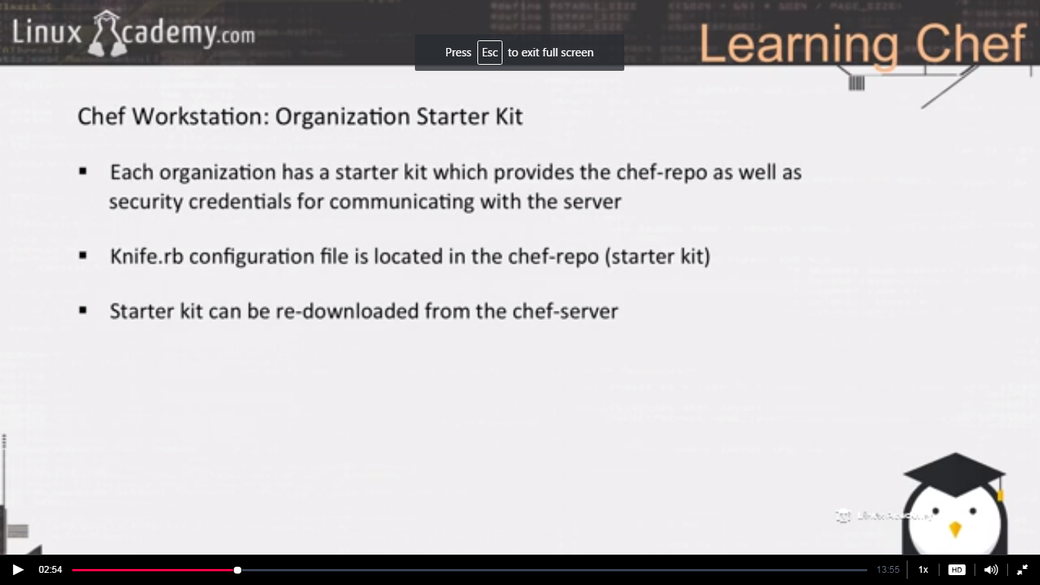

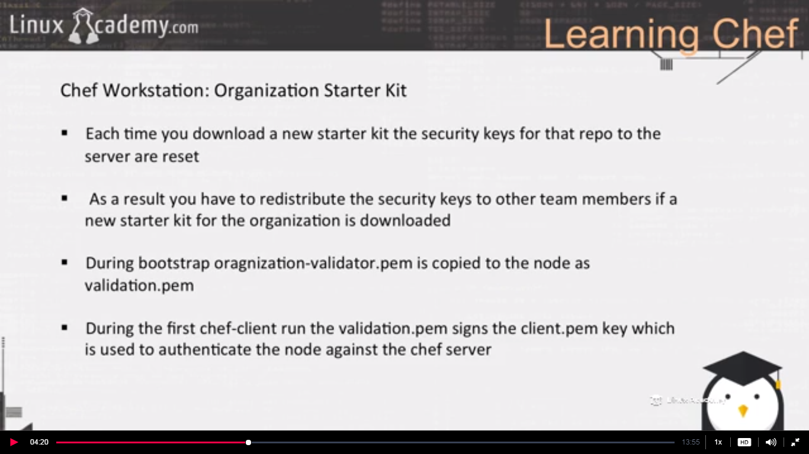

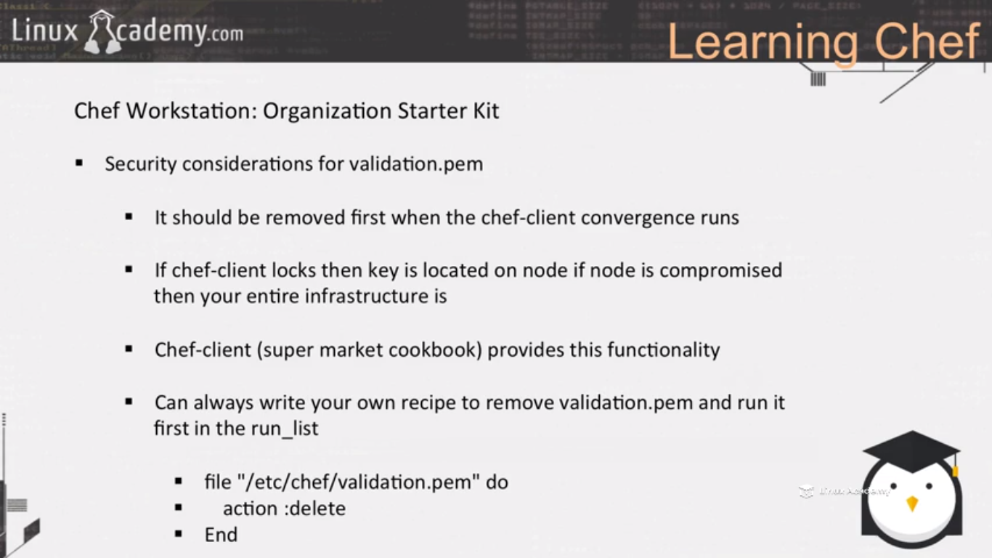

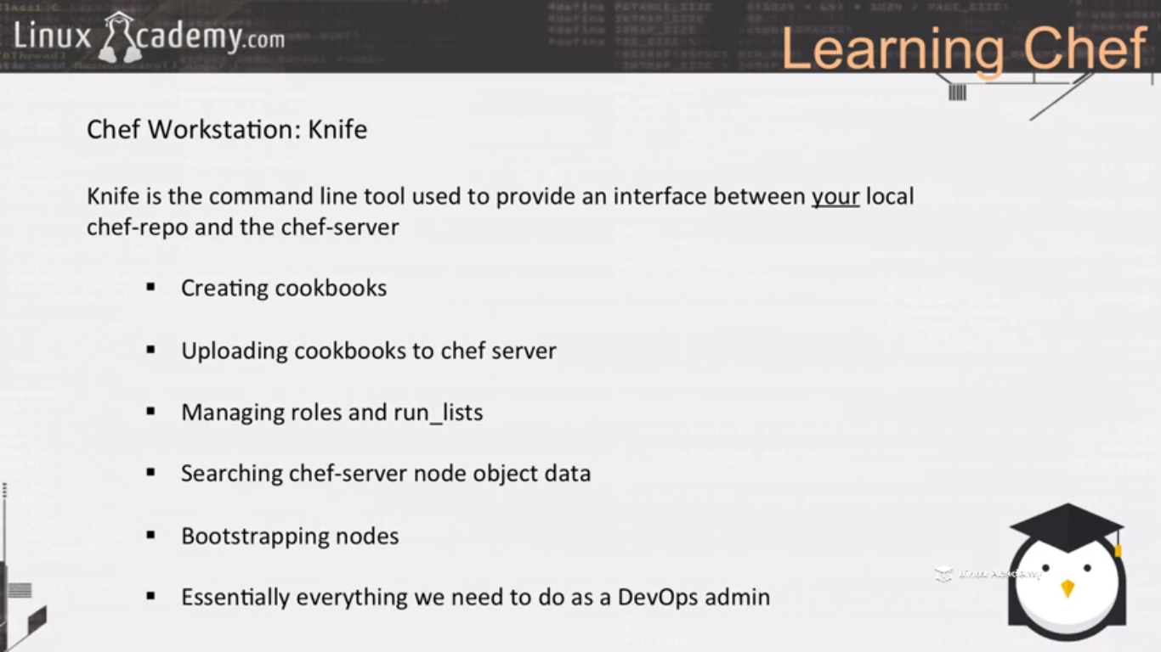

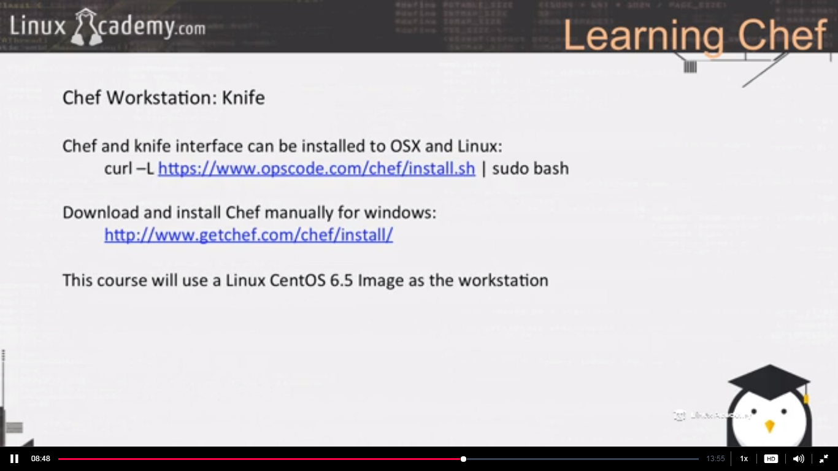

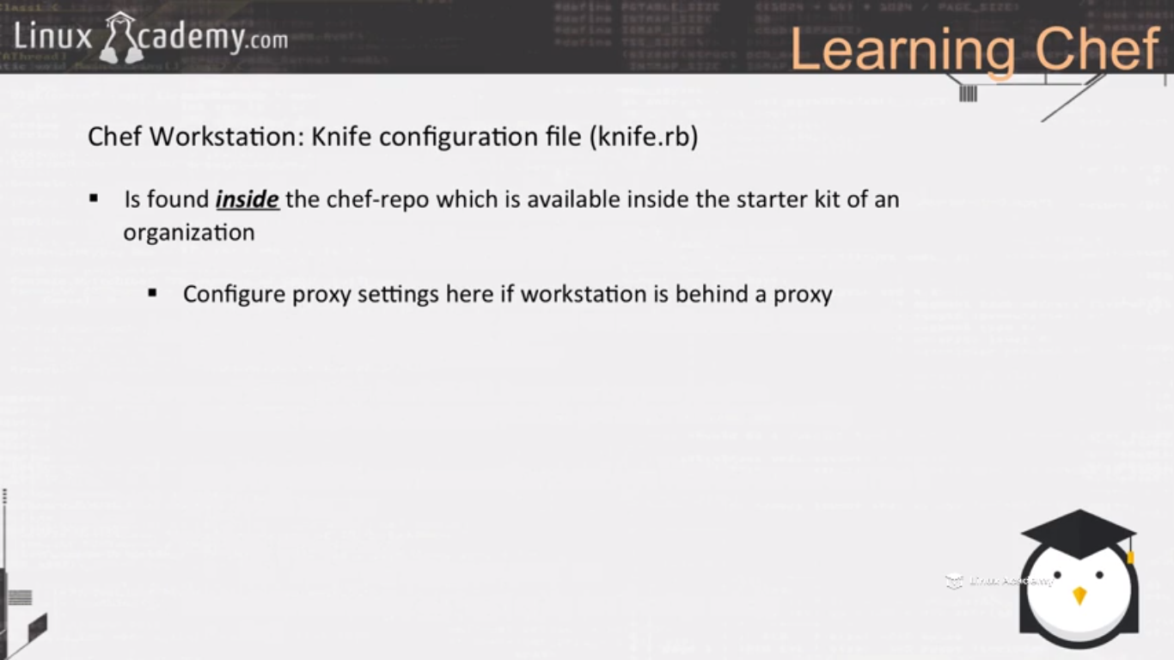

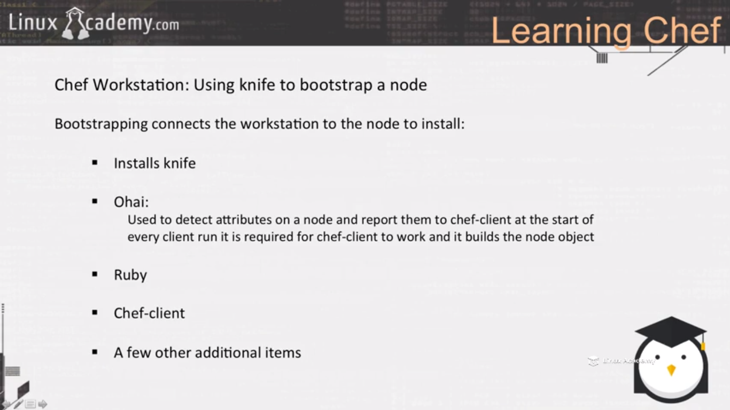

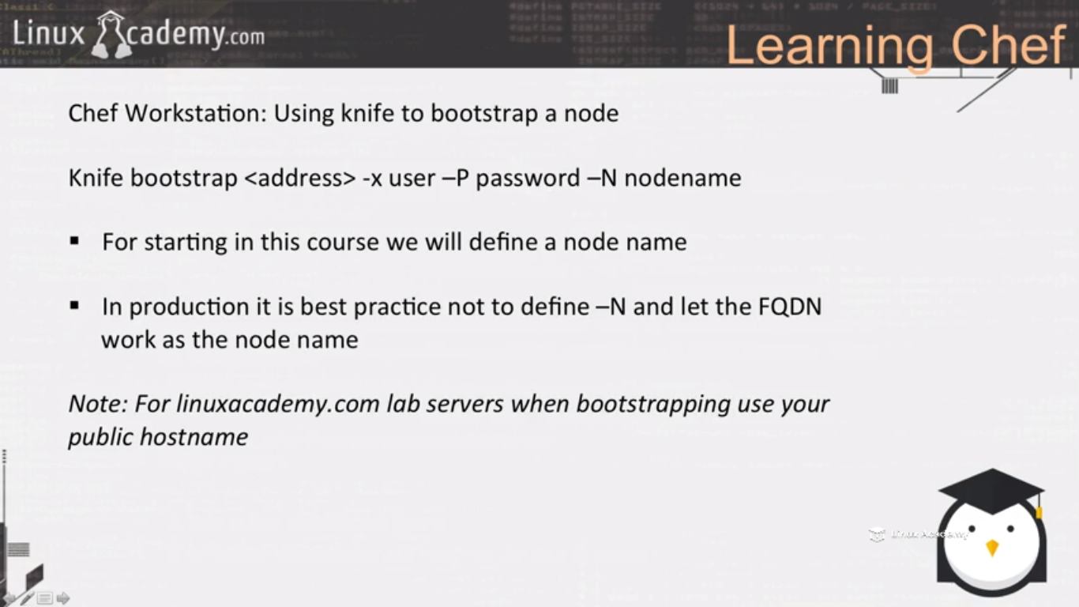

**Lecture: Chef Workstation - Looking At Security And Configs**

In this lesson we are going to work inside our command line terminal on our workstation to view the security concepts, bootstrapping concepts, and starter kit concepts as they relate to the Chef workstation.

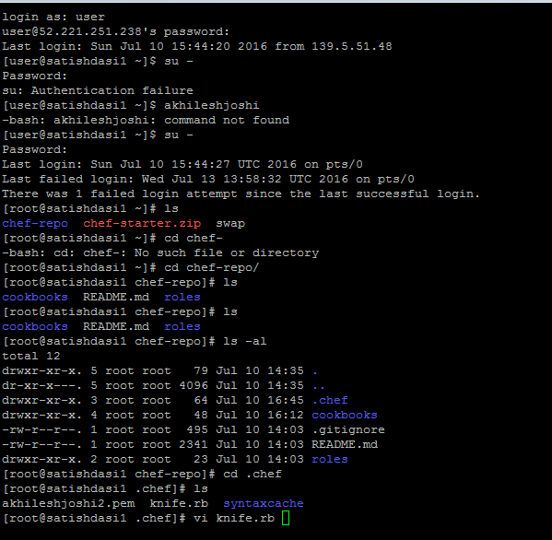

Inside the knife.rb we configure our workstation .

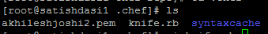

This akhileshjoshi2.pem is the client key which is used to communicate with the chef server.

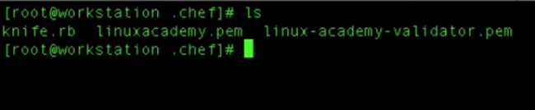

Here linuxacademy.pem is the client key and the linux-academy-validator.pem is the file which is uploaded to the nodes at bootstrap and used to create client.pem file which is needed by the node to authenticate itself to the chef server.

Go to the node and

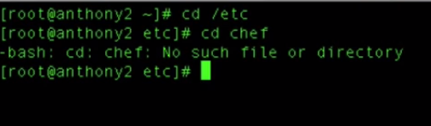

It means this node is not bootstrapped yet. Enable PermitRootLogin inside /etc/ssh/sshd_config

So bootstrap it via the below



And after running this on workstation if you come back to the node and check in the /etc/chef folder you would see the validation.pem

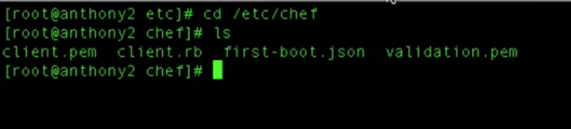

We can compare the validation.pem file of both the workstation and the node and they would be the same. So what the bootstrap did is that it copied the validation,pem from the workstation to the node.

So if we run our chef client as

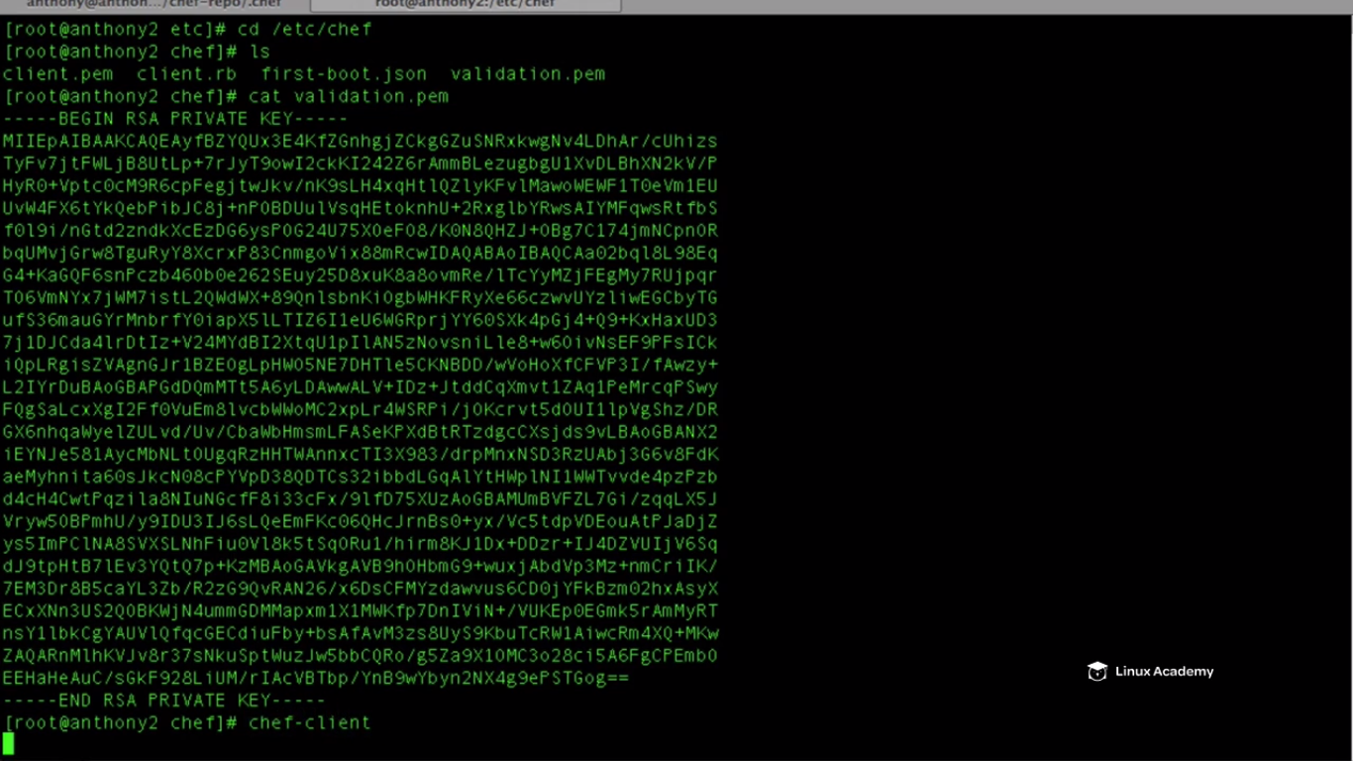

When we run the chef client for the first time chef will create a client.pem file which it already did during the bootstrap .

Once this file client.pem is created we don’t have the need for the validation.pem file.

We just need client.pem to validate against the chef server. Leaving the validation.pem there is a security risk as it is required to create the client.pem .If someone gets this he can access any node and even the workstation.So we need to remove that.

If client.pem doesn’t exist your convergence will fail so that file must exist.

So if you download a new version of your organization

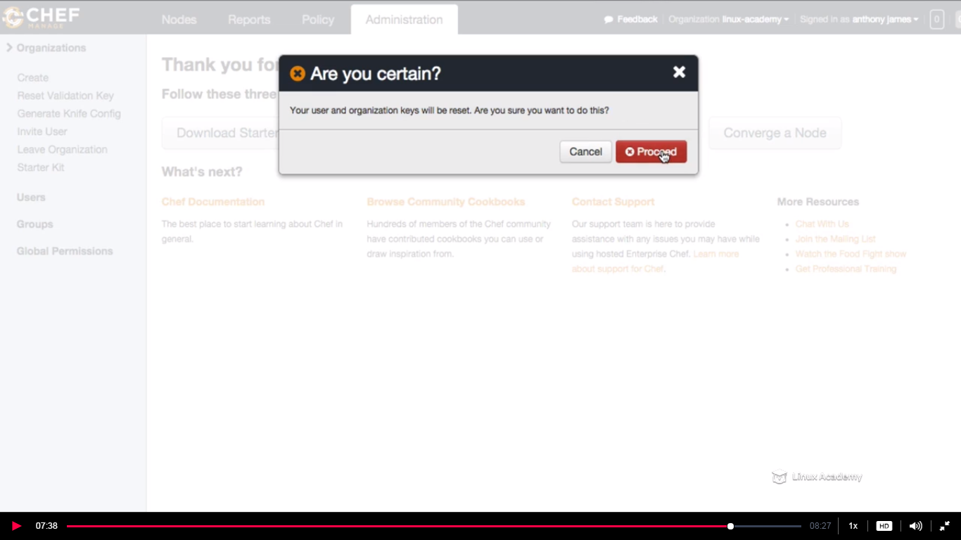

So once we did this we won’t be able to communicate with the chef server with the old chef repo. Lets see this

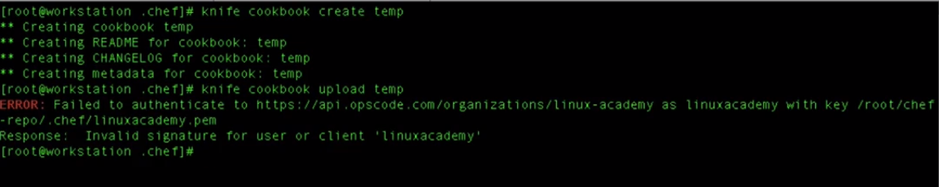

We created a cookbook and tried to upload and it failed.

So if you download a new starter kit u need to send the send the client key every other member of the team as it would have changed with the new starter kit.

**Lecture: Chef-Repo**

In this lesson we are going to talk a little about the Chef-repo and what it is used for. It's important to get the real concepts down on how Chef works in order to understand the entire Chef workflow and system.

The chef repo on our workstation are the local policies, the local configuration, the cookbooks, recipes,attributes, data bags, that we create and upload to the chef server. So these are all the local configurations on our machine. So the chef repo are the configurations that remains locally on our system and remotely on the chef servers.

In every organization there is a chef repo. So the local chef repo is used to synchronize your workstation to the chef server.

We create cookbooks and upload that to the chef server. When we create recipes, or we want a recipe to run in a role, or a node we also need to do add this to the run list. All this is done inside the chef repo. Also the knife command needs to be run through the chef repo.

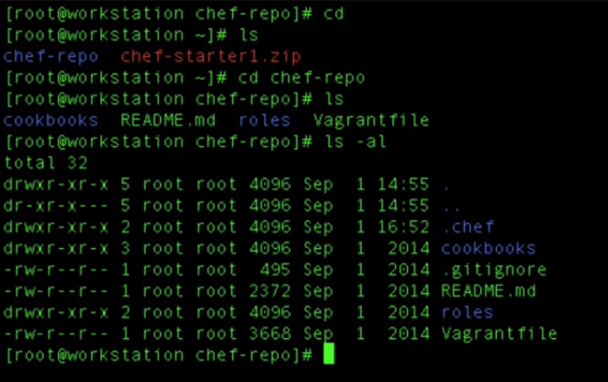

**Lecture: Chef-Client**

In this lesson we are going to learn about the role the Chef-client agent plays on our nodes and as part of our Chef infrastructure.

Chef client is a agent that runs locally on every single node registered with the chef server. When the chef client runs it does a lot of steps to bring our node to a desired state. When the chef client runs it does what is called a convergence, it communicates with the chef server, receives the information, it registers and authenticates the node with the chef server. It built the node object when the chef client is first run and also when it has completed running. It runs the Ohai to build the chef client and it does it both time before and after chef client runs so that the chef can determine the differences between the nodes before the client is run and after the client run.

So basically it captures all the changes during our chef client run, it synchronises the cookbooks so that when we add to the runlist for a specific node or a role, it communicates with the chef server, downloads the cookbooks and the recipes that are associated to that specific node .From there it compiles it and puts the nodes, follows the cookbooks and moves the node to the desired state so that it has all the attributes, all the dependencies , all the recipes and moves our node to a desired state based off the recipes that we created and had kept inside our cookbook and associate that to the node.

So it takes all the appropriate steps necessary to configure your node.

So whenever client runs we can have exceptions. So based off exceptions for we can write handlers that can notify us as devops or sysadministers that there was a exception during the run of the chef client.

In our prod environment we can automate our chef client running process for every hour, 30 min. Why we want to do this is because if we want to install new software packages on our nodes throughout our infrastructure,if we want to download security updates, we wanna add new users, we want to change the configuration changes or files. We want our nodes to receive that information from the policies on the chef server and configured to the desired state that we have configured based of our recipes. So we can automate the process of running the chef-client.

So inorder to communicate with the chef server the client need to have the validation.pem file inside the .chef configuration directory located under our chef repo.

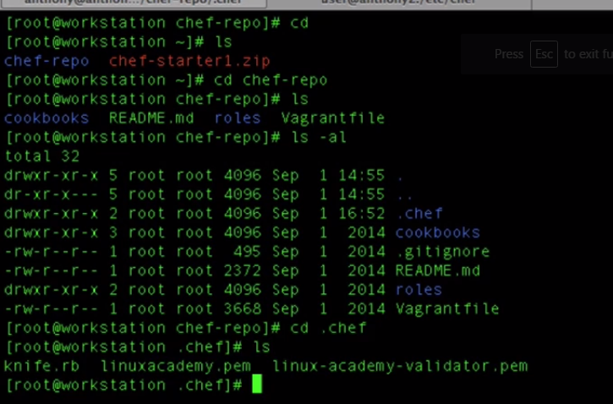

When we bootstrap the node for the first time, this validation .pem(here linux-academy-validator.pem) is copied to the node inside the chef directory as

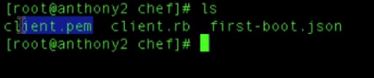

We see the client.pem as we have already removed the validator.pem file. The client.pem file is created from the validator.pem and we have removed it . This client.pem communicates with the chef server (convergence) and synchronizes the policies required for this nodes and executes the policies to put the node to a desired state.

We also have a client.rb file. This file is our chef-client configuration file. IF we vi to this file we see the below

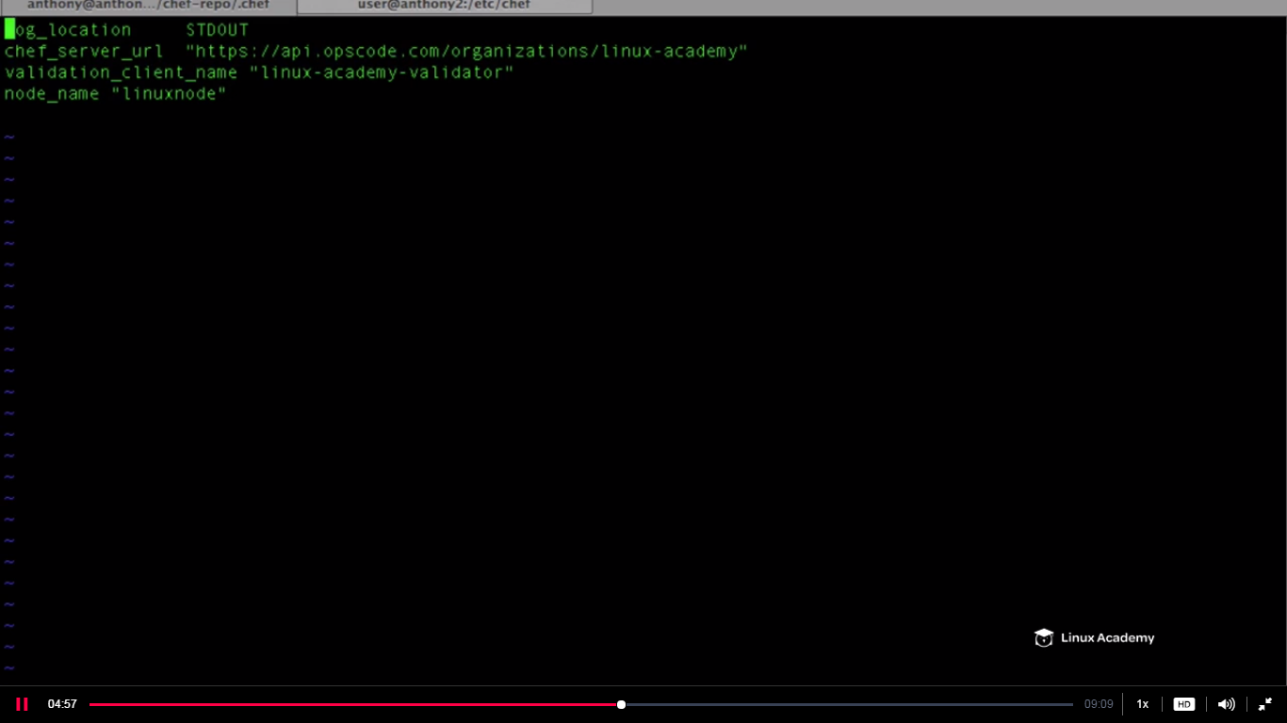

When we say convergence we mean the chef client has run

So if we want to provide more details on our client run or say convergence we add a line on our chef client configuration file as

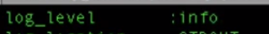

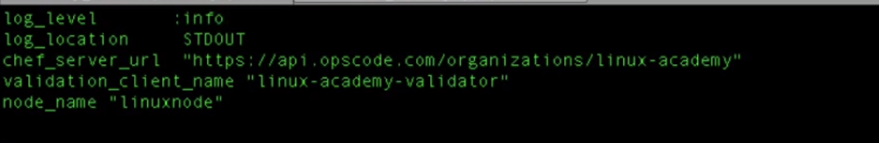

What happens when we add that line is that when we run our chef client we have more information during convergence..

For running chef client we do

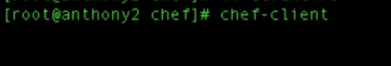

And we see more information on the adding the line log_line in the chef-configuration file during convergence as below

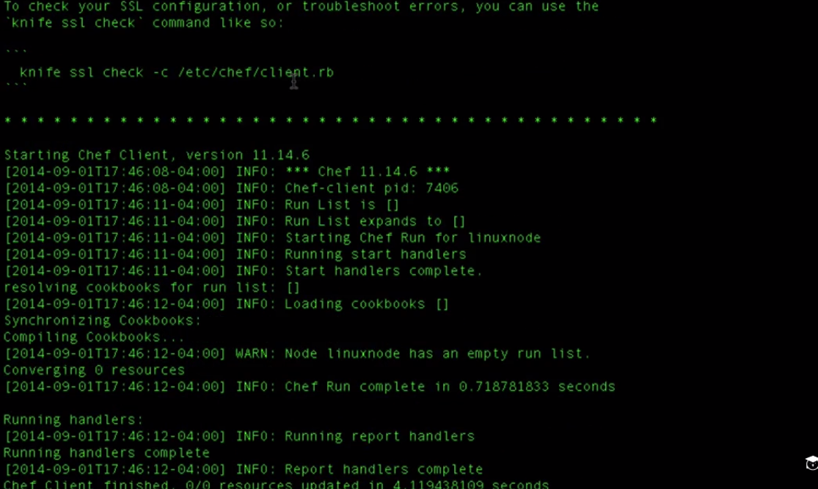

If we run **ohhai** we can see details about client object as

Just put ohhai and you will see below details

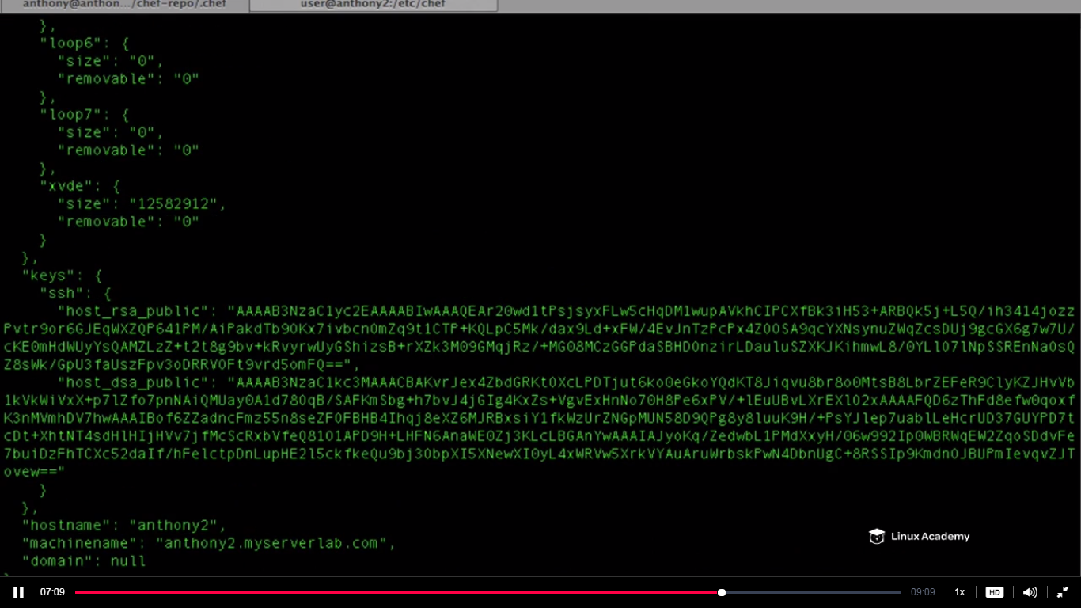

So when we run chef client the ohhai which is a program creates a chef object which authenticates the node to the chef server and sends the information of the chef object to the chef server. So whenever we run the chef-client the chef-object is created.

If we go to

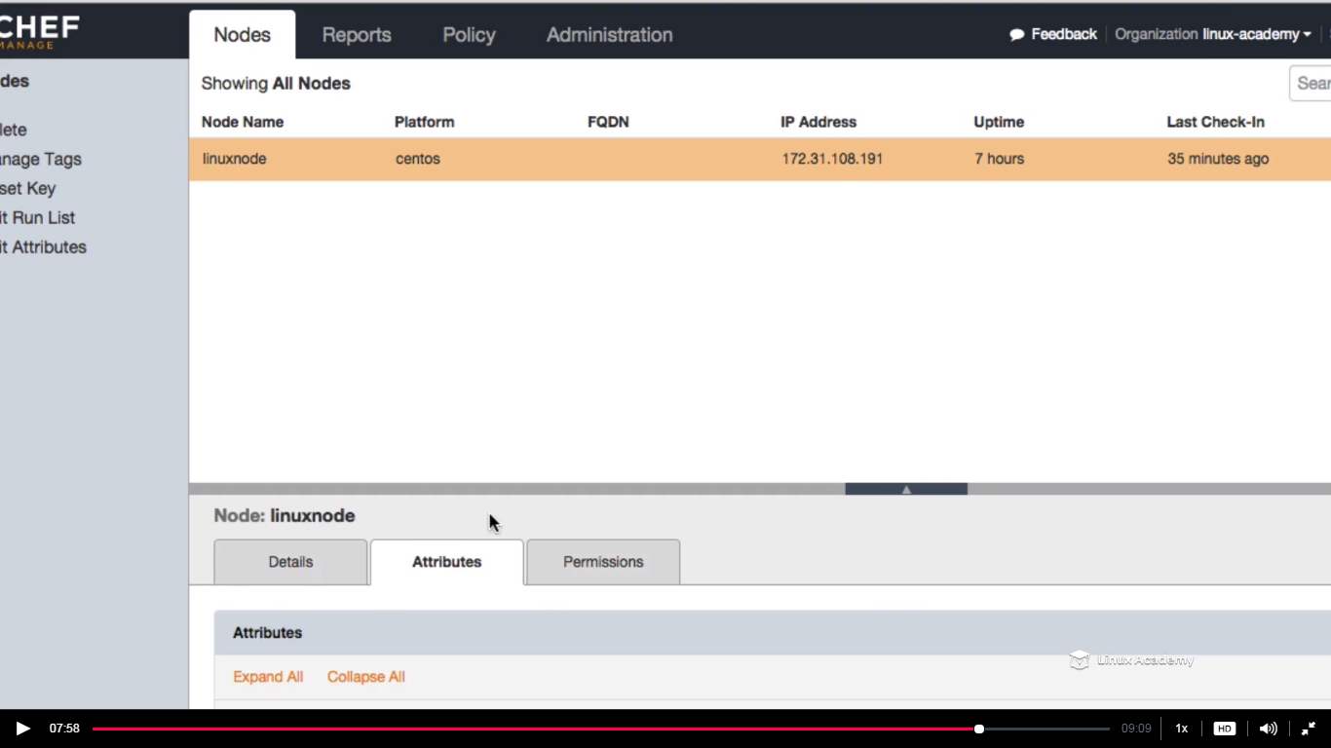

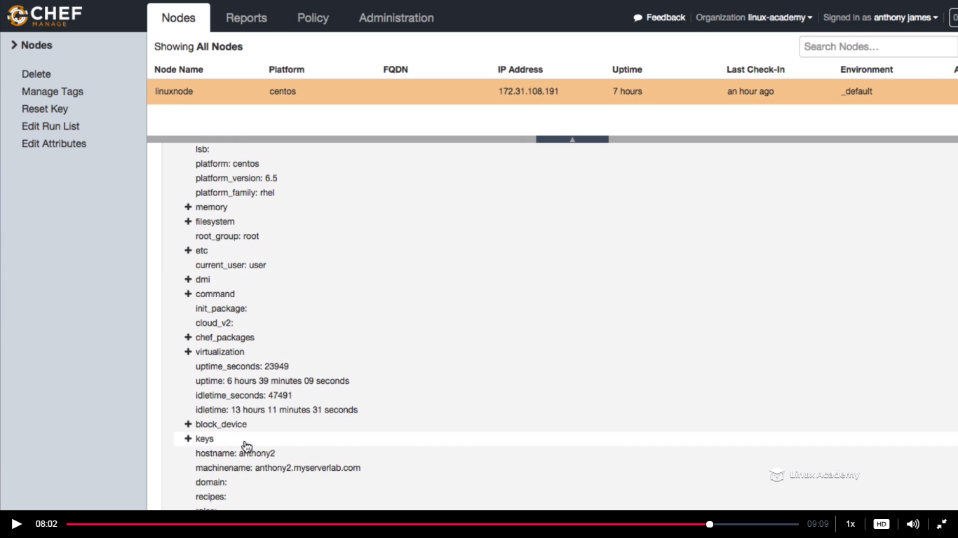

This is the all information which is generated when ohai is run during our chef client run or during the convergence. **So remember the node object is built before and after the client run. Because before the run the state of the node is different than after the client run .After the client run the state would be changed as it would get new changes or updates as per the cookbooks assigned for that node and follow the instruction and policies that we dictate inside our recipes.**

**Lecture: Servers And Nodes**

In this lesson we are going to cover the core concepts of nodes as well as the anatomy of a Chef-client run

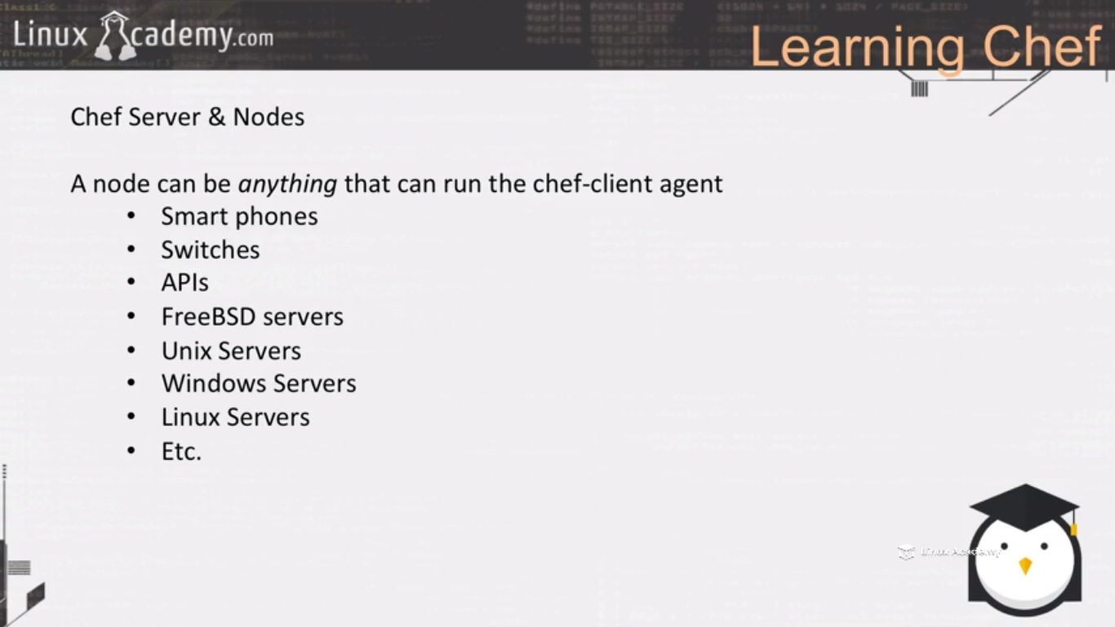

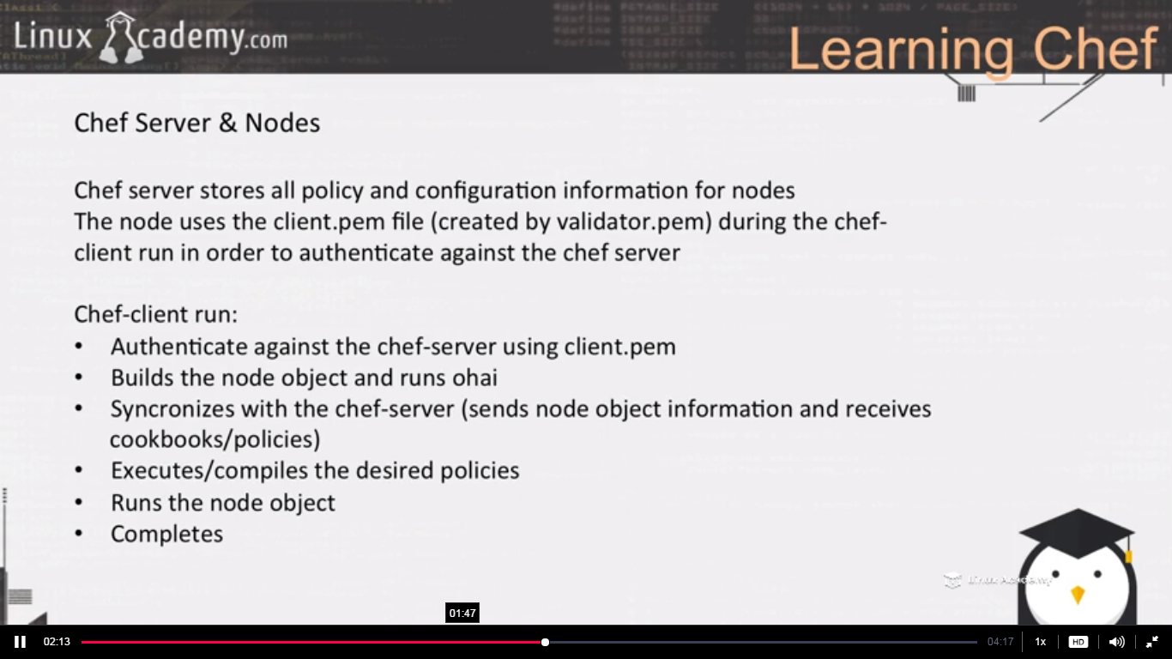

**Lecture: Chef Configuration Concepts**

In this lesson we are going to do a quick summary of Chef configuration concepts. This will help us prepare for our hands-on section.

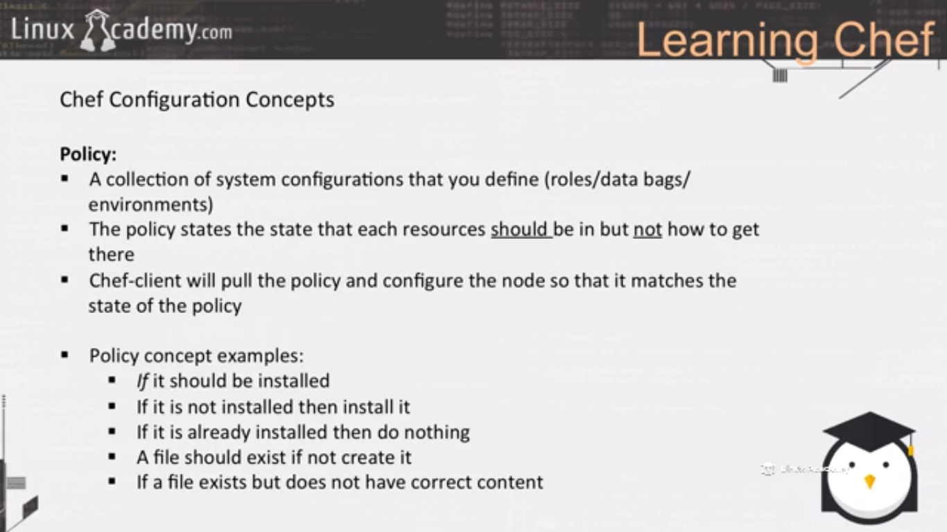

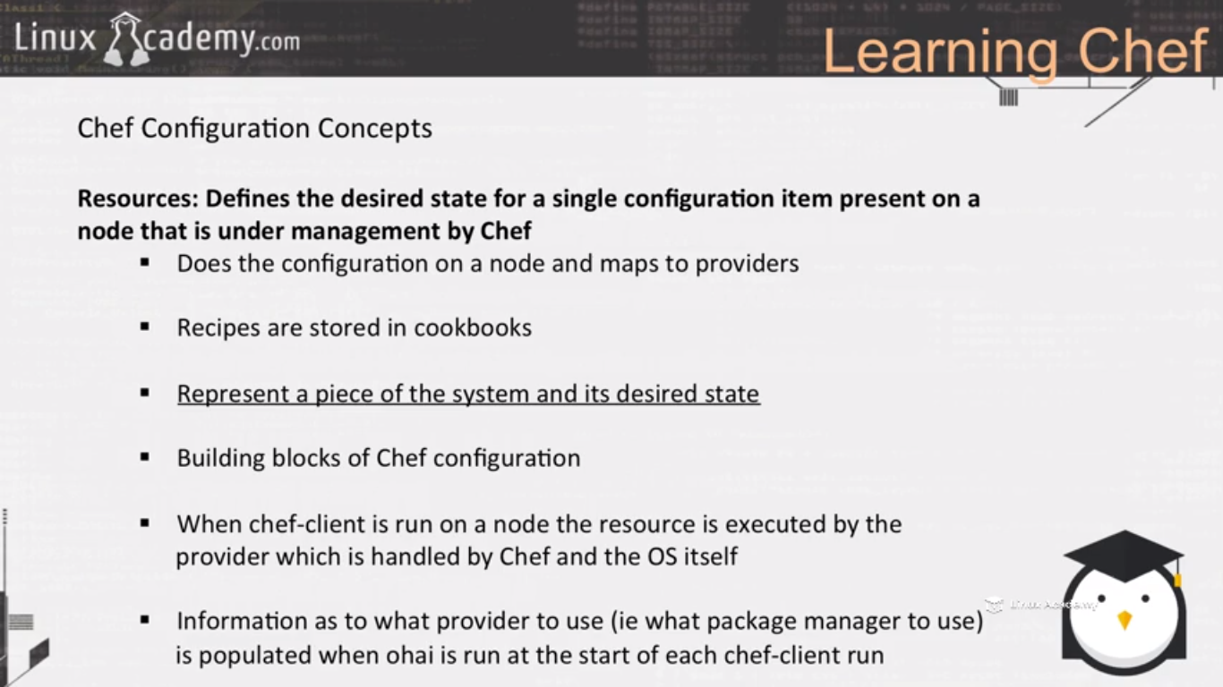

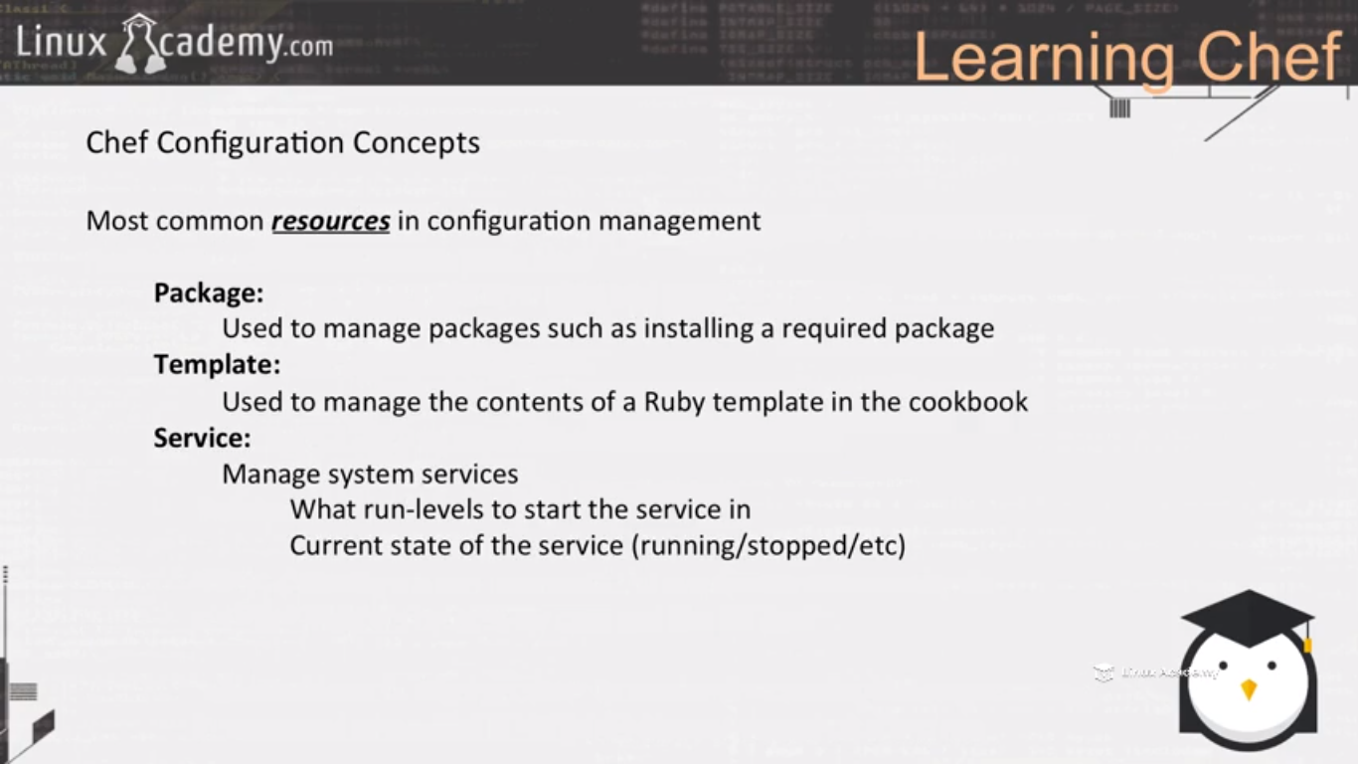

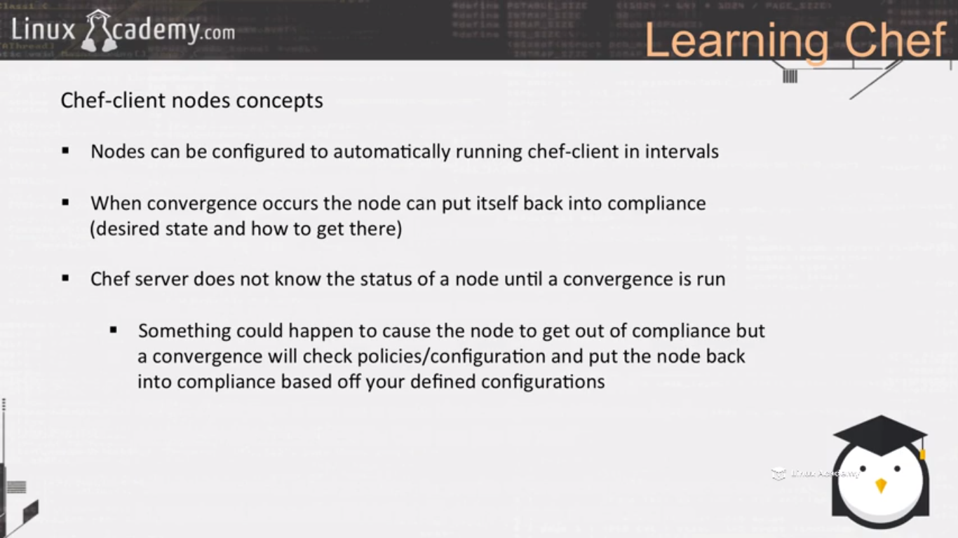

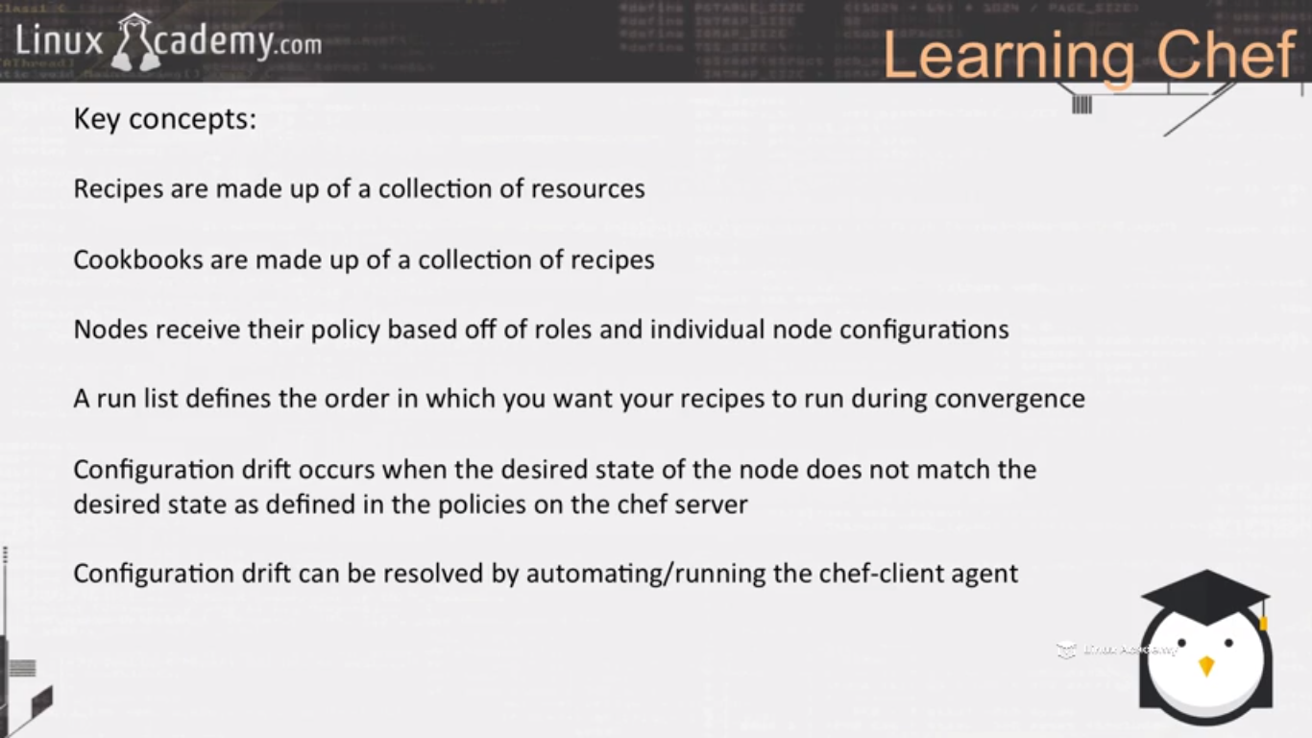

**Building The Web Server Cookbook**

**Lecture: Getting Set Up**

In this lesson we are going to get set up with our workstation and node. During this process we are going to reset and download our starter kit for our organization and bootstrap our first node. We will also walk through how to use the Linux Academy lab servers in order to follow this course.

Now we are laying foundation for a new course hence deleted all previous configurations and downloading a new starter kit.

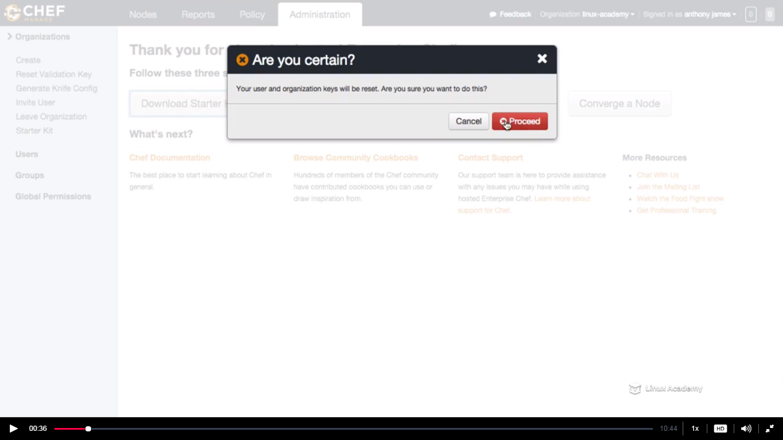

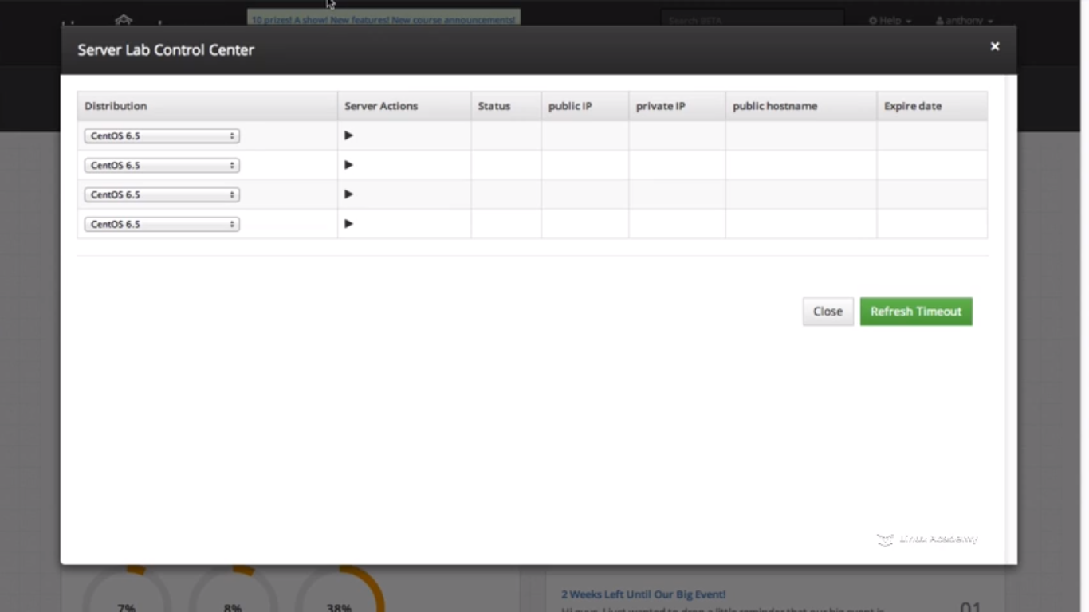

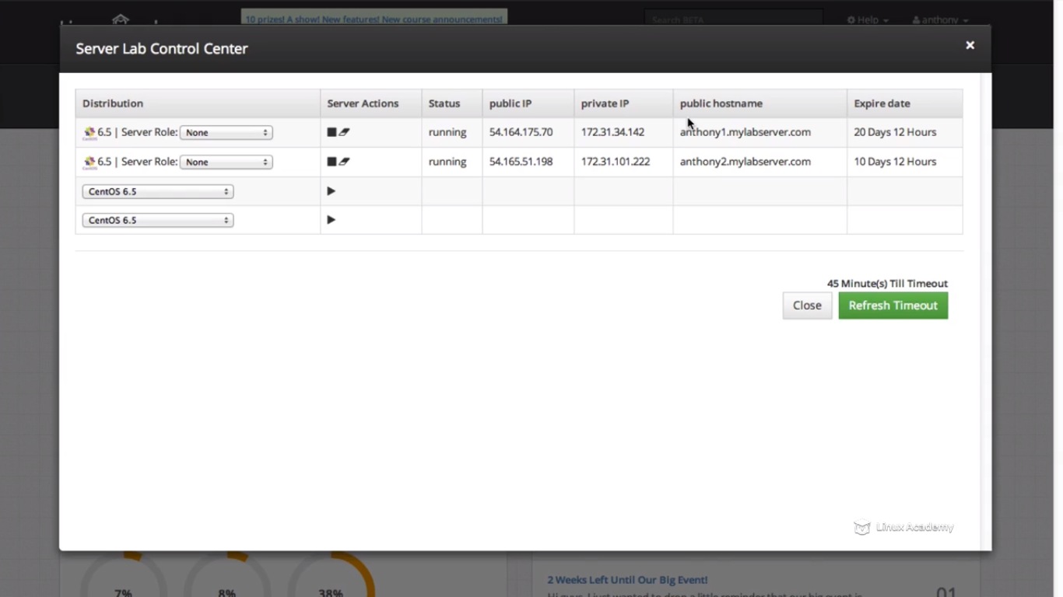

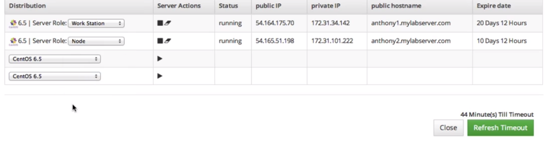

**Go to the node and enable root login for the bootstrapping**

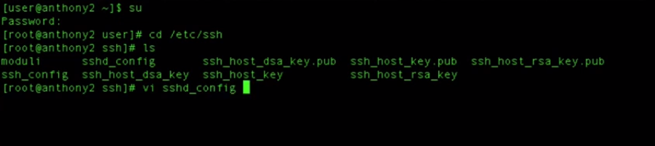

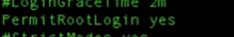

**Inorder to make the changes do service restart**

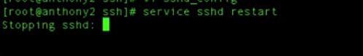

**Now make the workstation ready, need to bring the starter kit that we downloaded to the workstation so use some ftp server to move the starter kit to the workstation. We used firezilla in our first bootstrap process earlier..**



**Copy the starter kit to the workstation from firezilla**

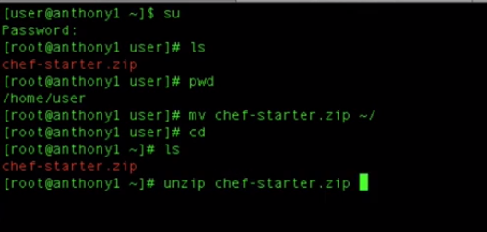

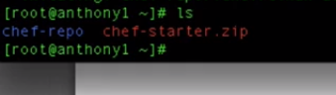

**Till now we don’t have chef tools like knife, ruby components so let’s download them**

**Make sure curl is installed**



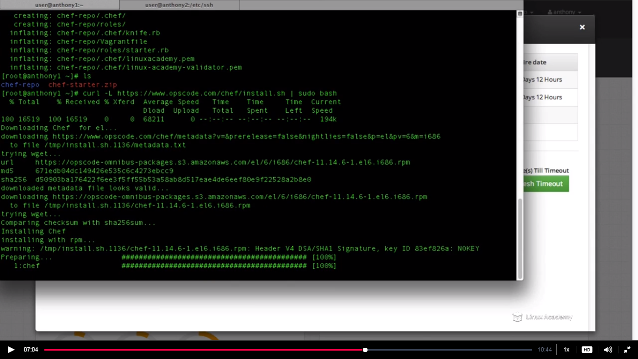

**So lets bootstrap our node. What bootstrap does is that it downloads and install the chef on that bootstrap node, copies and validates using the validate.pem file authentication keys to create the client.pem file which is required for the node to authenticate against our chef server.**

**So lets bootstrap the node. We would use the second server to do this. Here we are using the linux academy second server and the hostname to do this .If you are using your virtualization environment you have your internal ips for the server which you are gonna use. This is done from the workstation**



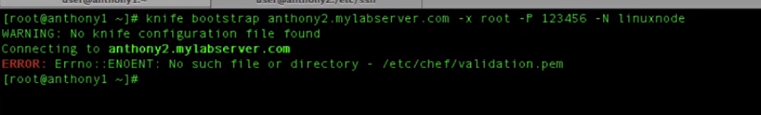

**This is because whenever we issue the knife command we need to be inside our chef repo**



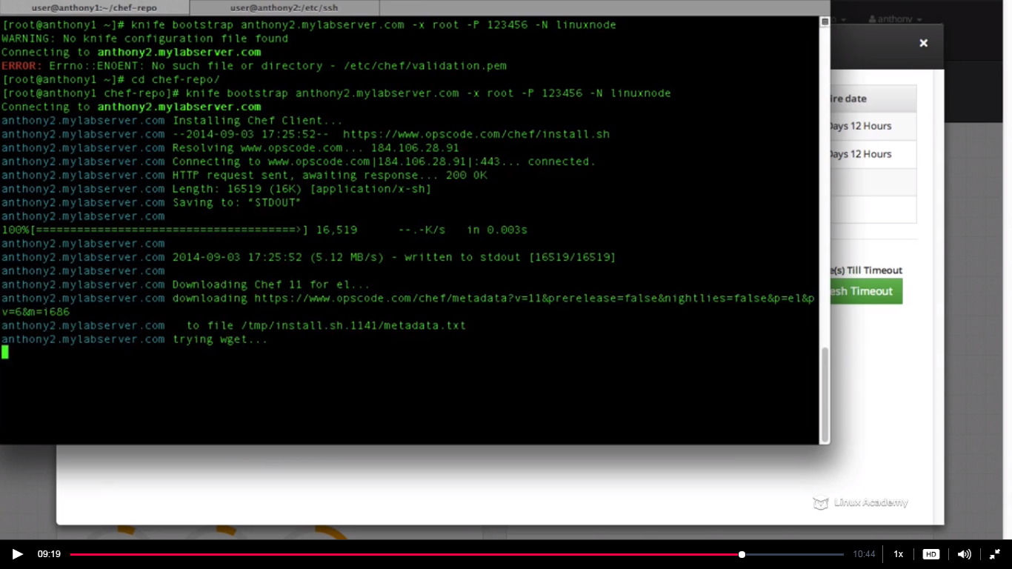

**Now lets go to the node and enable advance logging as it would be helpful to know the errors while writing recipes later.**

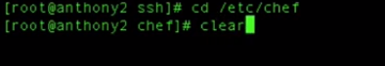

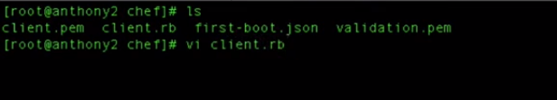



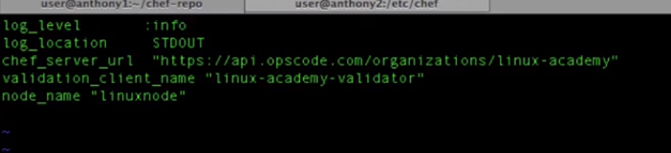

**This is gonna enable advance logging.**

**Just to verify everything is working we will do on node**

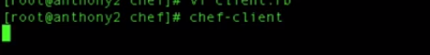

**Lecture: Starting The Apache Recipe**

In this lesson we are going to start building our cookbook and recipes. We are going to learn how to troubleshoot a few items as well as use the Chef documentation. This is the foundation for the rest of this section where we spend most of the time actually writing the code for our infrastructure.

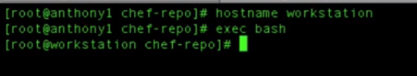

Now we will create a cookbook for apache

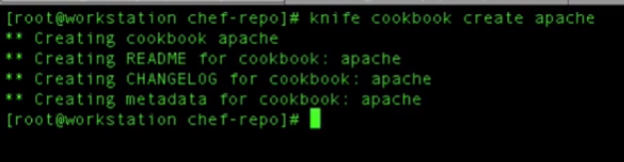

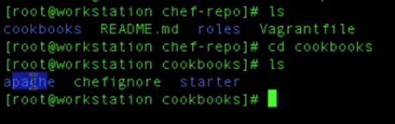

We see we have the apache directory or say the apache cookbook.

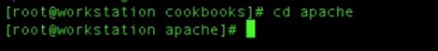

This is where we would working now and now we will be creating the recipes

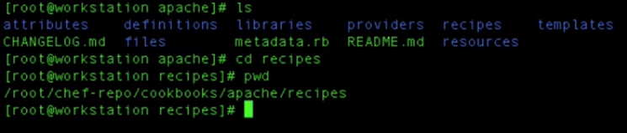

Inside recipe we have a default recipe i.e default.rb

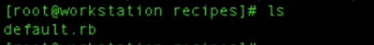

This default.rb would be doing us the most of the thing, the core functionality.

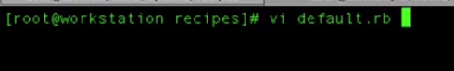

Our recipes allow us to define resources that allows to give directions for what needs to be installed and configured on the node. So the directions on which we would be starting with would be installation of the apache service. Also we are sure we are doing it on centos machine as of now.

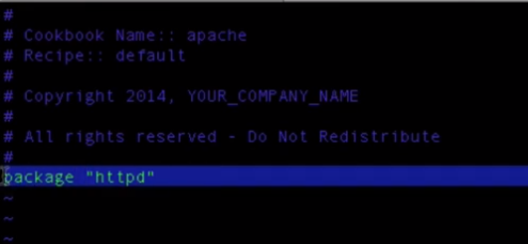

This highlighted a resource .We have just defined a resource specifically the package resource. A package resource allows to enable and install packages

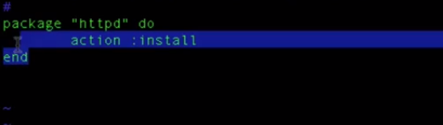

This a a resource and it defines an action and that action is to install the httpd package on our centos machine. Now when we install the package though, the package is just gonna be there, that doesn’t mean that our httpd services would be enabled. So lets start with it.

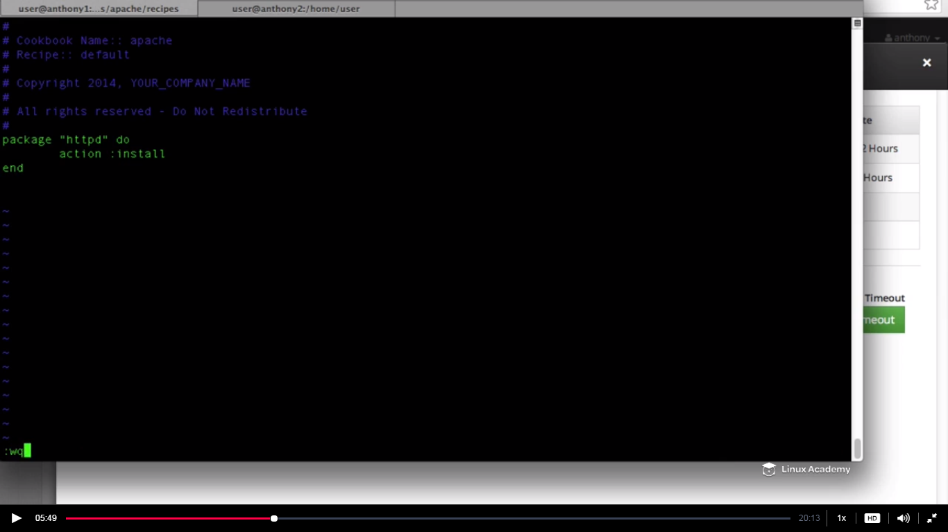

Now I would use my knife tool to upload the cookbook to the chef server. IT would upload all the recipes, the attributes and templates associated with that our apache cookbook.

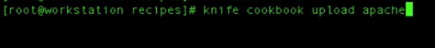

Once you uploads it gives you the version which its uploading .IT also states its successfully uploaded.

Now if we head up to our node and do a chef clinet as

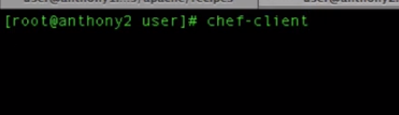

This is gonna install apache.

It would not run still because we haven’t defined the policies for our node so we need to define policies before running the chef client in the node. We need to define the policy that this node needs to install apache. So lets do that

For defining policies we need to go back to the workstation and use the knife command



**Linuxnode**-name of the node

**Recipe[apache]—**name of the recipe(we are running recipes in the runlist not cookbooks,however we can run cookbooks in the runlist)

But you might say apache isn’t a name of the recipe it’s the name of the cookbook, the name of the recipe is default.rb . Well the default.rb recipe defaults to the apache name. By saying“recipe[apache]” means that we are going to run the default recipe inside the apache cookbook. **If our recipe files name is apache2 then we would be using apache2 inside the bracket as recipe[apache2]**

And now hit enter on the above command and you will get the below

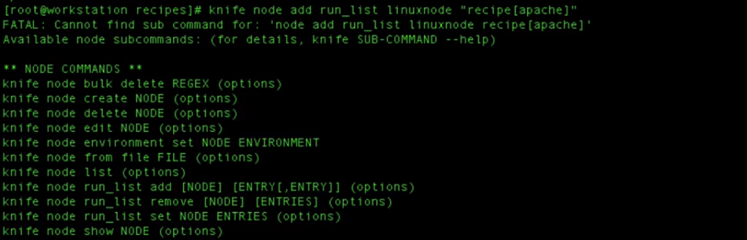

What is the error is that the knife node at run_list didn’t work. Let’s say we forgot the specific command.What we should do inorder to know the syntax of the command ,the parameters for us to upload this apache cookbook so what we need to do is

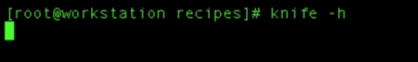

That would opens a help section for knife also we can open of going to docs.getchef.com as

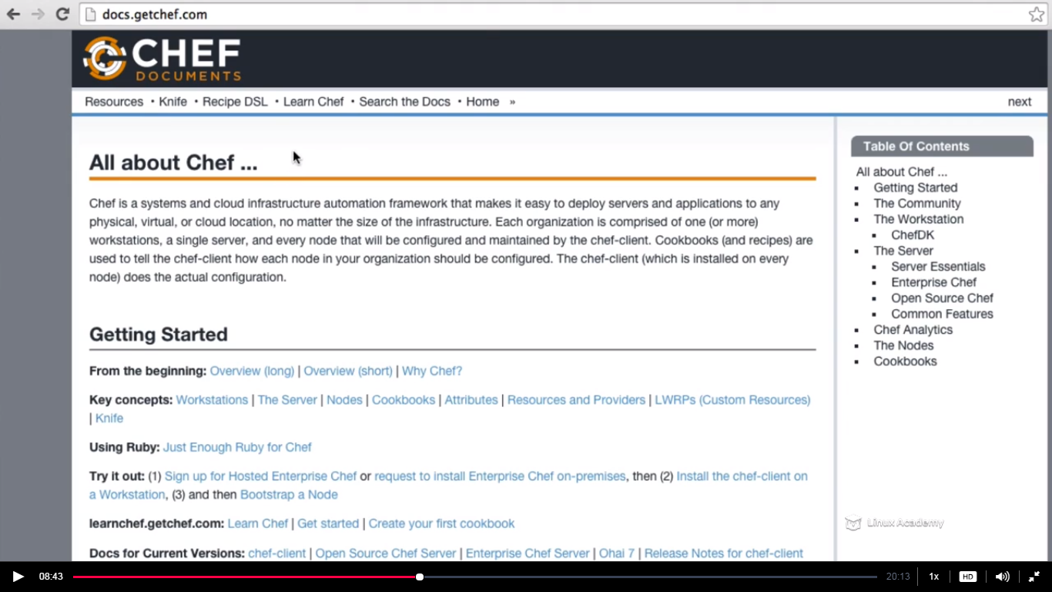

Click on knife and then search for cookbook or runlist by control+F and it will work for us.

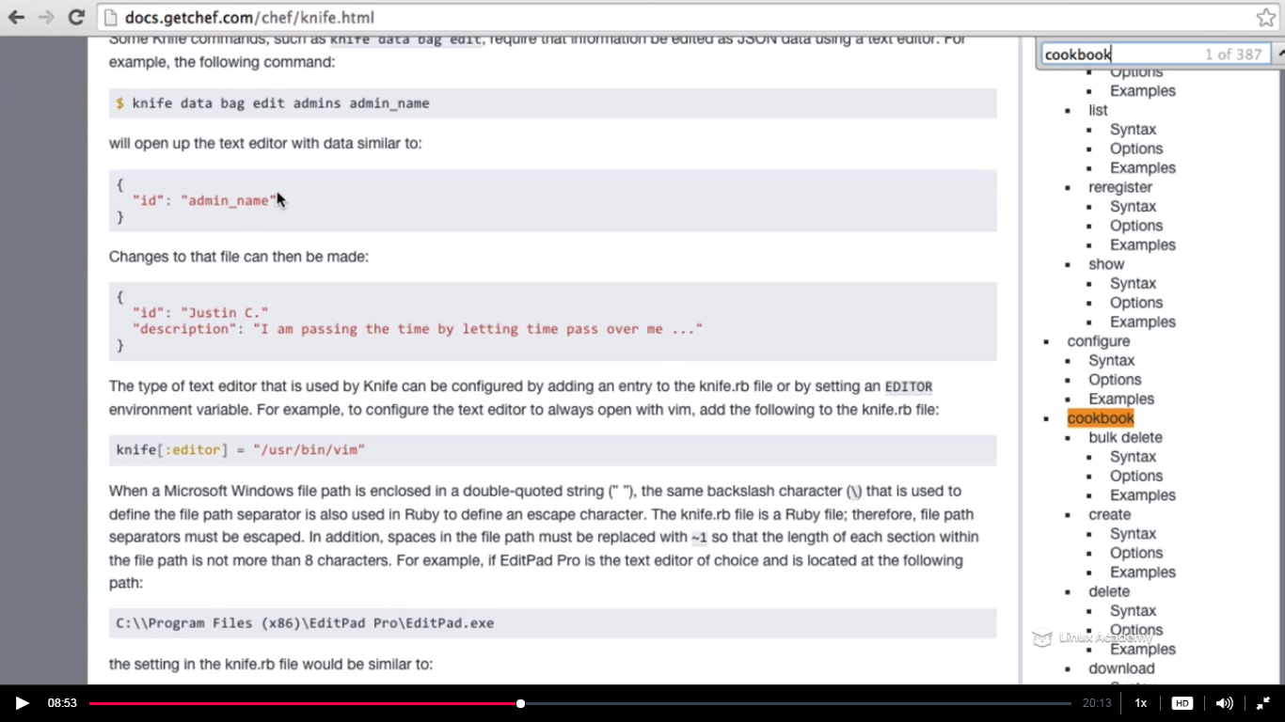

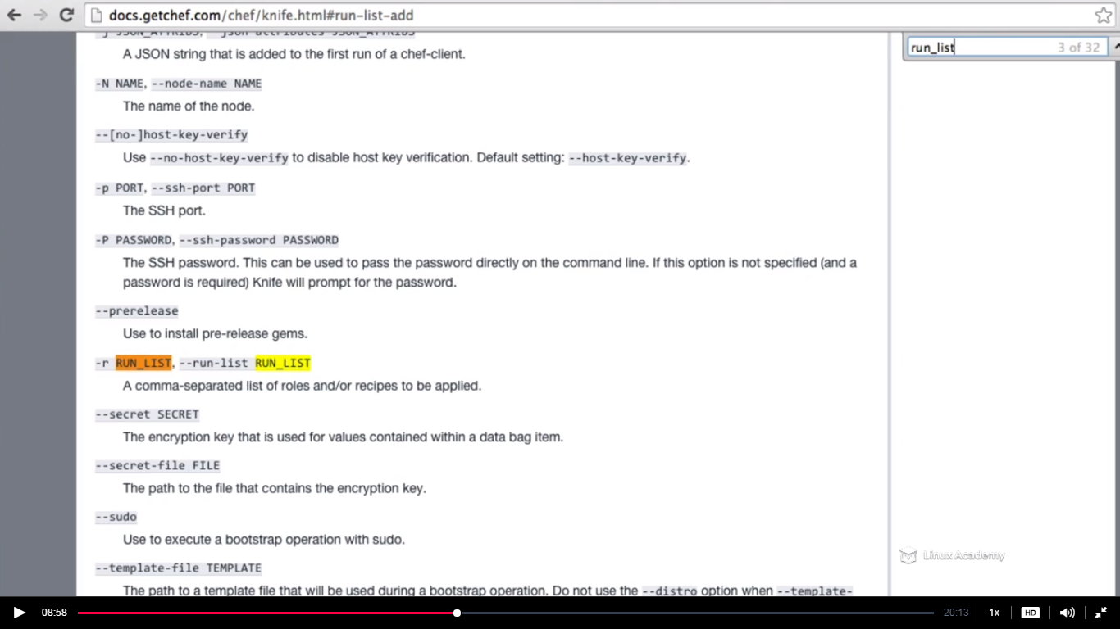

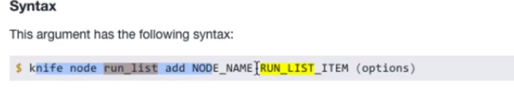

We found the above syntax for runlist add command above



For my terminal

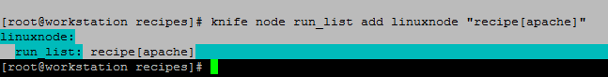

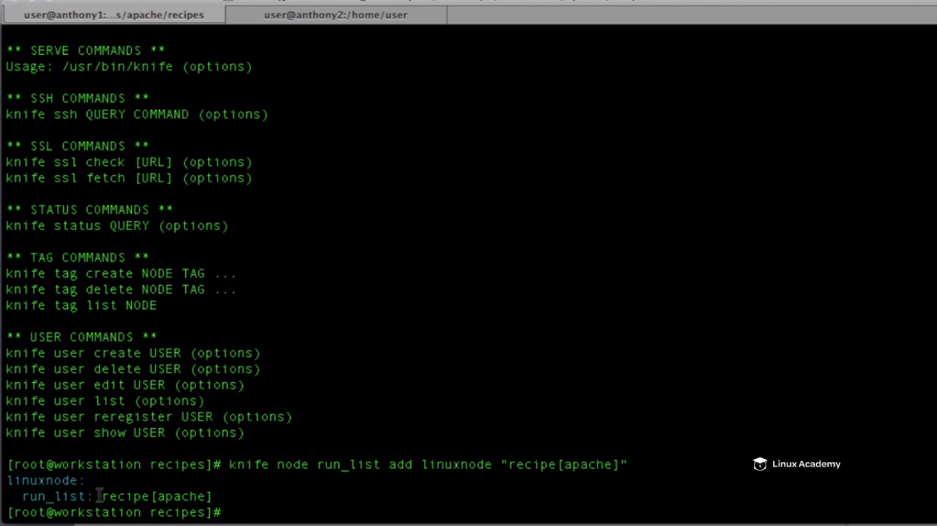

At the last we can see the current list. It would run the recipe[apache] first, offcourse coincide with default.rb file inside our apache cookbook. If we would have a file inside our apache cookbook called apache2.rb it would not run unless we would have added it into the runlist.

Now we have added the cookbook and added the recipes to the runlist for this node or linux node and now let me do a chef client on my node and it would do a convergence.



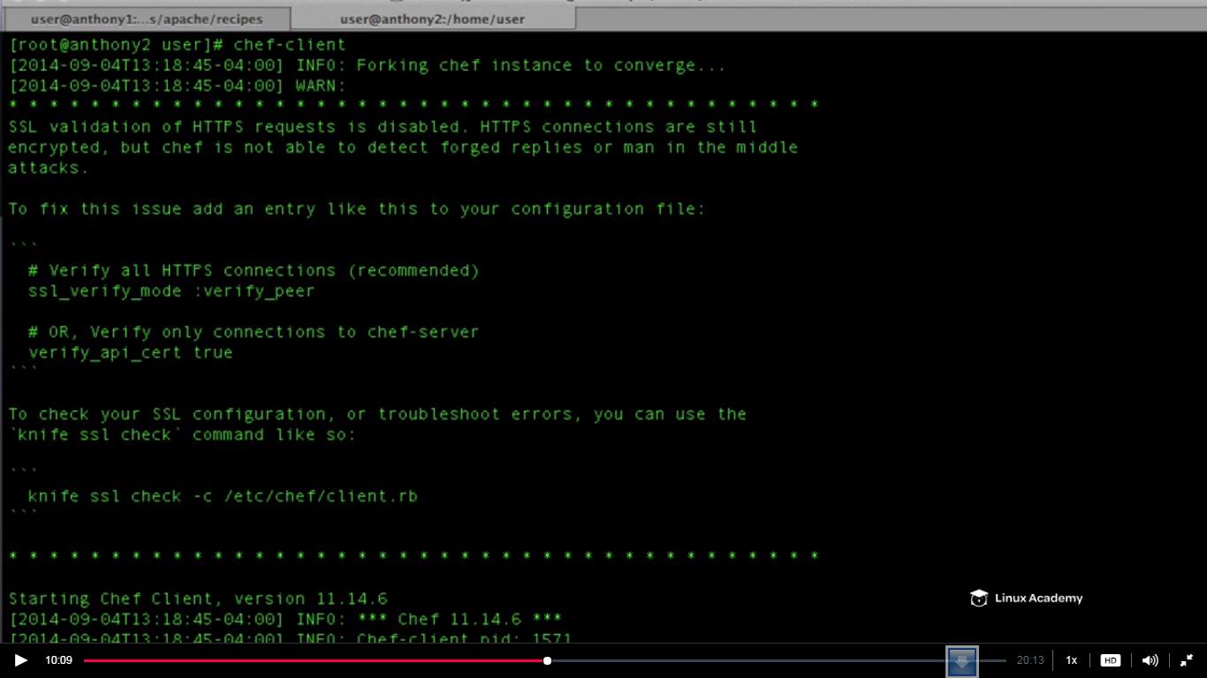

My terminal details

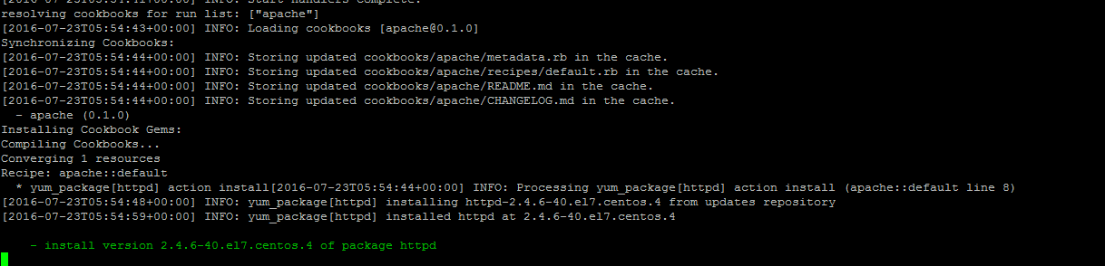

What it does is it downloaded and istalled the apache configuration.

**Not lets go to /etc directory and verify if there is httpd in there by doing a ls in the node**

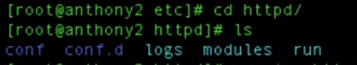

But if we do



The service is stopped. Our recipe just downloads it and do nothing else. Let’s see on our default.rb file in the workstation as

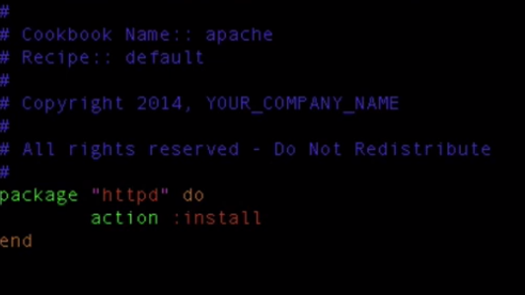

IT does things with the package but not anything with the service. So what we need to do is to use the service resource and define instruction what needs to apply . So the service resource would say what should or not be running.

So what we want is to enable and start the httpd service on boot up. We can do a lot of option like restart, stop etc which are provided in the chef documentation but currently we want to restart the service.

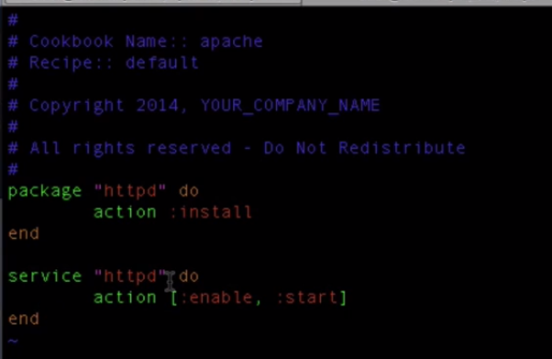

So if we save our cookbook

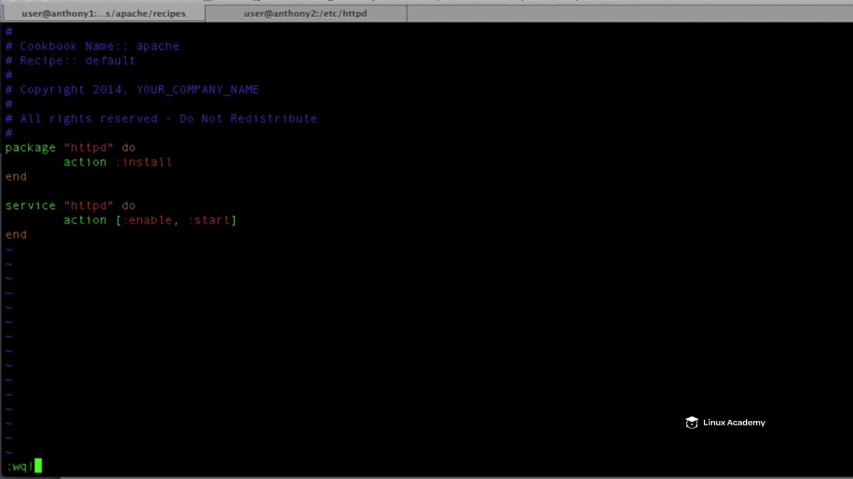

We need to upload the cookbook to the chef server.

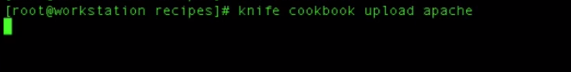

We don’t need to put it into the run list as its there already in the recipe.IT would run the updated version of the recipe. So lets run our chef client convergence.

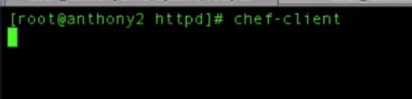

We can see the logs on the screen as we have enabled advanced logs on the client.rb

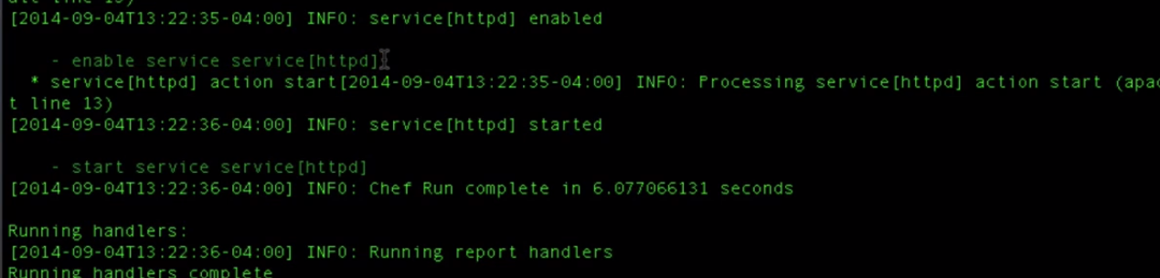

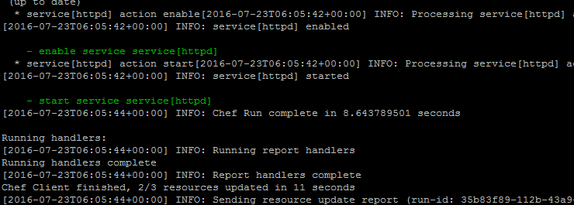

We can see the service is getting enabled and started on the startup. If we check the status of the service as



We see its running. Also we can copy our resource hostname or public ip and can put it on the browser as

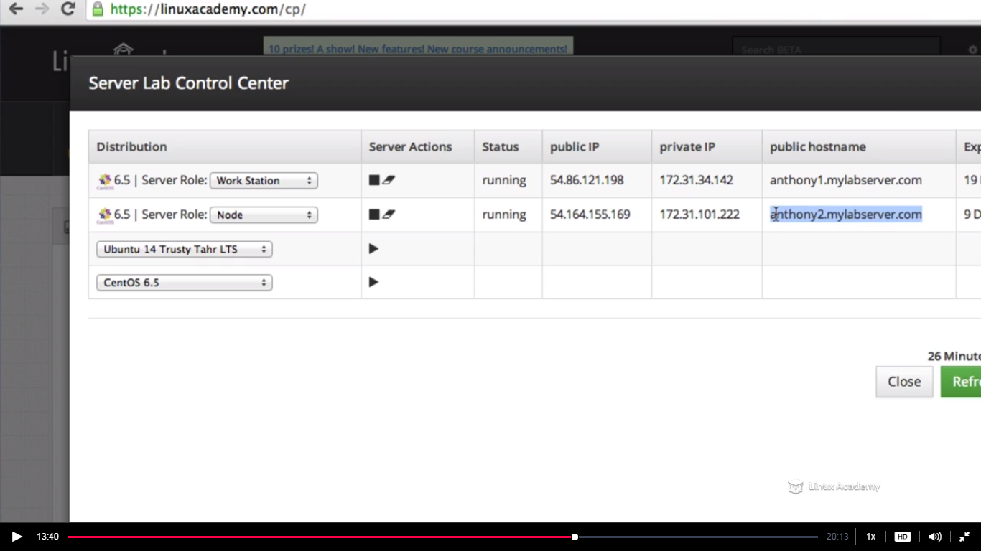

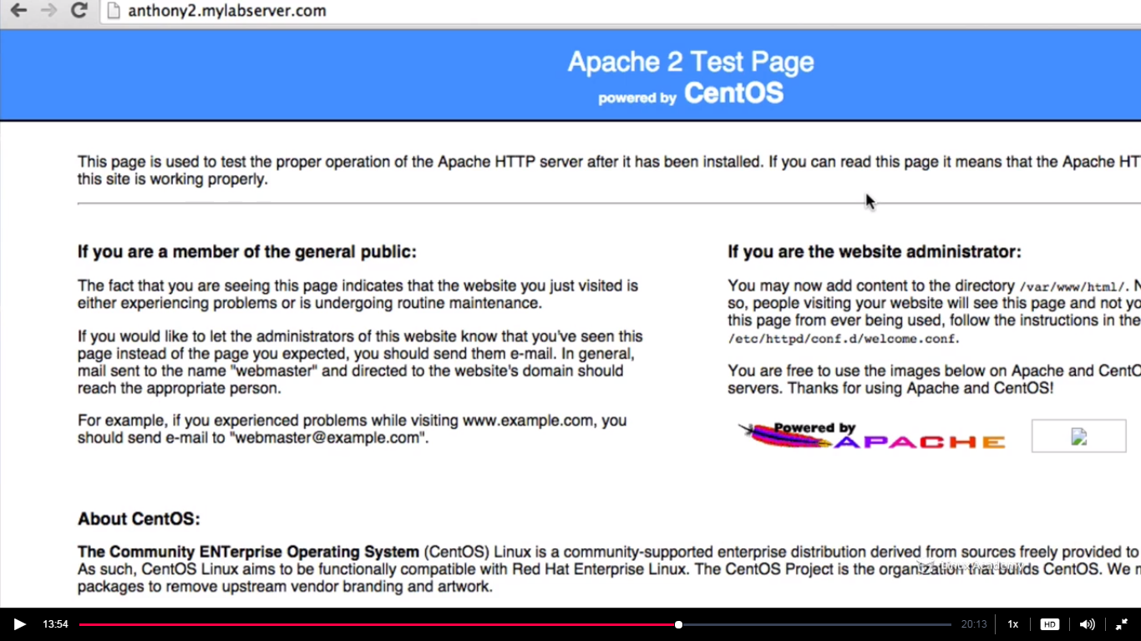

You might get this as well on your screens.

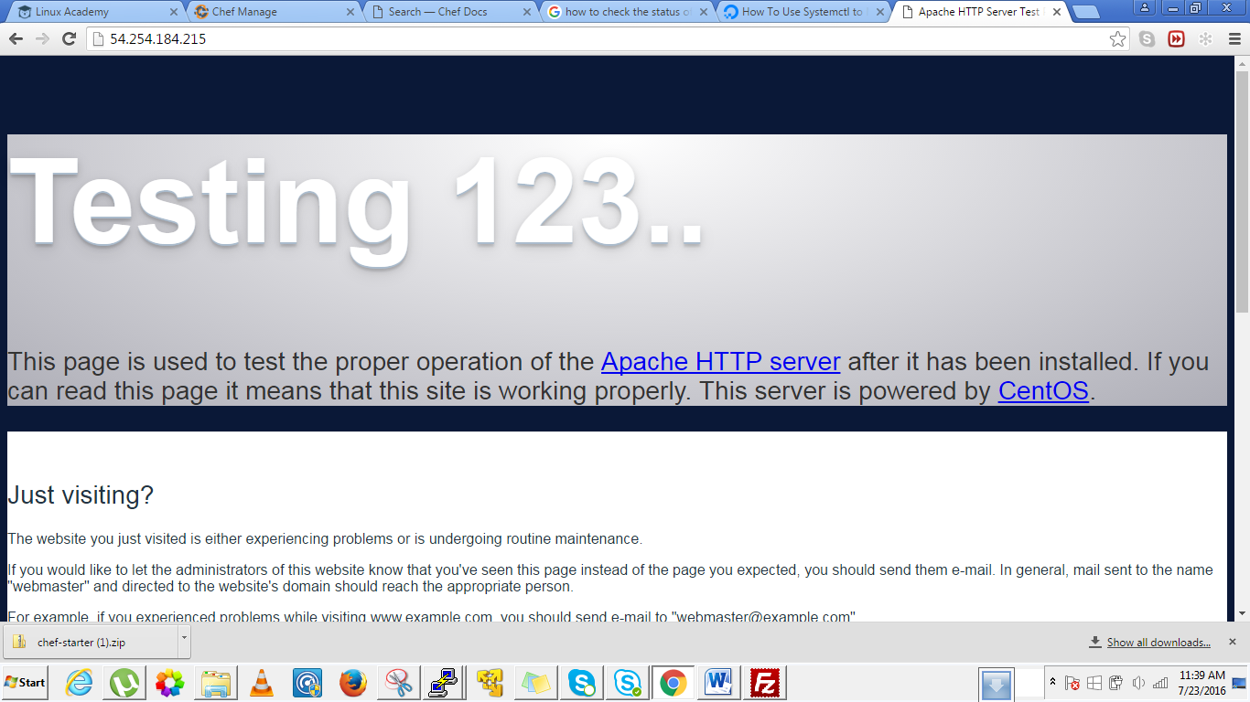

So apache is running successfully on our system.

If we go to our /etc/chef directory we see we still have our validation.pem file

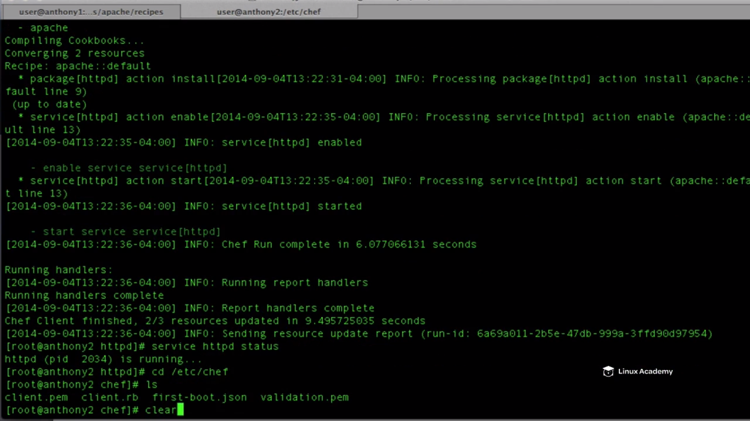

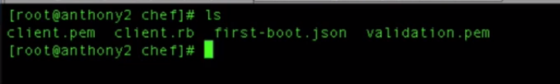

Maintaining the validation.pem here is a security issue.

We are building our cookbooks and recipes from scratch we don’t need previous ones.So lets go and add another cookbook into our workstation that removes the validation.pem file .



Lets navigate back to our cookbook section as

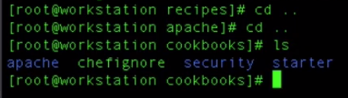



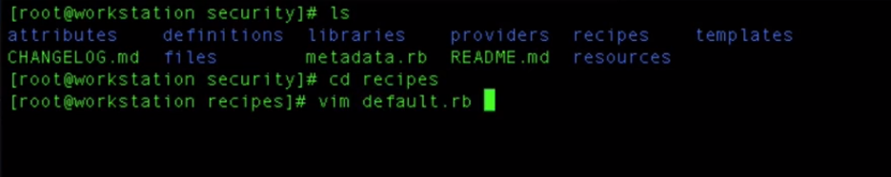

We would be using a resource called file which will look a file in the specified location

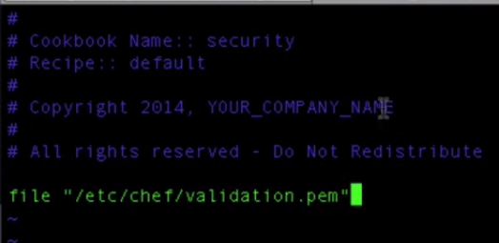

So this file resource look into that directory /etc/chef/validation.pem and will perform the action which we define as

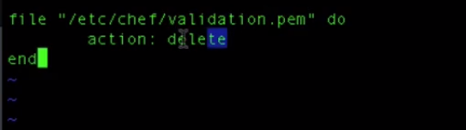

Resource file looks in the specified directory and if the file is there it deletes it.

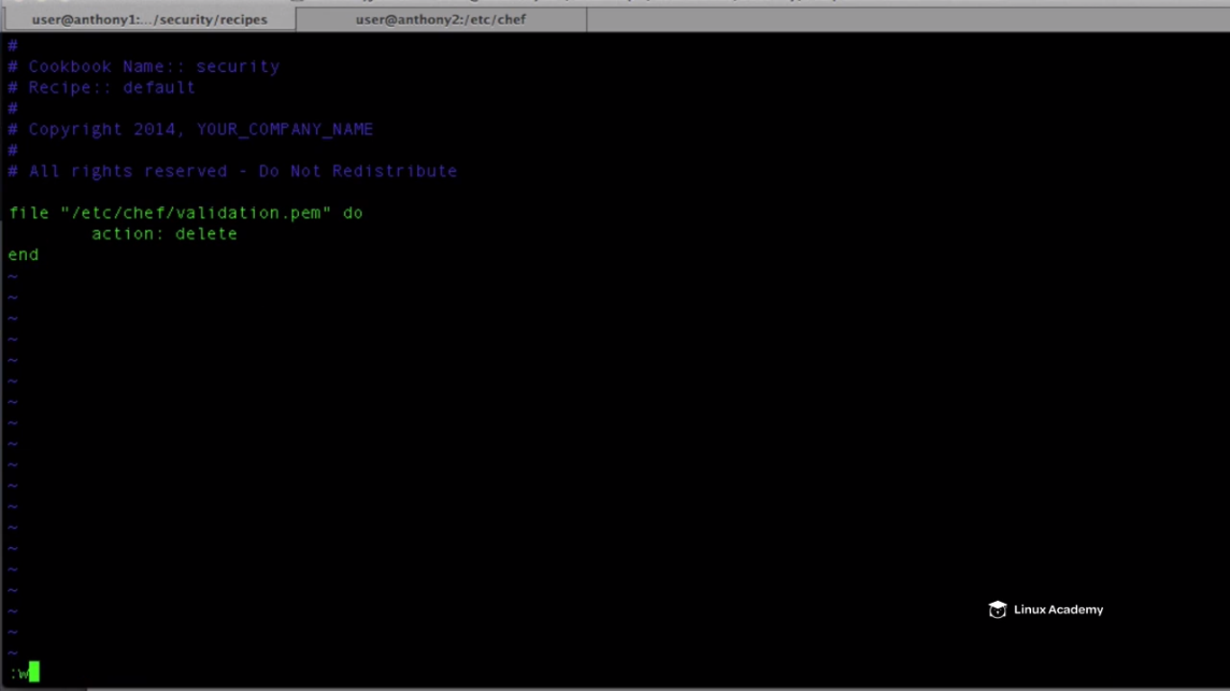

Now we need to add this into our runlist because even this is in our cookbook it is not going to run it unless we add it to our runlist.

This recipe would be the first to run because if it is not and in the meanwhile running some recipe if the chef client hangs and the security recipe didn’t run as its late in the runlist the validation key would still be there and it would again be a security issue.

So how should we add this recipe before the apache recipe in the runlist.

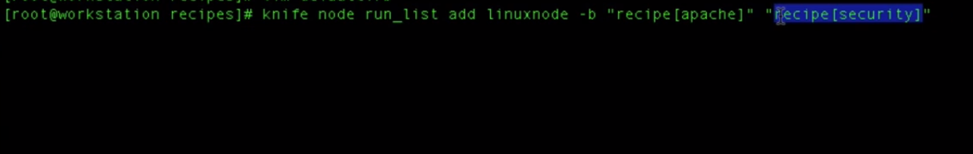

So –b means before .Hence we added the security recipe before the apache recipe but the question is that security is not a recipe it’s a cookbook???

Because we added it to the default.rb it would be considered as a security recipe.

Now add this to the runlist as

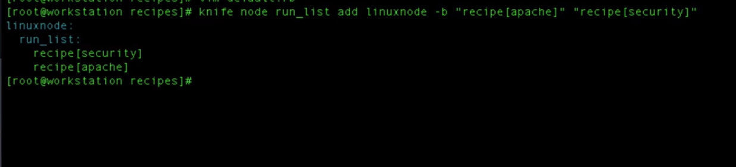

We know runlist runs recipes but it doesn’t run all recipes in the cookbook. They run individual recipes. So we see the recipe security is listed before the recipe apache.

So if we run chef client and do a convergence without uploading the security cookbook to the chef server we get the error as

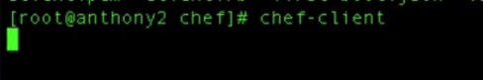

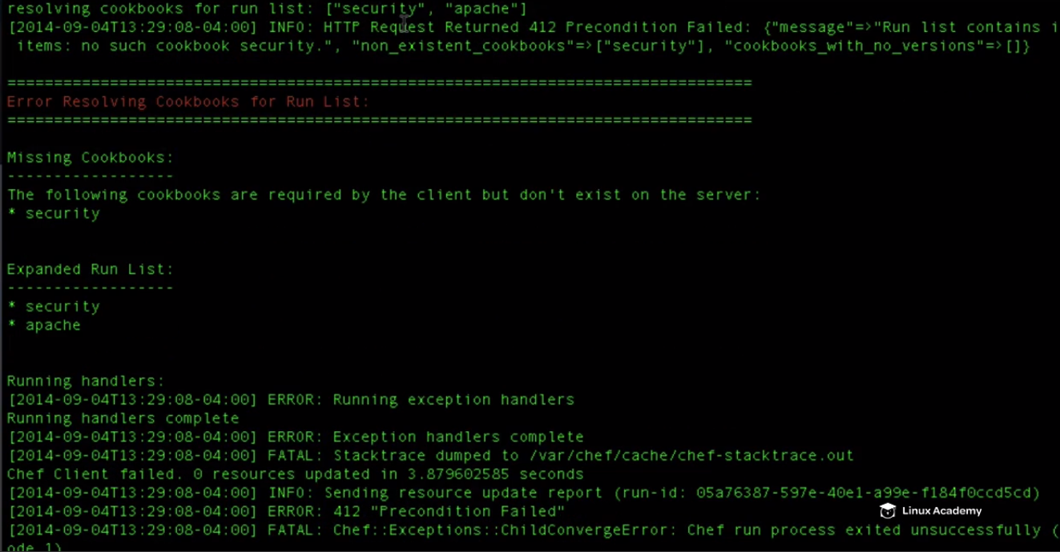

So we fix the error with

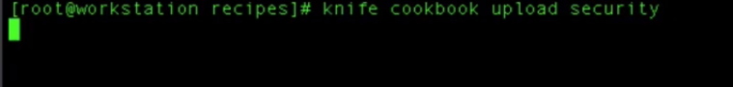

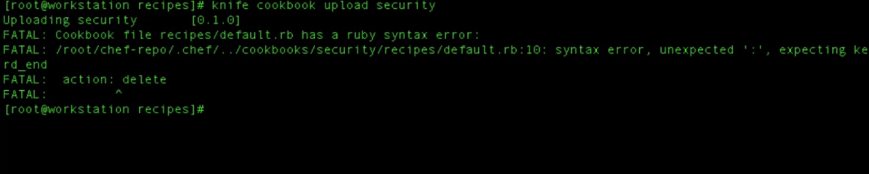

We got a syntax error lets check it

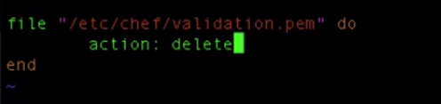

We need to have action :delete(action space delete) in the cookbook security

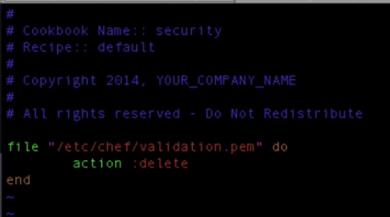

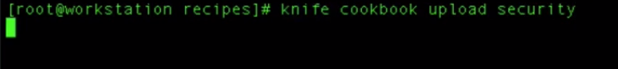

And then run chef client on the node once we uploaded the security recipe to the chef server as

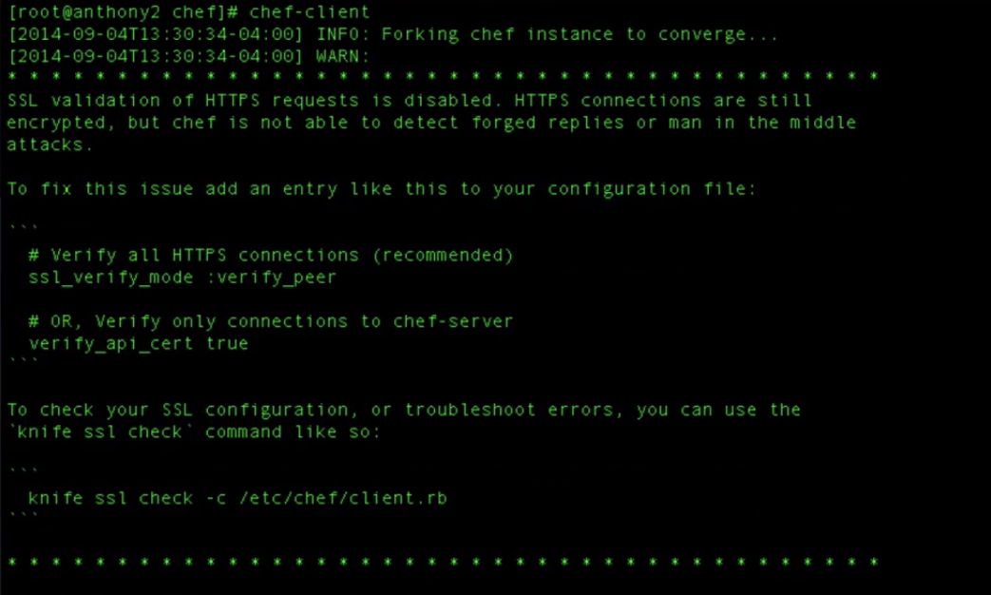

So if we a ls we see the validation file isn’t there any more

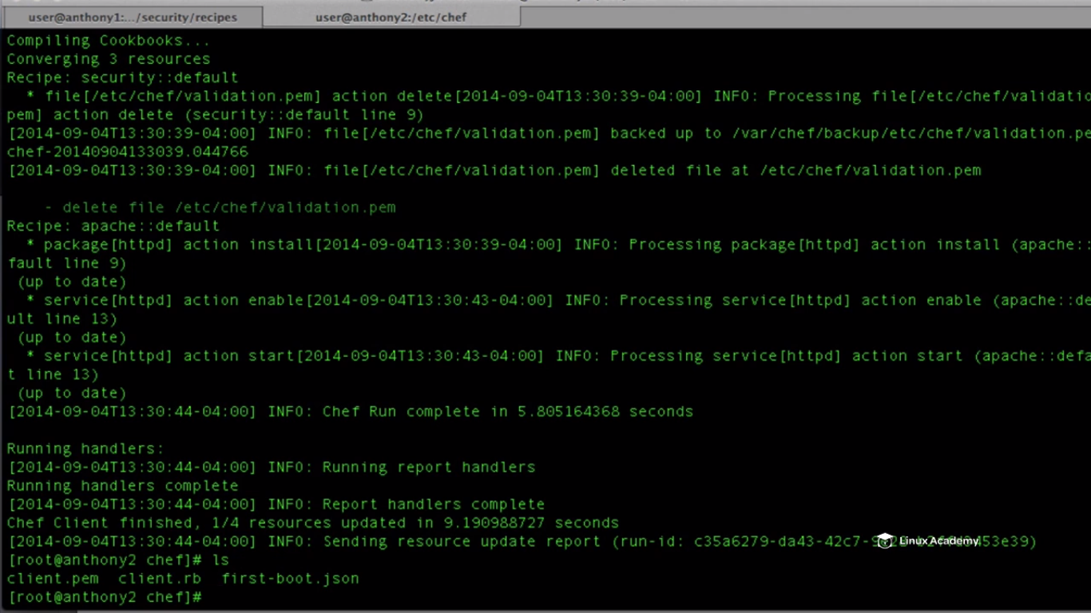

**Lecture: Adding Attributes, Recipe, And A Template**

In this lesson we are going to build the main part of our Apache cookbook. We are going to define attributes, build our recipe, and a template to configure our webserver to host websites.

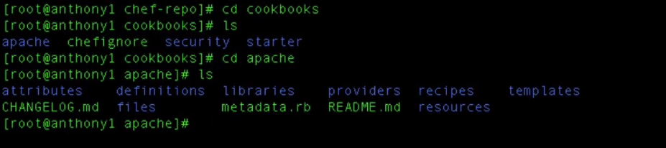

Lets get inside our attrtibute. An attribute is a specific detail about our node. We can know the current state of the node, determine what the state of the node was before the end of the chef run because of the ohai node object. We can use attribute defined by the ohai node object which gives us the attribute such as the memory running on the system, the operating system on the system. **We can define the attributes inside the cookbook, inside the environment as well as inside the roles.**

So the attribute allows to define information about something

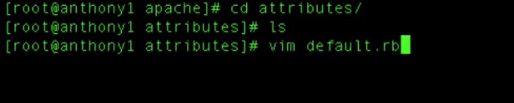

Here there are attribute precedence’s . We will learn about this in details in the next lesson. So the default precedence is the lowest level and is generally when we use precedence is when building all of our attributes inside our cookbooks, roles and environments.

So what precedence does is it allows us to give another attribute the higher precedence which means it will override the default attribute if its needed.



Apache is the name of the cookbook, we are defining sites and anthony2 is the name of the site and now we are defining some properties for this site anthony2



So what we are saying is that we are defining a site site anthony2 which runs on port 80 and the domain for the site is going to be anthony2.mylabserver.com(what is your lab server domain name give here). So we have do something more as we have to get this information inside our virtual’s host’s configuration. So we need to take our attribute information especially properties, need to populate a template that has our virtual host configuration in it and polls from these properties. So lets define our second attribute.



The file should be like this finally



Save and quit

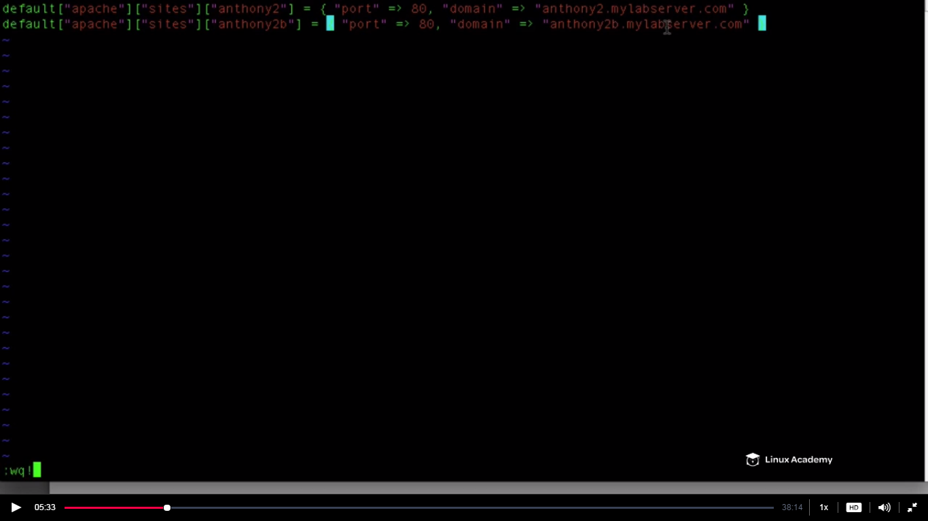

If there are any syntax errors we will be notified when we upload this cookbook. This is a ruby file we can write if else and any ruby logic to expand our logic and accomplish our goal for this attribute. **Also we can have more than one attribute file and also add them to the runlist,here we are using the default attribute file only.**

Since we have the attribute which defines the sites that we are adding to the web server as essentially we are building our web server node.

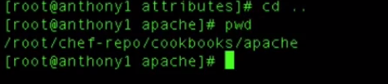

Just come to the apache cookbook directory

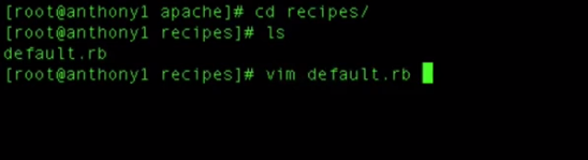

Lets explain in the language of the programmers like model, view and controllers. Take Attributes as model as this is data, think recipes as our controllers which takes the data and performs logic and then populates the view which is our templates. So lets write the recipes which takes the data from the attributes file, do something with it, and then populates our templates file and moves our templates upto the chef node and apply it to our apache configuration.

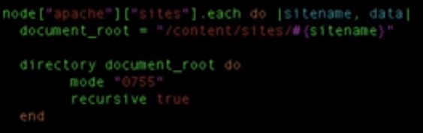



What does the first line mean in the above ruby code in the default.rb is -for each attribute(node[apache][sites]) which we defined grep the sitename(anthony2 and anthony2b) and its data(i.e port and local dns) and create a directory if doesn’t exist which is defined in the variable document_root. Document_root is a variable which is holding a value . so the code says create the directory if it doesn’t exists recursively and change the permissions of the directory as 0755. Attribute are already defined in the separate file earlier.

So there is a problem we haven’t created the directory in the node so we require a resource to create it and hence theword **directory** is the resource and the document_root is the variable. So what we mean is if the resource i.e the directory which we define in the variable document_root doesn’t exist then create it recurcisely.So resource is needed to perform the action.

Also there is a point how to grep the variable inside a string i.e when we defined the variable document_root and tried to give a value we gave it the value as /contents/sites/ and after this there is a dynamic value which will get here from the above variable which we grep in the above statement as sitename . We need sitename here so how to define it. All we do is do a # sign followed by a (. For e.g #(sitename)

So the whole file default.rb must look like

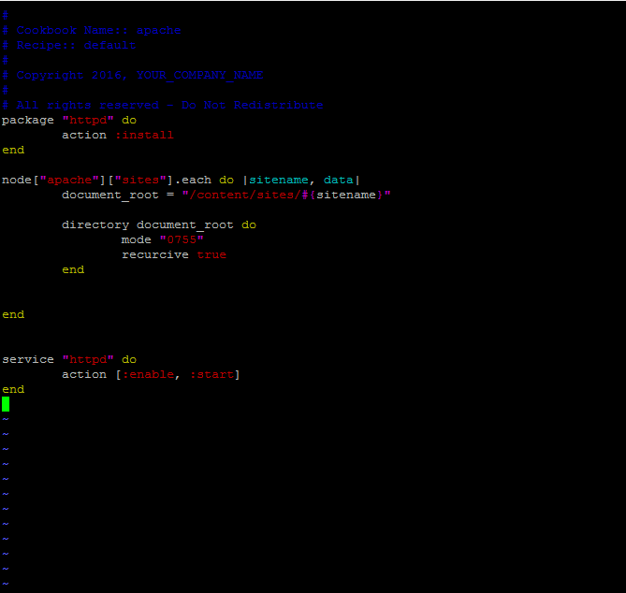

Just save and exit it. Lets upload this cookbook to the chef server. Make sure you are at the below directory

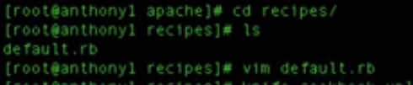

Then fire the below command

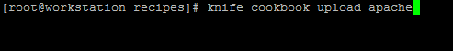

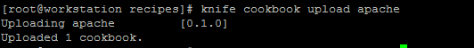

Above was my directory structure. Below is vedios structure

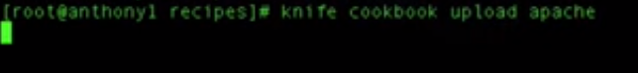

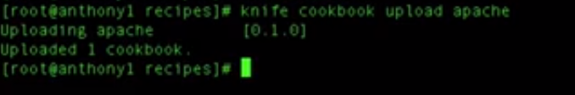

Now that our cookbook is uploaded we can do a convergence to our node.

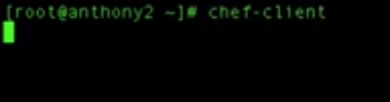

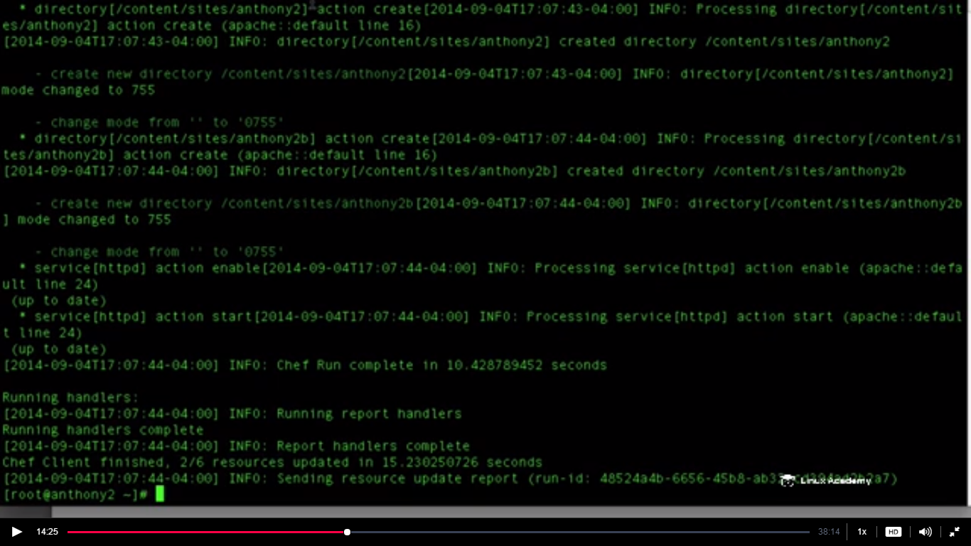

What must have happened is that it must have created anthony2 and Anthony2b in the sites location.

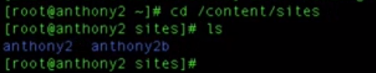

Next inside our loop what we want is that for each site we need to create an apache virtual host configuration file. In the infrastructure we have load balancer servers, ten web servers they all need this information. We would be able to automate the deployment of this configurations from our workstation to each of those ten servers . Just by building it here inside chef and allowing to deploy out to whatever role, whatever node has this recipe as part of its runlist .

We will now use our template resource . We should know where our apache configuration file lives in the centos. Make sure the location of the apache file according to your distribution.



So what our template resource is saying if the file 

Matches then use the template which we will define in our cookbook

Open a second terminal and go to the templates directory inside the cookbook as

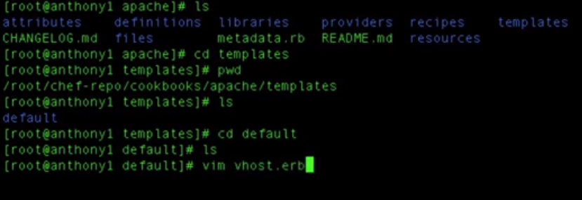

Create a file vhost.erb which is gonna be our template file

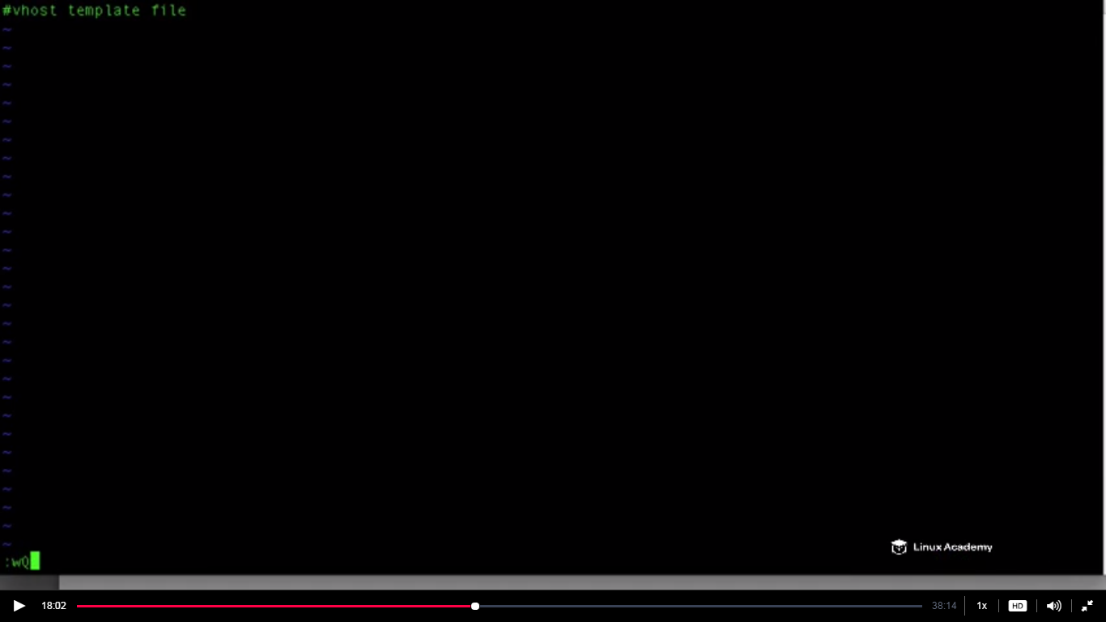

This file needs to create our virtual host configuration.

Go back to the recipes directory and the default.rb file and create a template resourece as

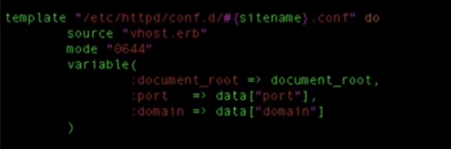

What this does is that it matches the directory as defined in the first line and if it exists it does nothing and if not it populates the vhost.erb file from the templates directory in the cookbook directory and places the variables defined inside that file to the sitename.conf.

The whole file looks like

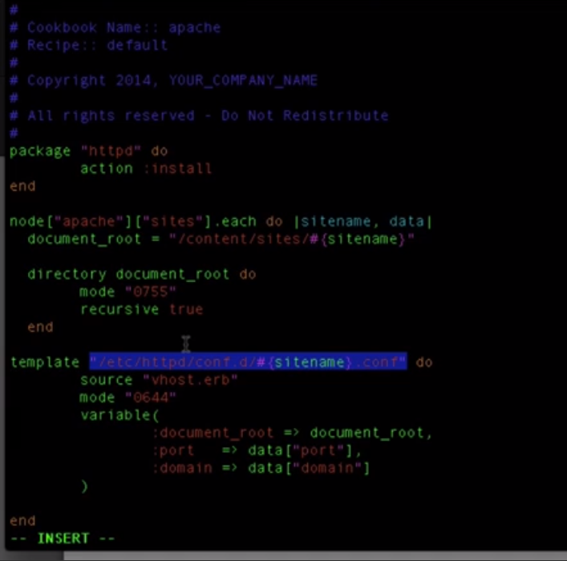

And now to reflect the changes we made on our system we we need to restart the apache service so how we do that . We can create a notification . So what we need to do is that we need to notify our service resource in our recipe 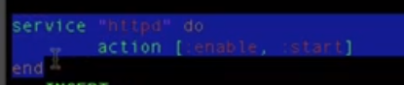 defined below in the same file to restart apache.This is very simple we just need our chef to notify our service resource to restart the apache so that the configuration changes are applied to our node. To do that we do

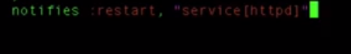

We create notifies and what it does it notifies the “service httpd”(defined below) to restart apache

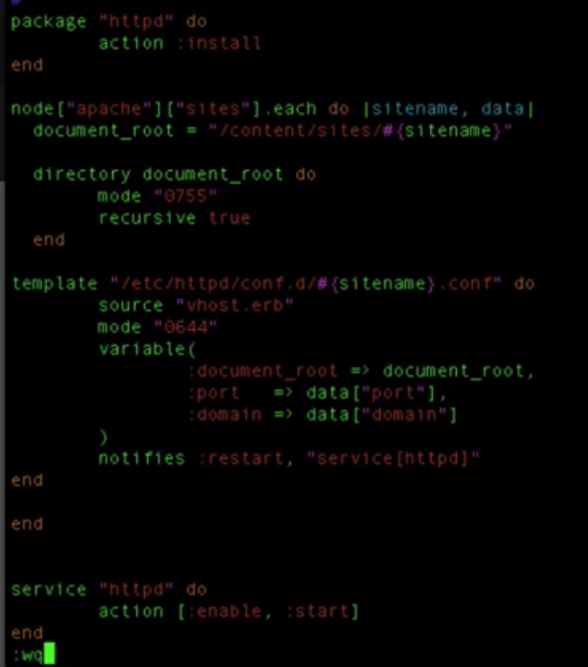

After save and exit we are done with the creation of first part of our apache recipe.

**Make sure template resource is inside the loop**

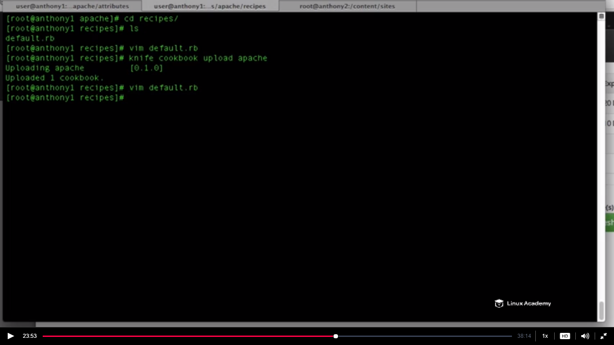

We have created our attributes. Now we need to create templates because even though we are defining those variables to create that configuration file, currently that configuration file doesn’t exist. If we go to in the below directory in the node

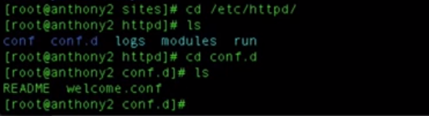

We don’t have the configuration file there for anthony2.mylabserver.com and anthony2b.mylabserver.com.

So we need to create our configuration file based on of our apache recipes

Go to

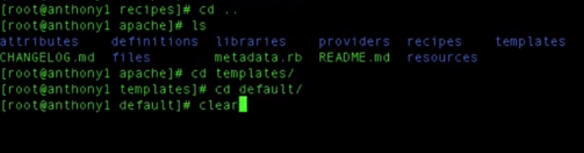

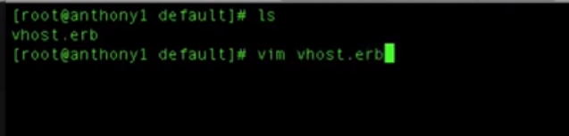

What we are going to do is that we are going to create all the static content that is going to be the same for each the configuration file. The only dynamic content that is going to be populated for each attribute for each site is our port, the document_root, and our domain name.

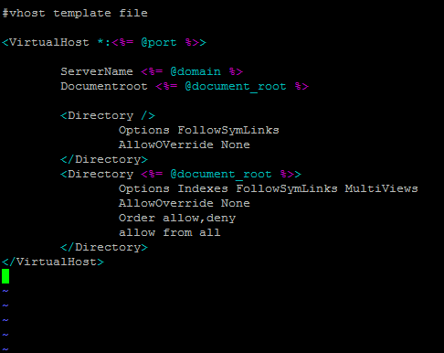

**Copy the whole content with concentration else errors are sure later**

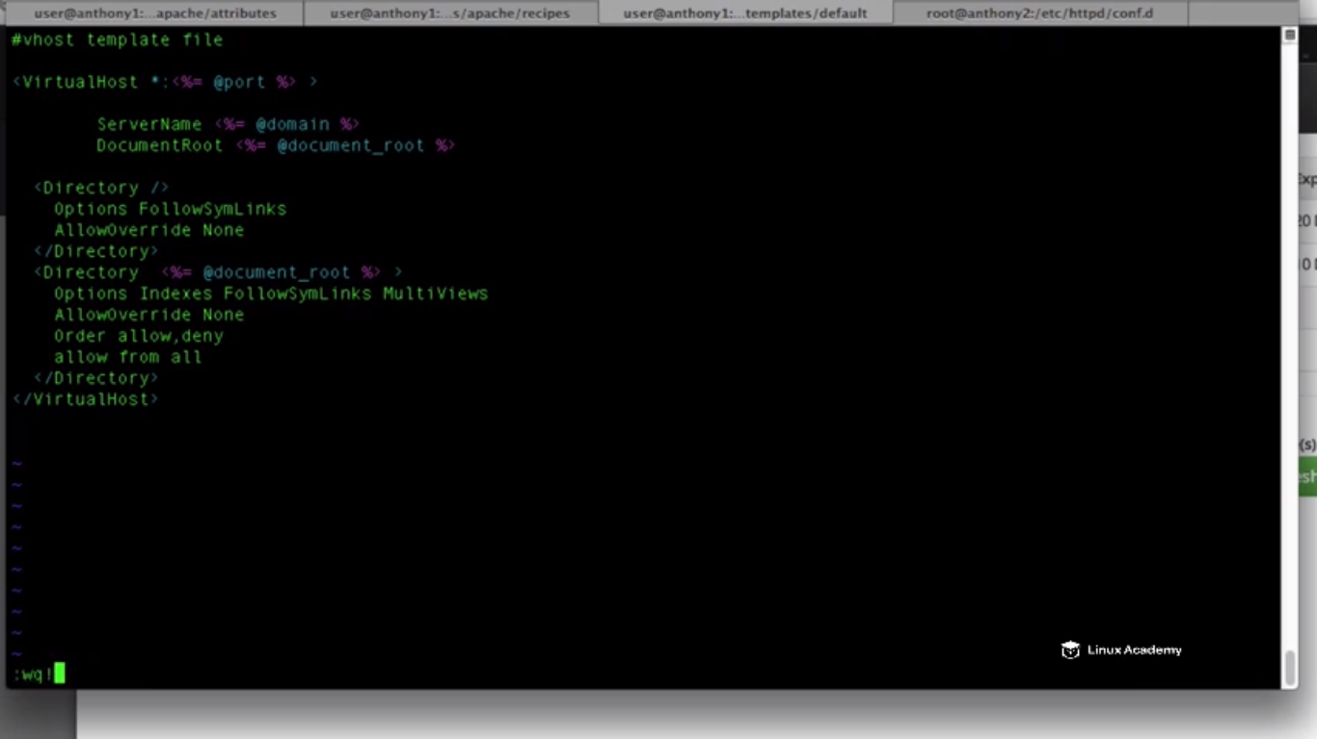

Now we have completed all this lets do a knife upload apache

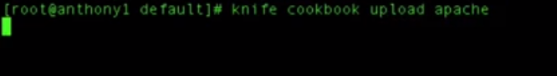

After that do a convergence

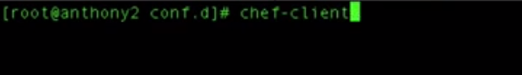

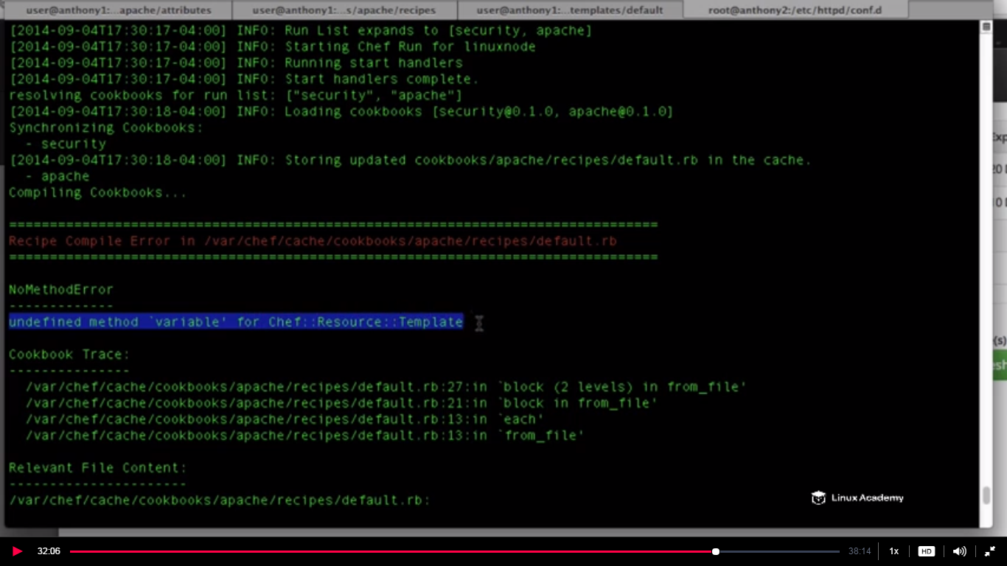

Error is there

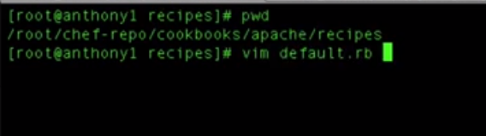

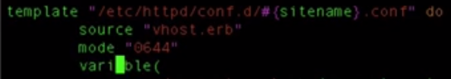

We have here variable which needs to be variables

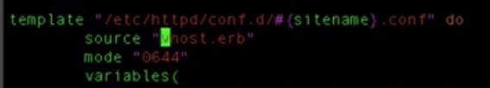

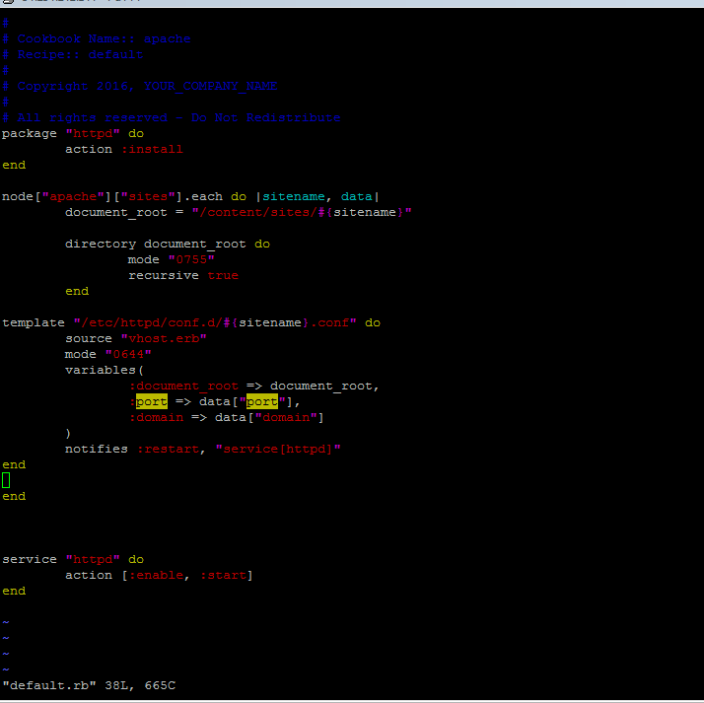



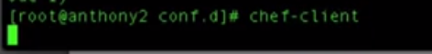

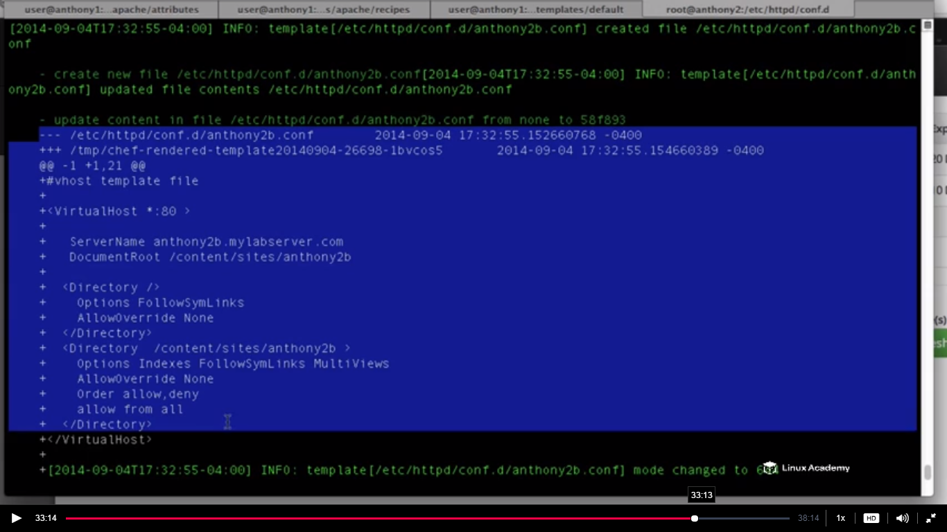

We have log info enabled and we can see what chef is doing.There are two configuration files which are being created anthony2 and anthony2b.



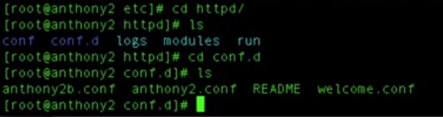

Two configuration file anthony2 and anthony2b are present. They are pointing to our

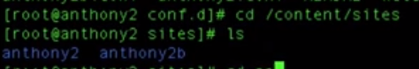

Anthony2 and anthony2b .

If we go inside anthony2

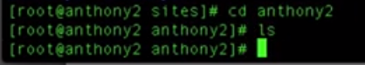

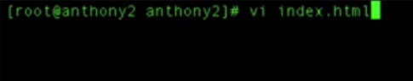

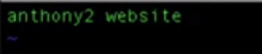

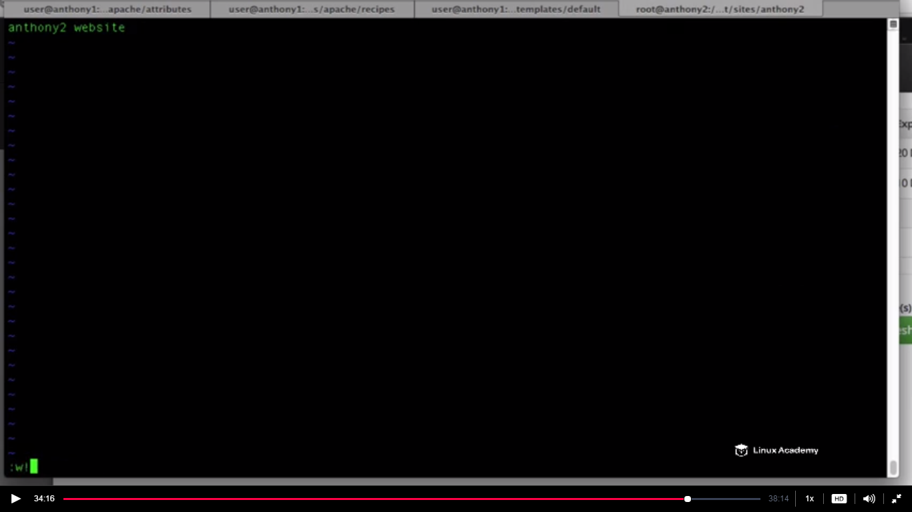

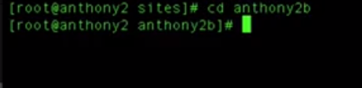

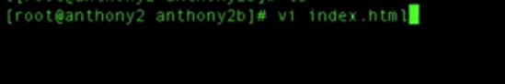

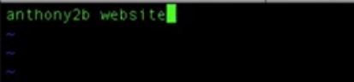

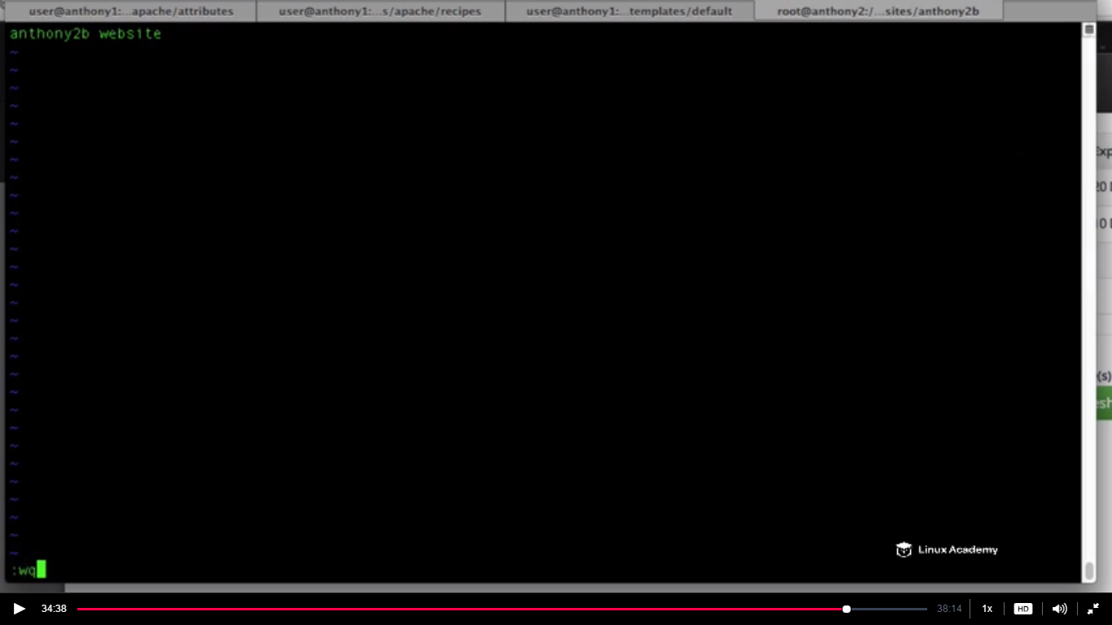

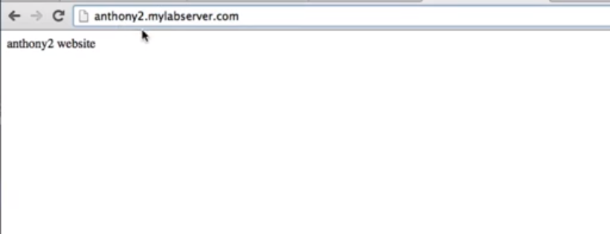

If we change the url to anthony2b.mylabserver.com still it will show the previous index.html file contents

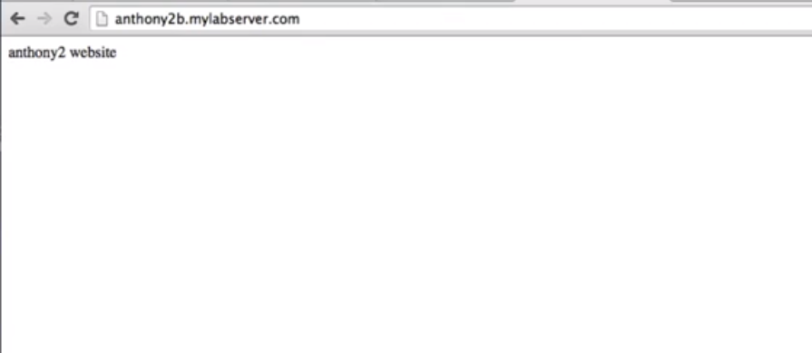

How to fix this

The problem is that with the apache virtual host unless u specify the usage of the named virtual host then you can have one domain name per ip address and we haven’t configured our apache virtual host template to accept that. Since both of our domains are going to run on port 80 we need to add a value that says allow name virtual host on port 80. So what we need to do is to edit vhost.erb template and add a if statement that says if our domain site is running on port 80 .Because if we remember we mentioned port 80 there, there may be sites that may not run on port 80. So if running on port 80 we just need to add a value. We will configure this on our httpd.conf file

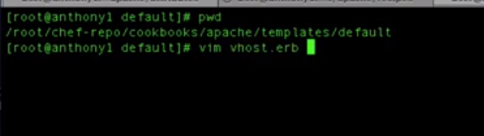

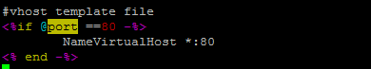

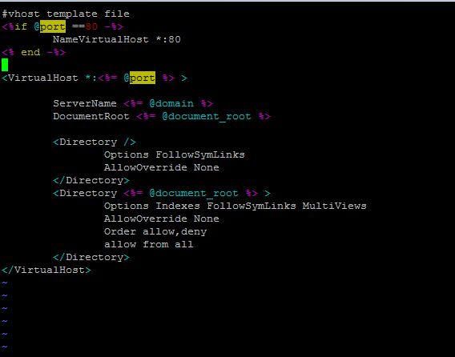

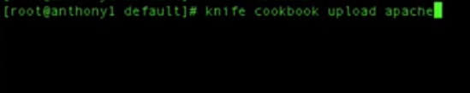

**Do a chef-client on the node** . Once that done go to browser.

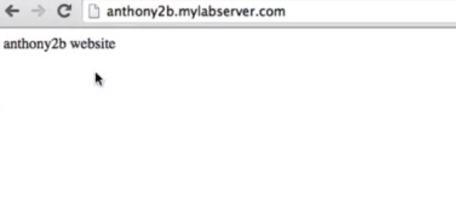

Things are done. Anthony 2b website is printed.

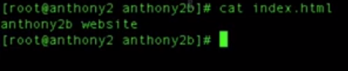

Now we have a cookbook which creates virtual host for us.

**Lecture: Attribute Precedence**

In this lesson we are going to discuss attributes and attribute precedence as it relates to Chef and the node object

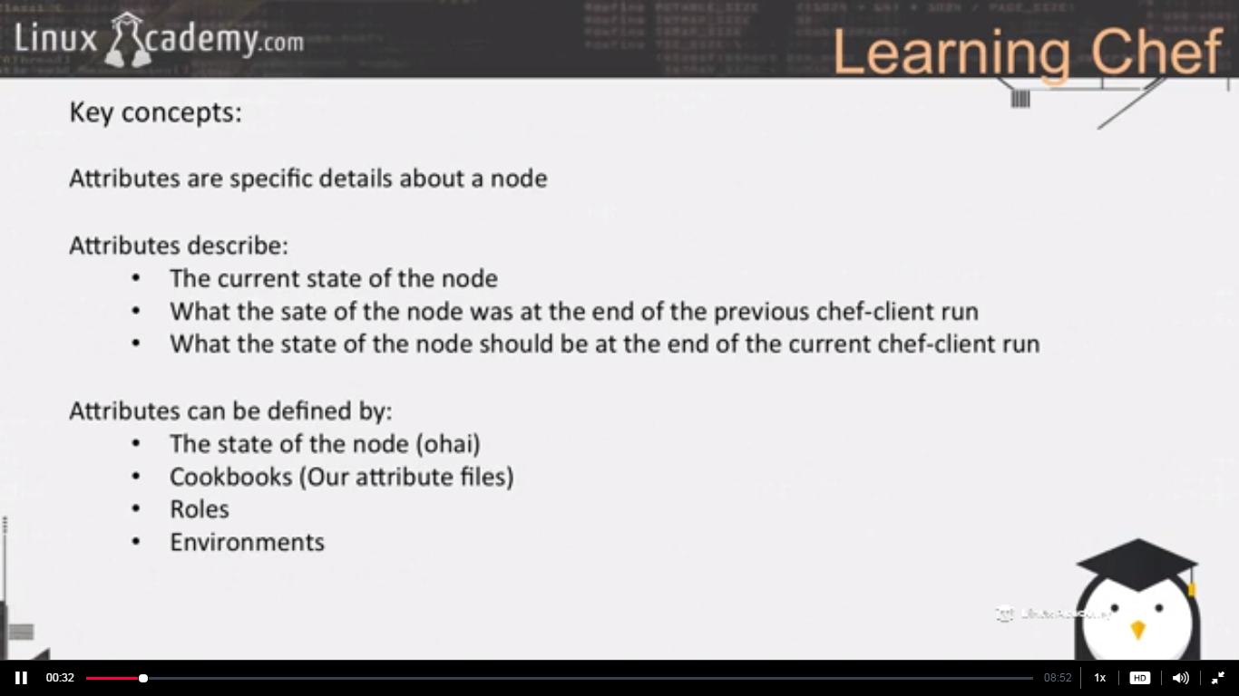

The ohai progrms runs at the chef-client time at the beginning of the chef client run, populates information about your node such as memory, processor. OS, users on your on your sysyem.. These attributes cant be changed by us inside our cookbooks.

Roles, environment variables and recipes can’t override these attributes.

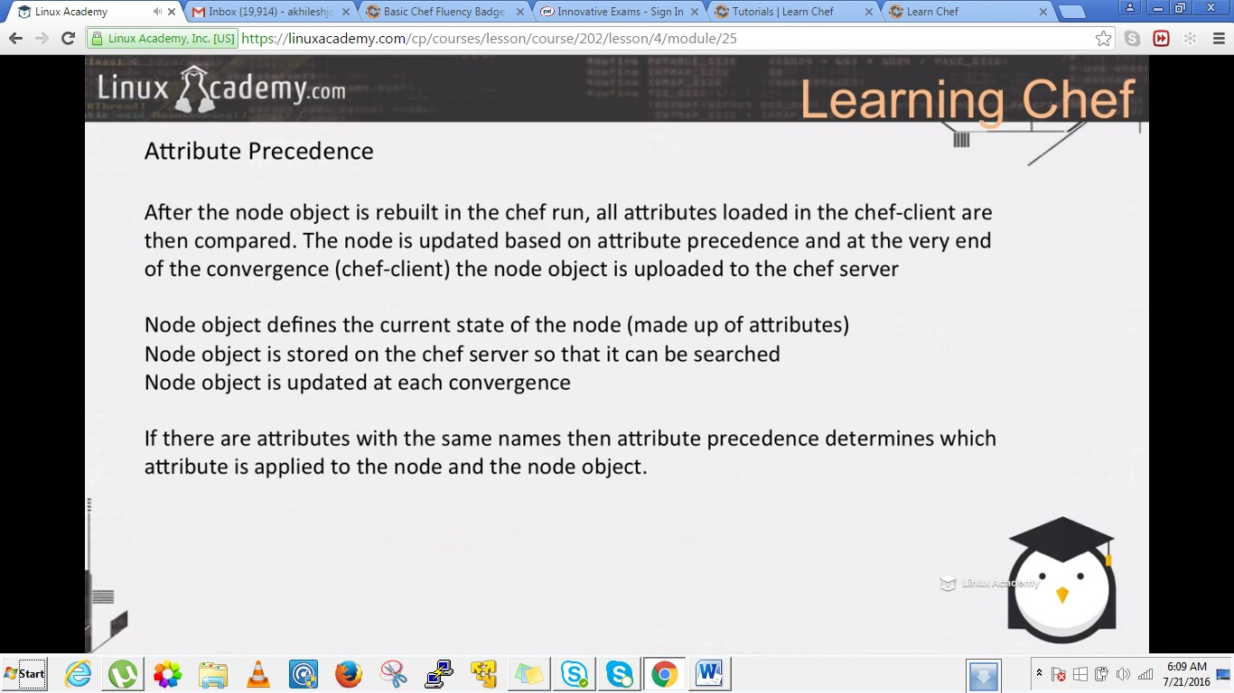

What happens in the chef run is that the chef run loads current node object which contains attribute information from our chef server. IT then also runs the ohai node object . It then loads all the attributes coming from our roles, environment, recipes,cookbook file. IT then determines attributes that needs to be updated or changed based of the precedence level. At that point it updates the node attributes at the node itself and it creates called a node object. And the node object is the container of the attributes information for your node. The chef client at the end of the the chef run then takes the node object, copies that to the chef server and now its available on the chef server for us to use our workstation command line tool knife inorder to query and search for attribute information on nodes.

So node object defines the current status of the node. Its made up of attributes. It is stored on the chef server so that it can be searched. It is updated at each convergence.

If there are attributes with the same name or same attribute information then attributes precedence determines which attribute is applied to the node in the node object.Lets say we have an attribute called site name and that’s inside our cookbook and we have the same attribute defined in a role then which one is going to take the precedence. We can define maual level of precedence.

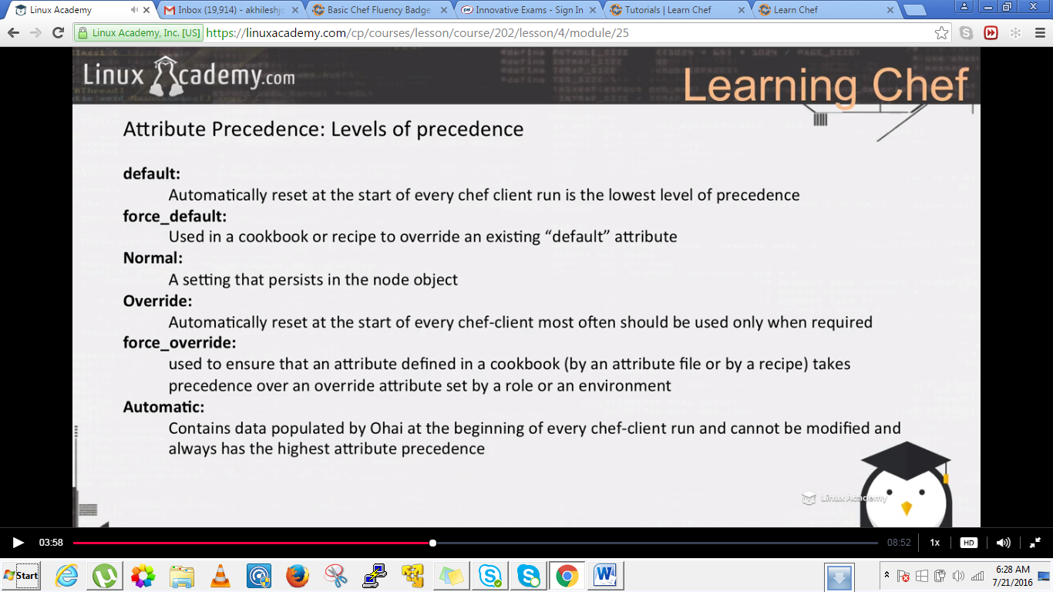

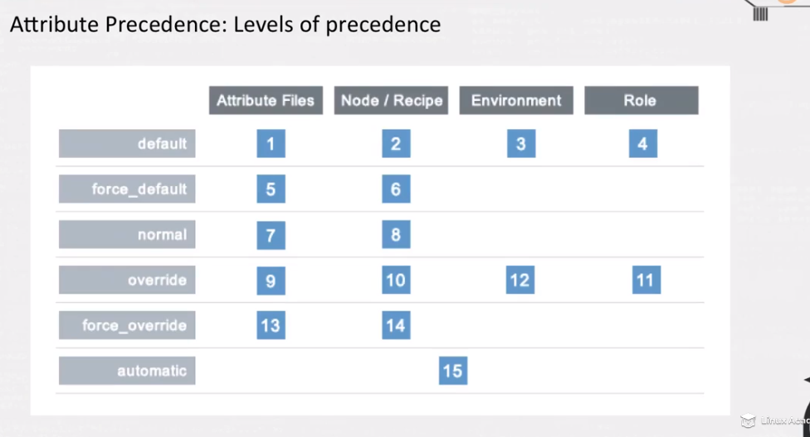

**Lecture: Adding HTML Templates Dynamically With Chef**

In this lesson we are going to learn how to dynamically add index.html files to our custom sites within our cookbook. This lesson builds on the existing cookbook and adds another template as well as resource declaration within our cookbook.

**We are going to automate the creation of the default index.html inside of our /contents/site directory on our webserver nodes.**

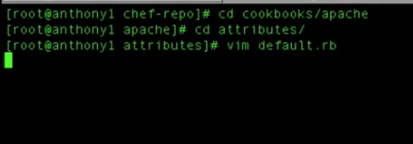**inde**

Add the below entry in the default.rb and inside each attribute



The entry should look like

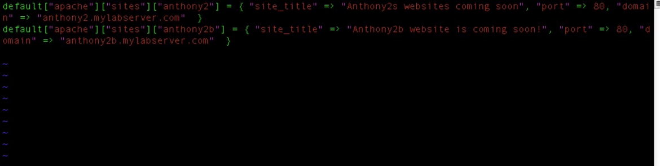

Save and exit.

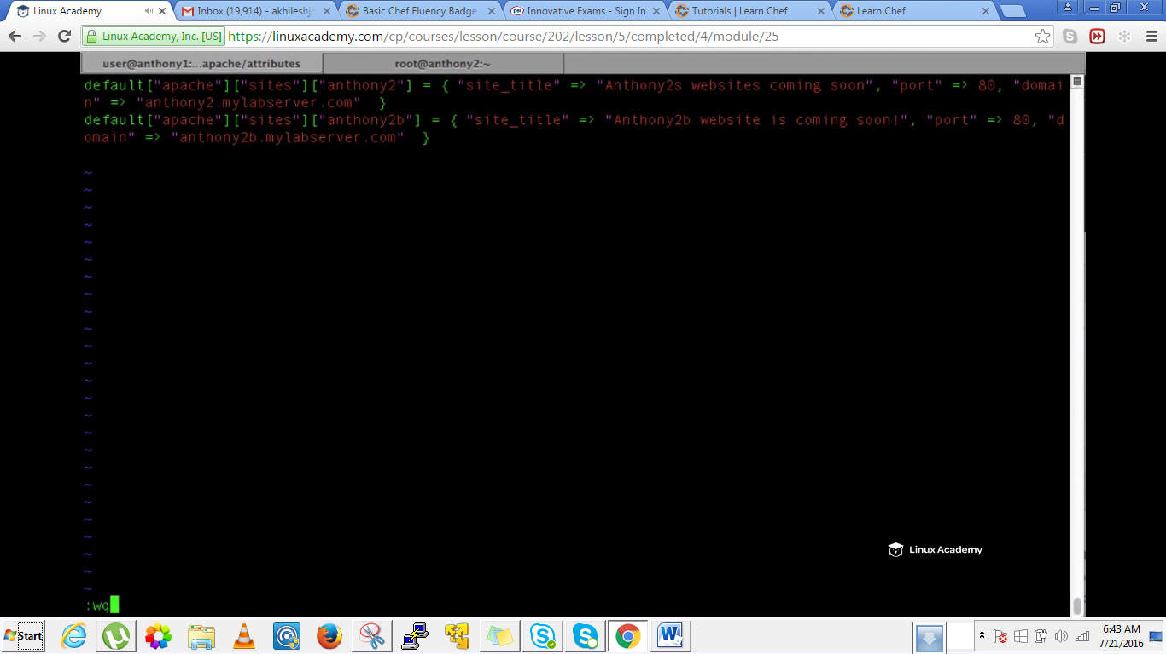

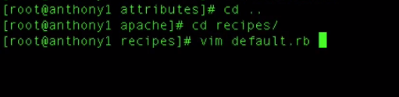

Insert the below template between there in the default.rb

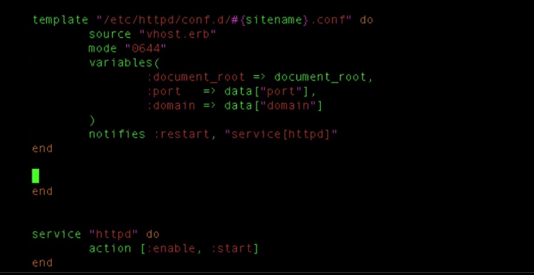

First make this

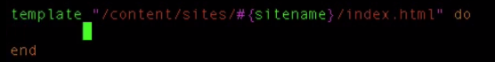

Now start writing inside this .Each do must finish with an end so its better to make the loop first and then write the code inside as

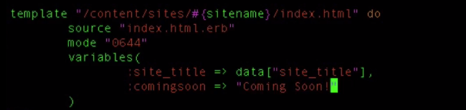

This is a template. We want to create a file index.html automatically inside /content/sites/index.html(this is the directory where index.html should be placed hence we chosed a template resource in order to match if the directory exists or not, if not it will create it) . And inside that file(index.html.erb(erb is just the defult format), we need to pass some variables hence we are defining variables which would be populated dynamically. We defined a custom variable here i.e comingsoon as it is not defined inside our attribute file.

This template should be at the below position(before the service resource) inside the default.rb file

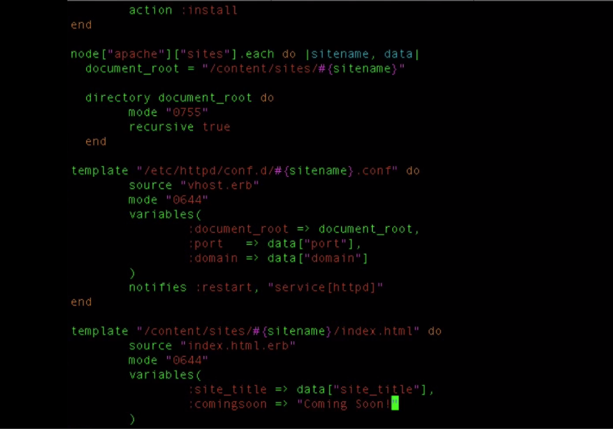

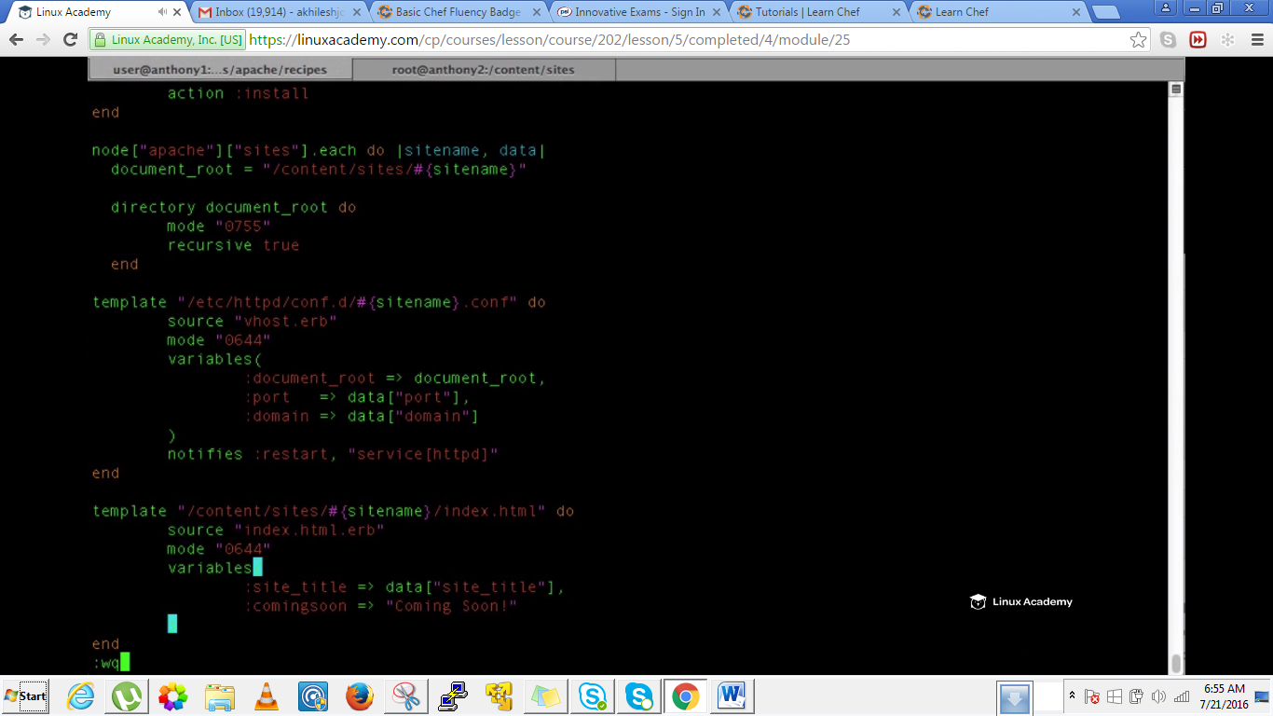

Go to template inside our apache cookbook and create a index.html.erb

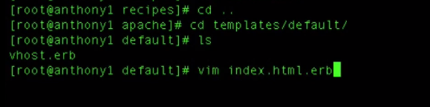

Lets create the static content and reference the variables passed in here from our recipe.

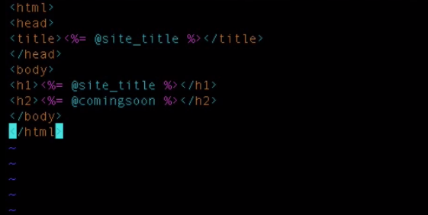

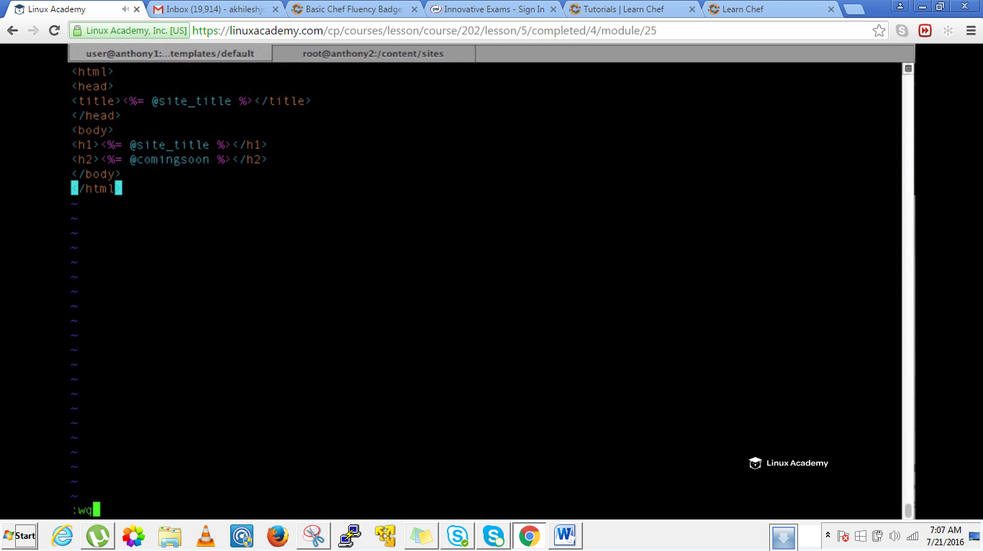

Do a knife cookbook upload after coming back to the recipes directory as

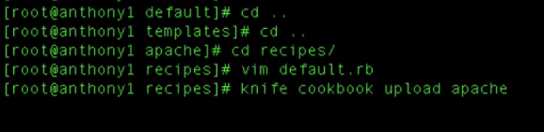

Come to node and run a convergence

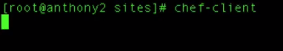

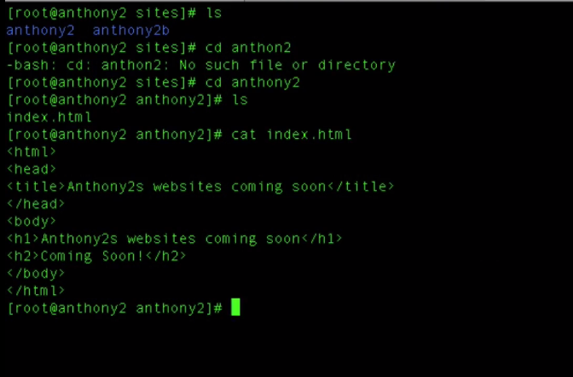

We can see the variables are populated correctly here inside the index.html.erb.

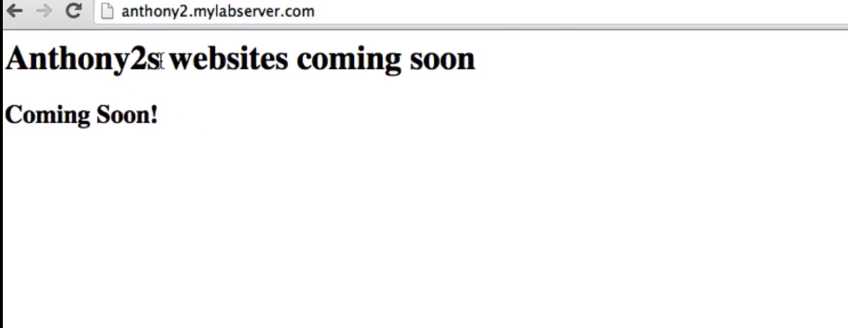

We can see the source by right click and select source

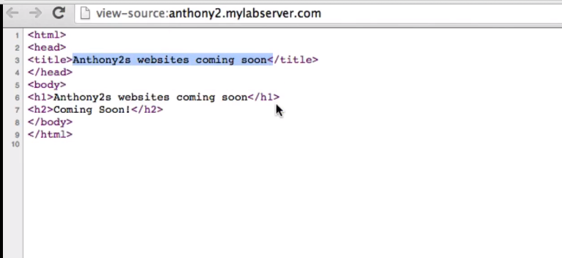

If we put our other domain it will even populate correctly.

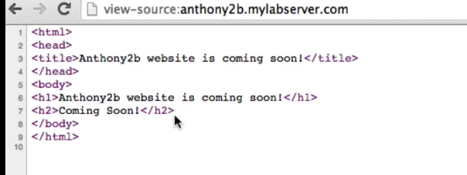

**Lecture: Recipe Includes And Dependencies**

In this lesson we are going to add in a PHP cookbook. With this cookbook we are going to learn how to create dependencies and include recipes from other cookbooks. This is a very important part of the Chef infrastructure.

**In this chapter we are going to learn how to include a recipe within another recipe.**

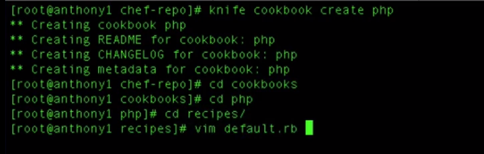

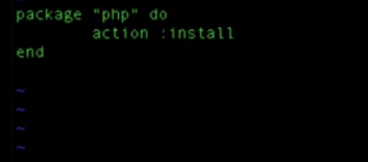

Save and exit.

In general we would have added this recipe to our runlist but here we will include this recipe inside our another recipe that is inside apache cookbook.

Lets get inside to our apache cookbook as

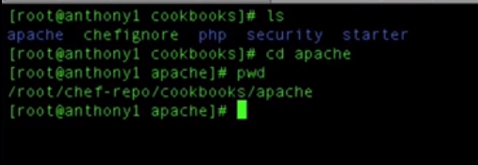

Inside hear we need to edit metadata.rb. The metadata allows us to manage a few additional item

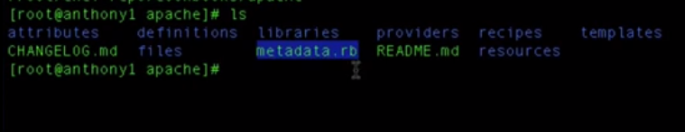

Lets look into it

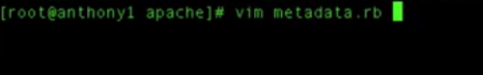

**If we need to access the attributes within our apache attribute files from our php cookbook or just a another cookbook that is not apache we would do is do a “it depends”** .We would do that inside the cookbook we need to access that on.

Add the below line

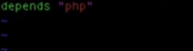

So wat we have done is that we have created a php cookbook . We need to access the attributes, the recipes, the templates everything from the php cookbook to our apache cookbook. So inside our apache metadata file we would do a

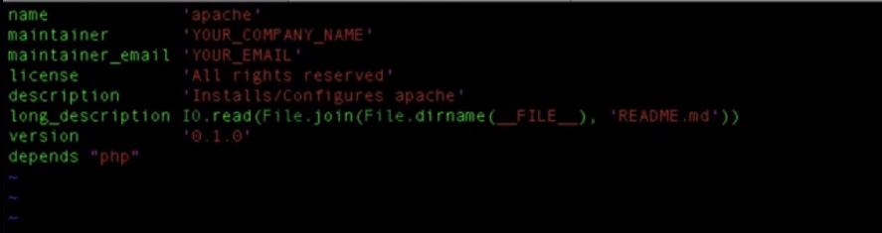

Save and exit



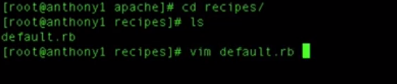

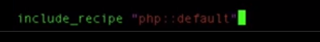

Add the above at the last or below the service resource as

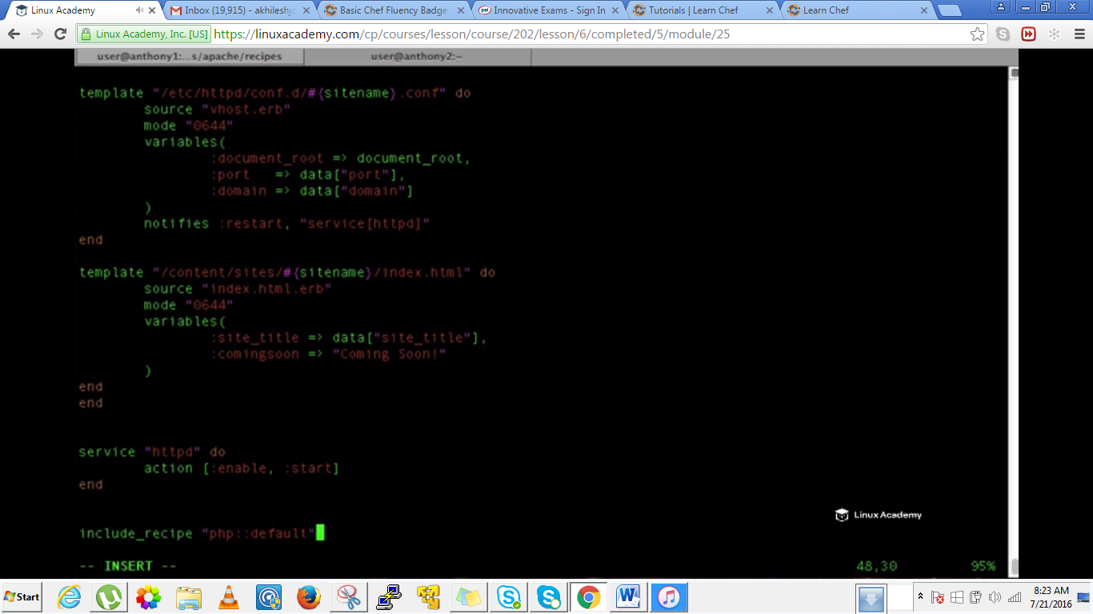

Save and quit.

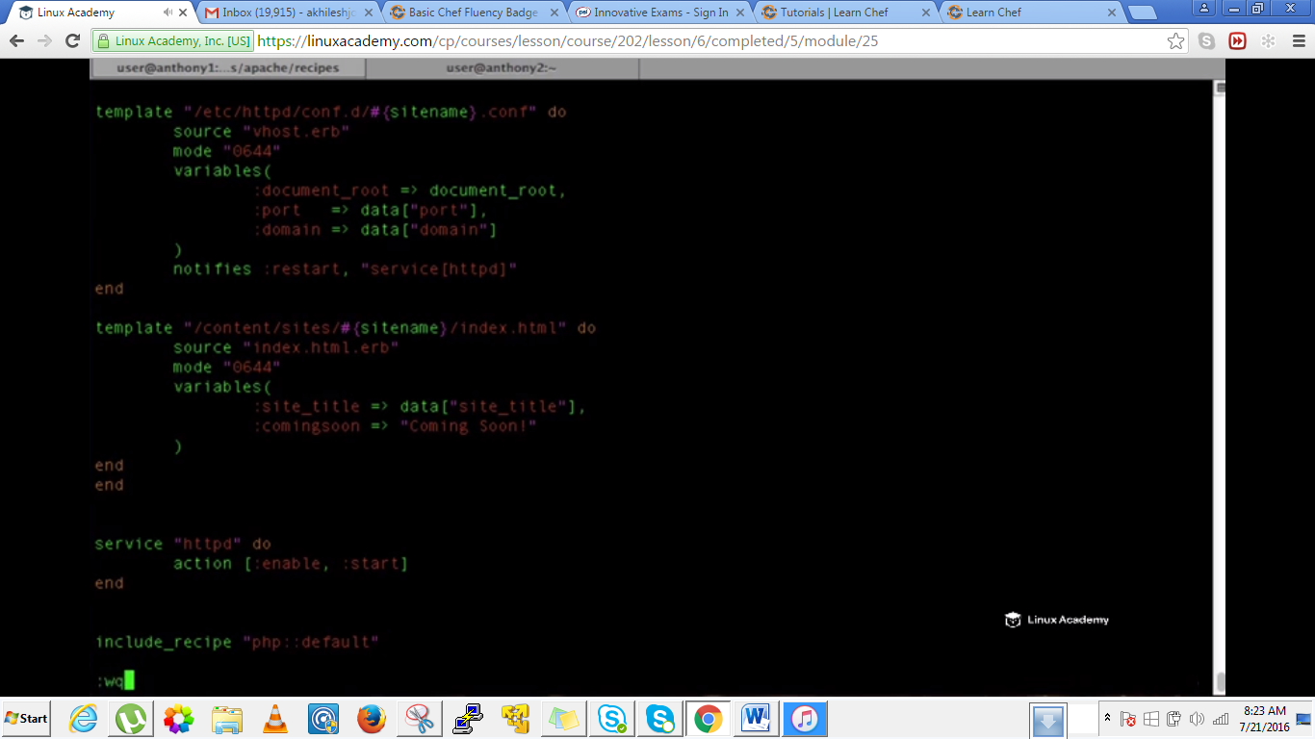

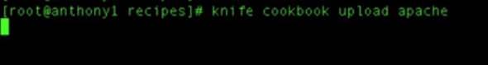

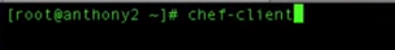

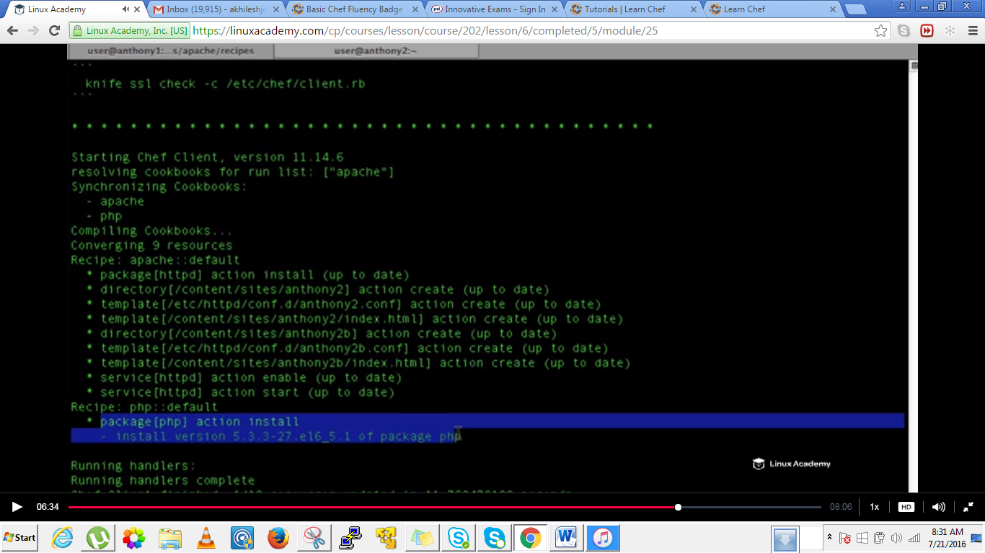

IF we go to our /etc directory and see if php is installed





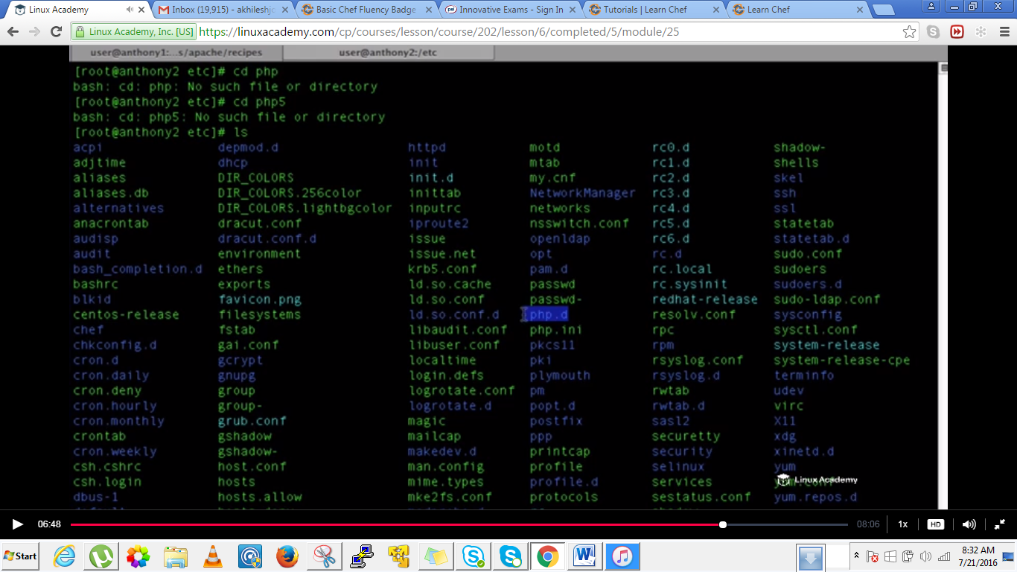

We found php installed as shown above.

**Why dependencies? We can use dependencies so that our apache cookbook can access resources like recipes, attributes,etc from our php cookbook or If we would have created on our php cookbooks a dependency on our apache cookbook that php cookbook can access apache’s attributes, recipes and use them and include them inside its own recipes**.

**Lecture: Copying Config Files To The Node**

In this lesson we are going to take our PHP.ini file from a node and put it under management from within our Chef cookbook. We are going to learn how we can make a configuration change in one place and apply it to all our nodes under management. While doing this we are going to be introduced to the cookbook_file resource type.

We need to download this php.ni file and copy it to here inside /etc via firezilla.

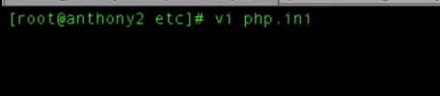

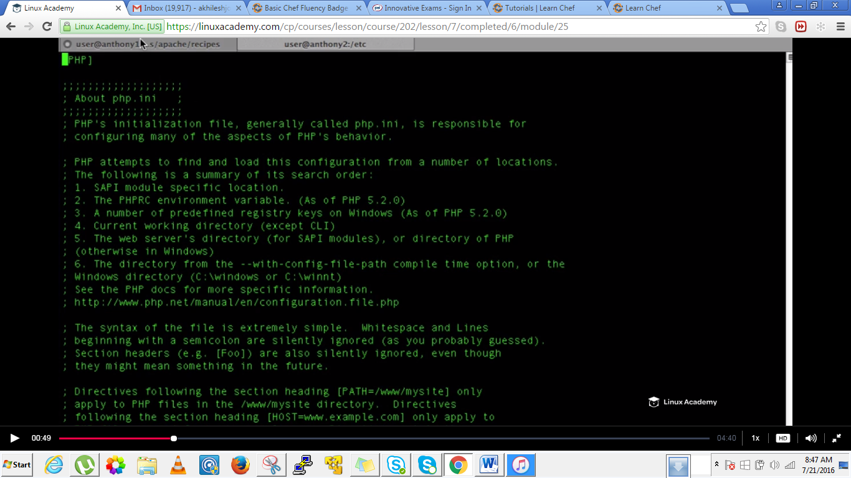

This file should like the above, its just the downloaded file no changes are still made. Just need to download it.

Now go to the wokstation

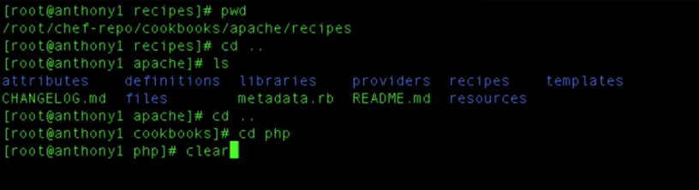

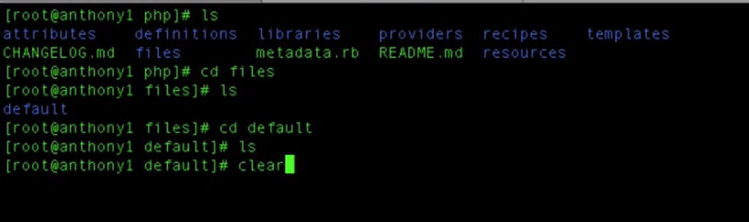

Create a file **php.ini**

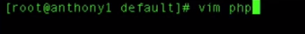

And paste the contents of the php.ini file which we the downloaded earlier and moved inside the /etc directory via firezilla.

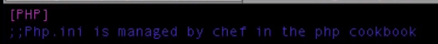

Add the above line at the top of the file

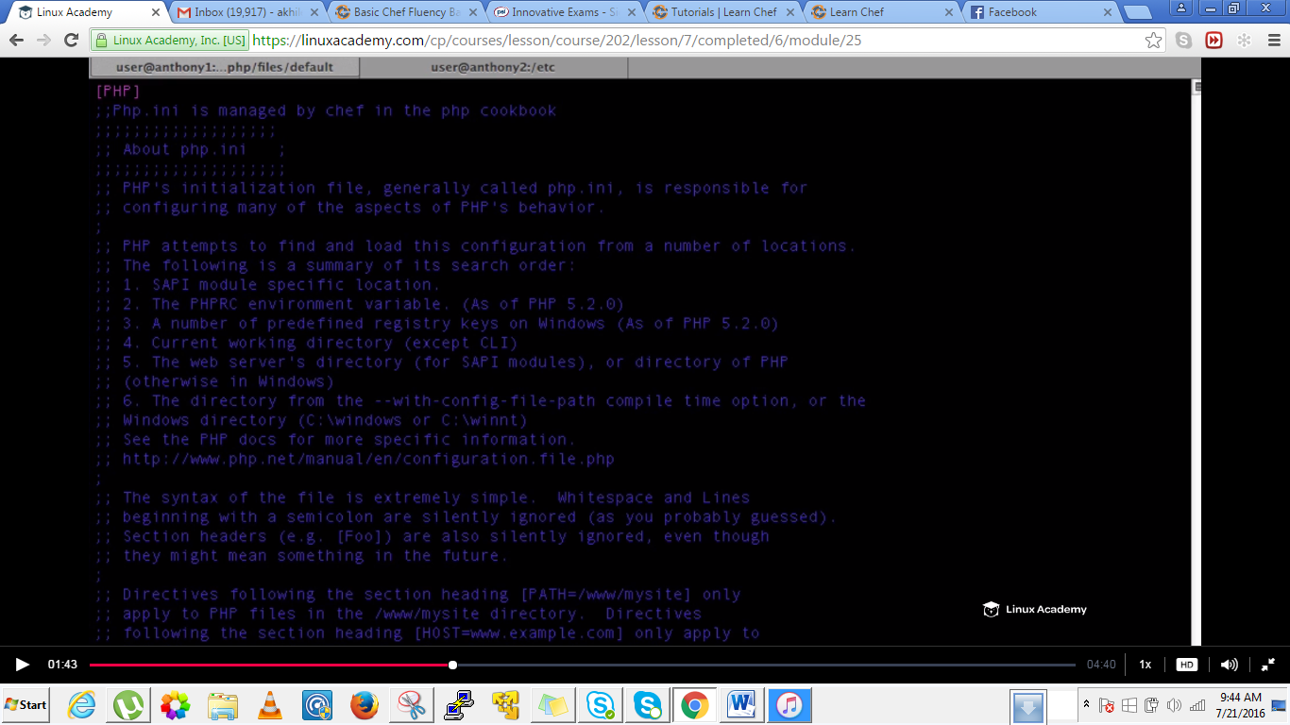

This file is not going to get populated within variables because whenever we want to update the php.ini file all we have to do it to edit the file.

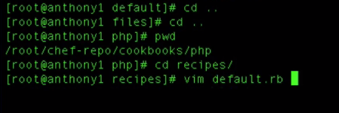

Inside here we need to create a resource that says if the file doesn’t match that’s currently on the system then go ahead and upload our new php.ini file configuration file. We do that by using a **cookbook_file resource**

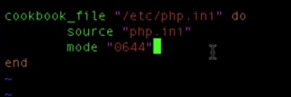

Whats the above template going to do is that its going to upload the php.ini file from the cookbook /files/default directory to the /etc directory if it doesn’t exist or if there are changes made to it.

Just save and quit.

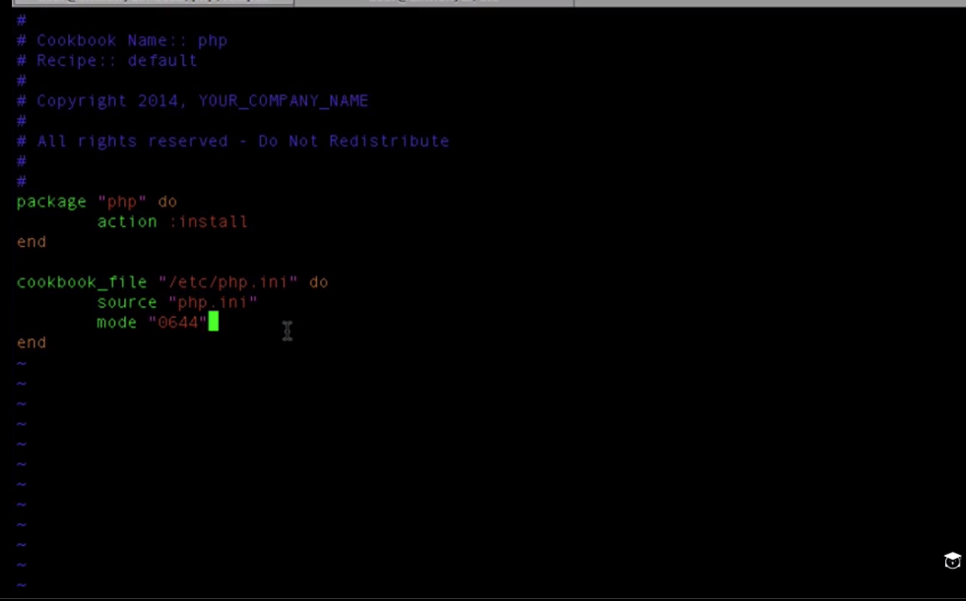

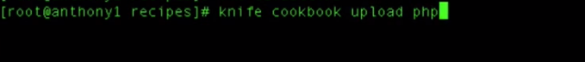

As this php cookbook is included inside the apache recipe we needn’t to add this inside the run list.

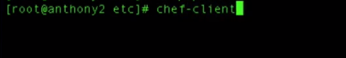

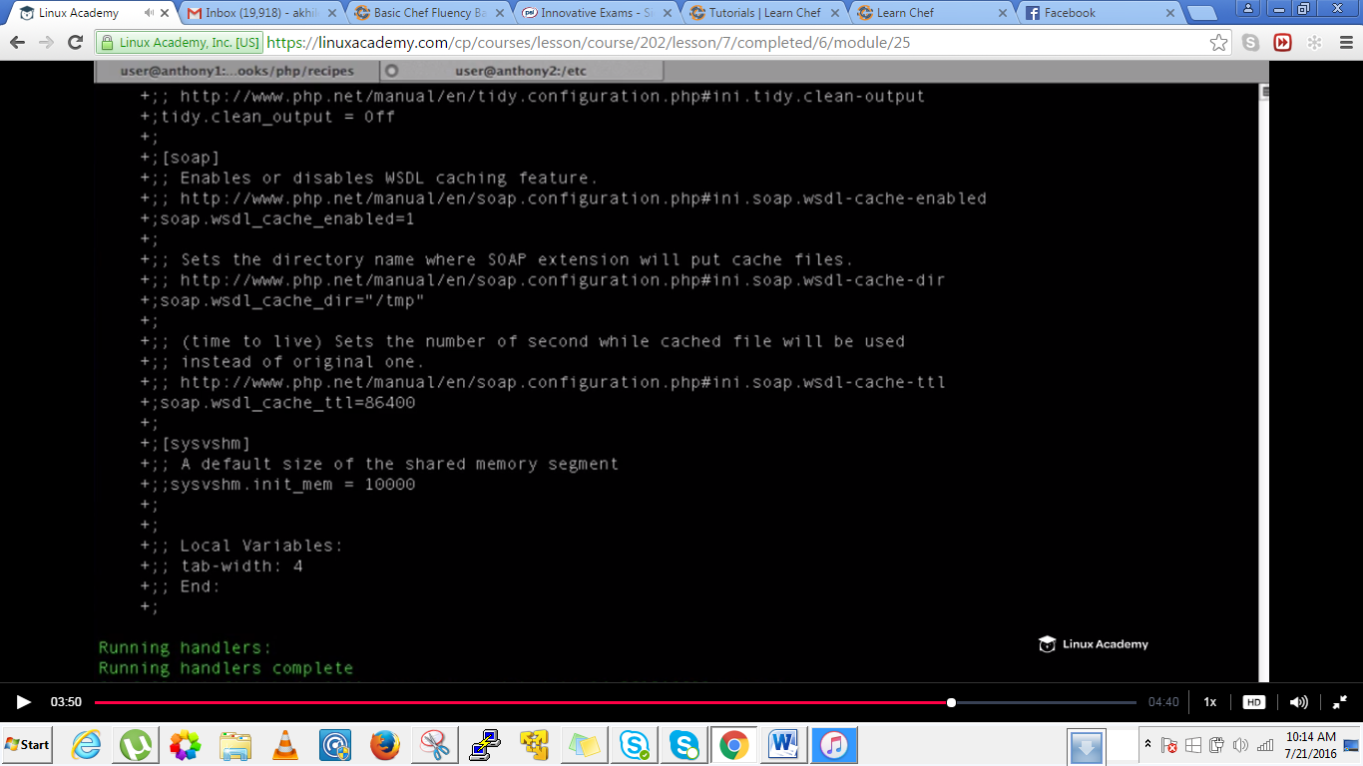

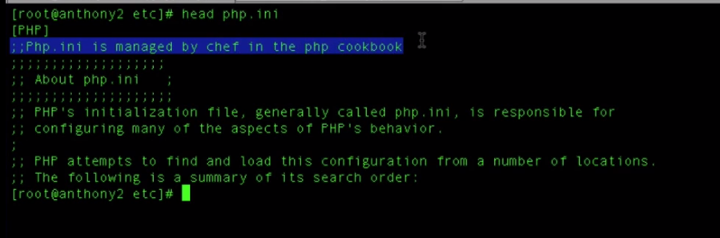

We can see the new comment we added to the php.ini file in the /files/default/php.ini file.

So when we need to do make a change to our php configuration file we have to make that change at one place on our workstation and that can be uploaded to all of our nodes that are configured to run this cookbook. If we need to find the old configuration file that was there then on our node we can go to

Tm#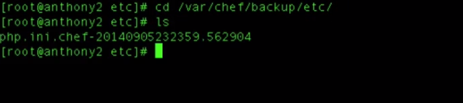

serWe can see the php.ini file which was just replaced is actually located inside in this backup section.

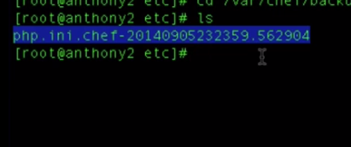

**Lecture: Executing Linux Commands On The Node**

In this lesson we are going to be introduced to another recipe resource type the "execute" resource. In this lesson we are going to learn how to execute commands as if we were on the Linux terminal. We are also going to learn how use only_if as well as File.exist?() method to assist in this process.

In this lecture we are going to learn how to execute commands on our linux nodes.We are going to do that using the execute resource.

We have talked earlier about a term called ideimpotance and what it does is that it basically states that if a system is in a specific state don’t perform a task. So we created a resource called package resource which says install a package, if a package is already installed our chef recipe would not execute the install.

When executing linux commands on our linux machine how do we make sure that we enforce our ideimportance, if we want to remove a file lets say for example we don’t need to continuously try removing that file when the command is continuously failing so for that we can use methods, functions of our chef environment inside our recipe. In this specific case we are going to use only iff and file exists

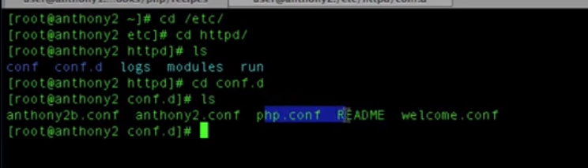

The welcome.conf takes us to a default apache page, we don’t need that once we have our hosting environment setup. Lets write a resource within our apace recipe to remove the file welcome.conf and readme file if they exists.

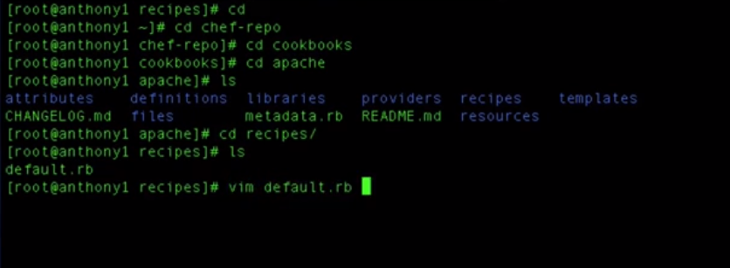

Come down upto here

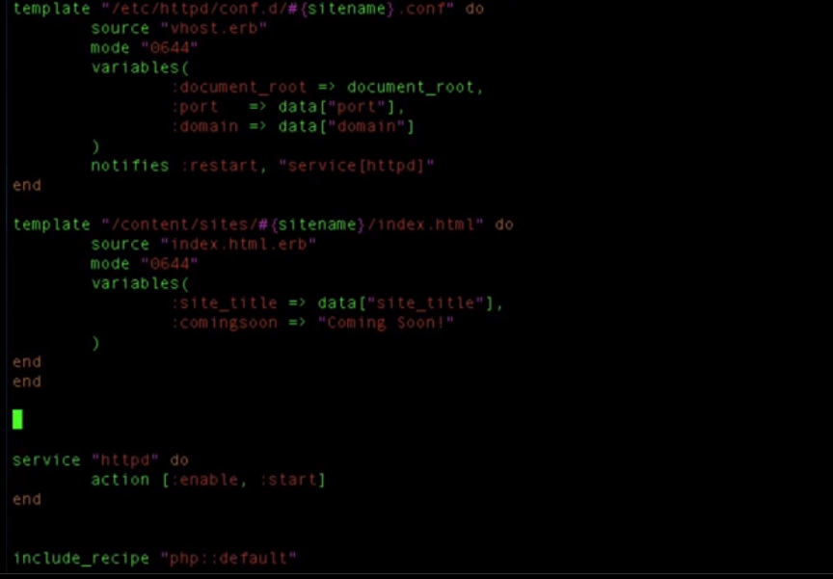

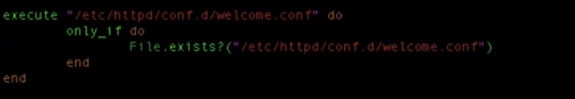

What exactly is happening is that –It says if the file(/etc/httpd/conf.d/welcome.conf) exists remove this which is written after the execute resource(i.e /etc/httpd/conf.d/welcome.conf)

Also pass the notifies so that changes reflect as

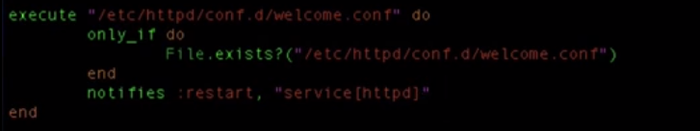

How to get the location of the welcome.conf –go to the node and copy the location and paste in the above template as

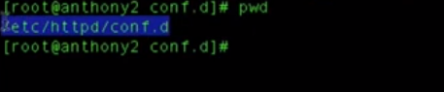

So after making changes to the default.rb file inside the recipes save and quit and upload the cookbook

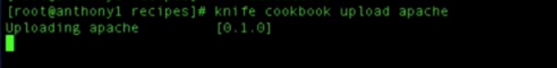

Then go to the node and do a convergence.

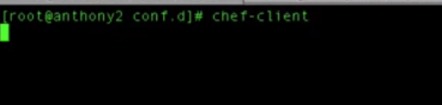

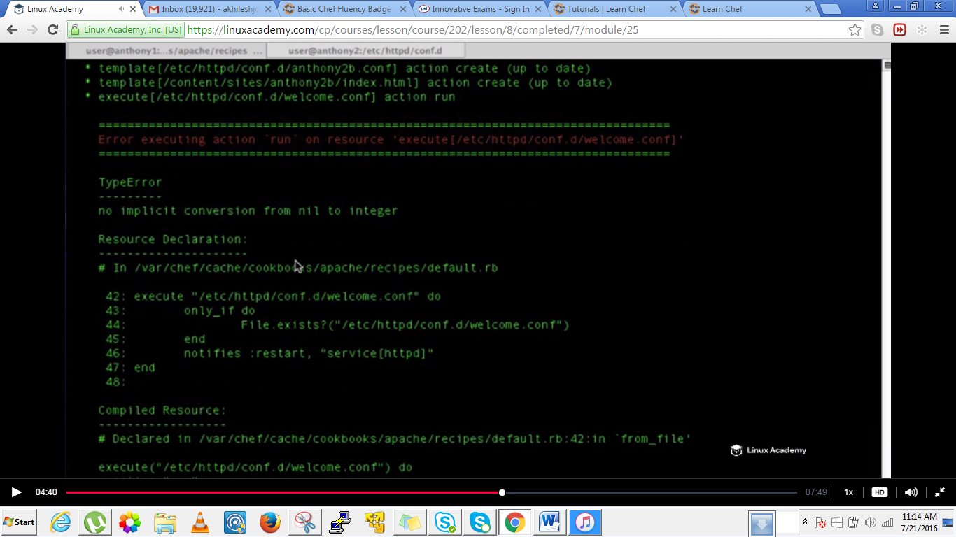

Looks like we have an error.

To resolve that go to recipes

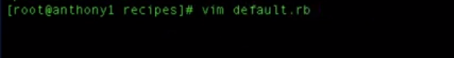

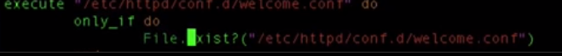

Remove the s from the exists .IT should **only be File.exist? Also we didn’t issue a command there inside the execute resource . IT we don’t provide any remove command how it is going to remove.**



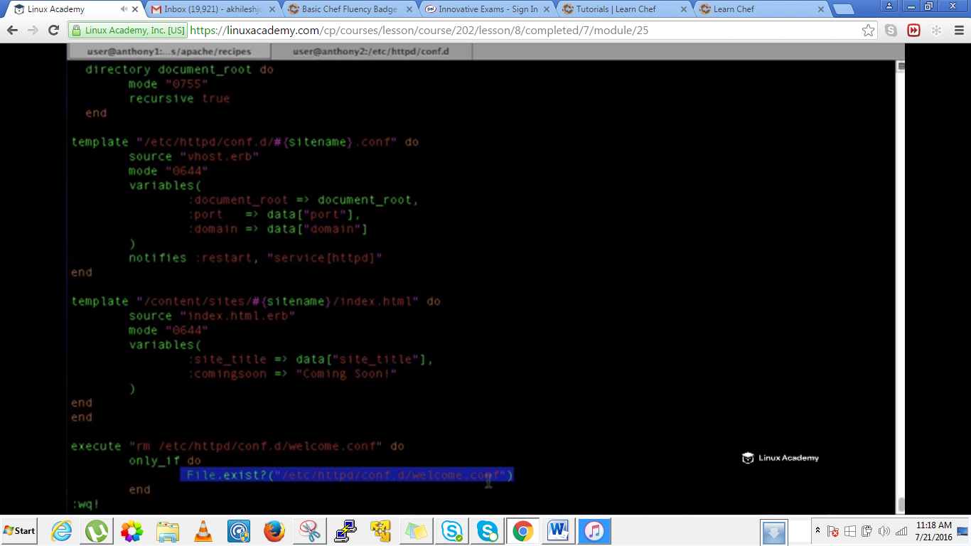



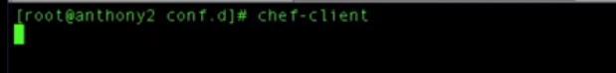

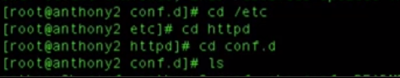

We can see there is no file welcome.conf as

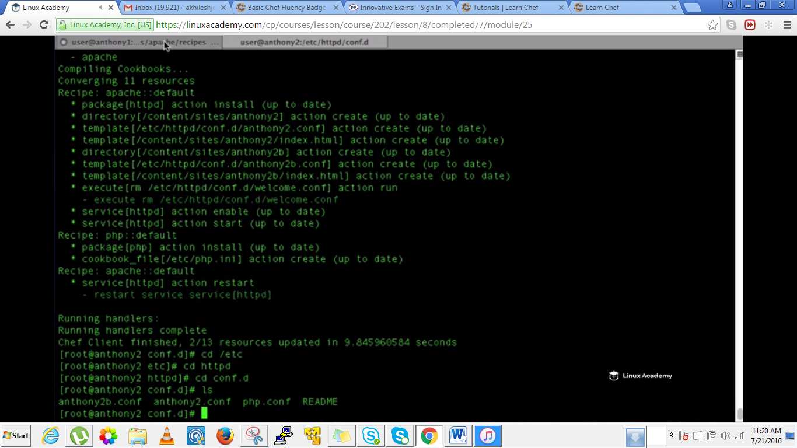

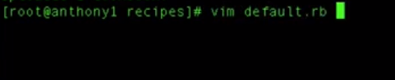

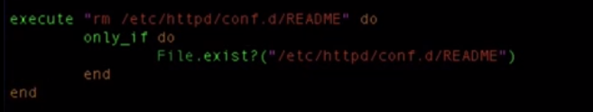

Add this below the previous remove template as

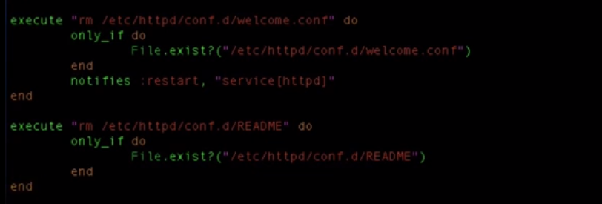

Save and exit.

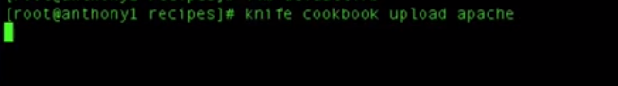

Run the chef-client as

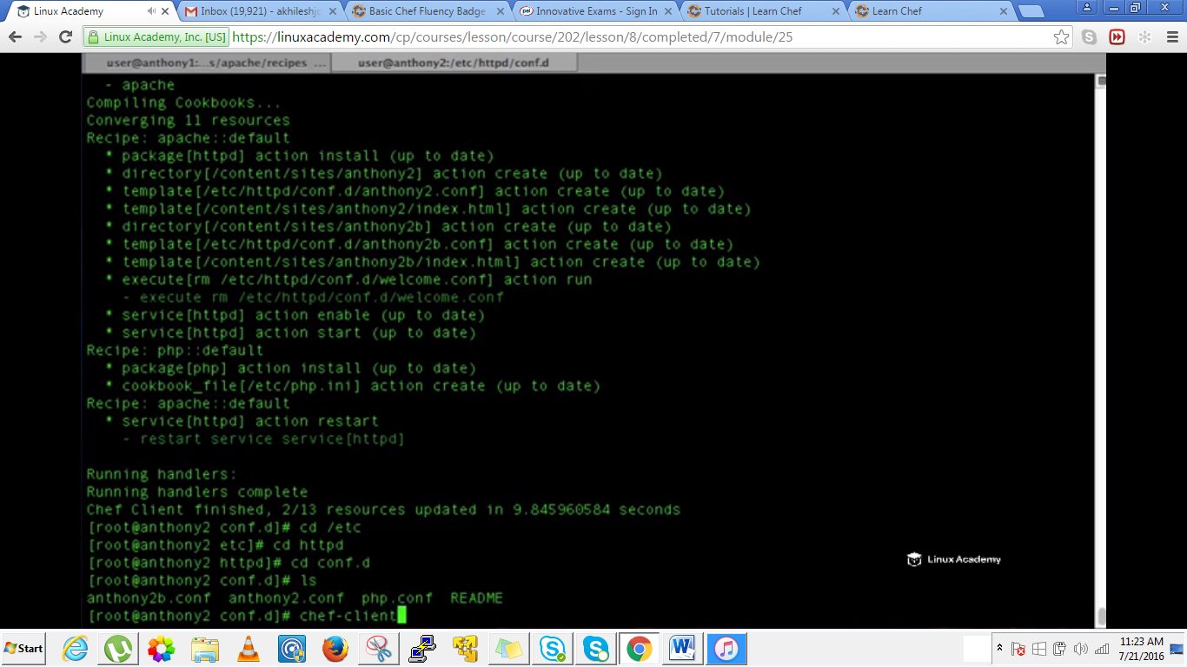



IF you there in the above directory inside the node the readme file wont be there.

**Lecture: Adding Platform Support To The Cookbook**

In this lesson we are going to learn how to adapt our Apache cookbook to work on either centOS 6.5 or Ubuntu 12 LTS.

In this lecure we would be adding a new distribution to our chef infrastructure.We would be adding a centos 6.5 and Ubuntu 12.

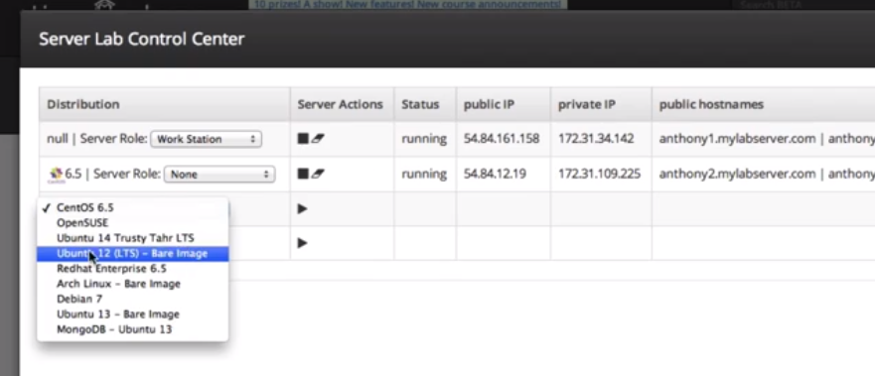

The goal here is to deploy out to our centos node and linux node that we have been using and also to deploy out to the ubunto node.

What we need to do is to prepare these node just to receive these recipes and get connected to our chef environment..

Well we need to bootstrap the node , be sure its added to our chef server, we need to add the apache recipe to the runlist for the node and then we need to change a lot of the code inside our recipes to make this dynamic or to make sure it install the correct packages. For example with apache when we install to a centos machine we use the package name as httpd and the service httpd. However on Ubuntu we use the package name apache2 and the service is apache2. Not only that, the location for the virtual host configuration files are located inside a different directory then our centos machine.

So let me login into my Ubuntu machine

Make sure the root login is enable in our machine so that we can properly bootstrap it.

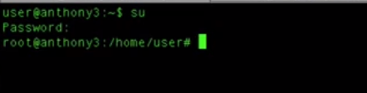

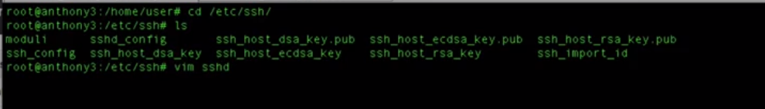

Its ssshd_config

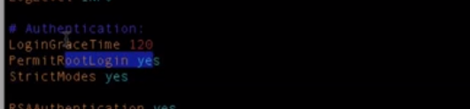

Make sure permit rootlogin is enabled as above. Save and exit.

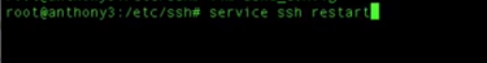

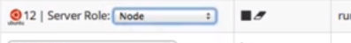

Do choose the role as node in the Ubuntu server which we just launced from the console and copy the hostname because if we remember we bootstrap using the hostname.

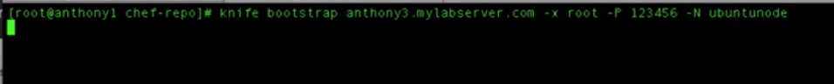

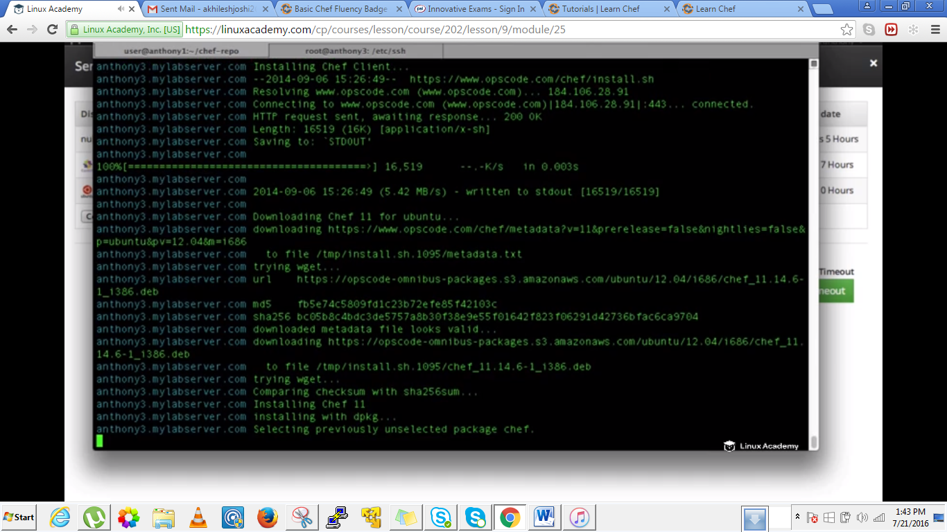

We can head over to our chef server interface and can see the Ubuntu node there as added

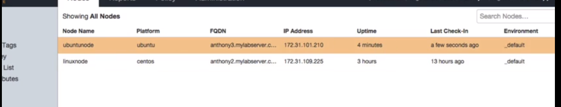

Now since we haven’t added this to our runlist if we run convergence on our Ubuntu node nothing happens. So lets add apache to our runlist



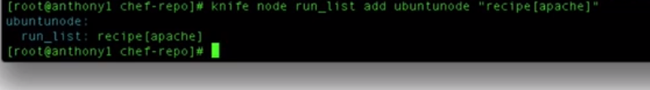

So now whenever we run the chef client it would run apache to that runlist.

Lets add our security recipe which deletes the validatiom.pem to our runlist before the apache recipe as



We have added security recipe before security recipe and it would before the apache recipe.

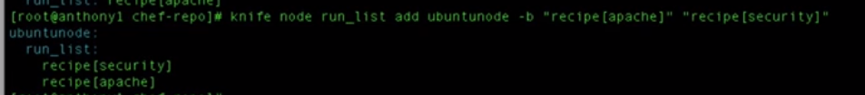

So even though we have configured the node and if we run a chef-client on the Ubuntu node it wouldn’t run because we fired a node without apt-get hence repository information might not be there and second is that it would be installing the httpd package which on Ubuntu linux doesn’t exist. The package name for apache2 in Ubuntu is apache2.

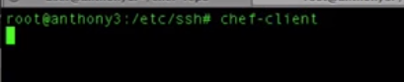

We would get errors so lets go to the recipe in the workstation and modify the recipes so that they can run them in the Ubuntu machine.

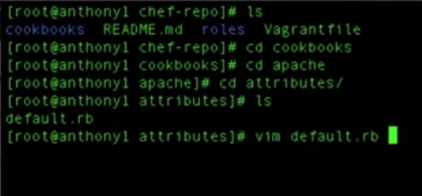

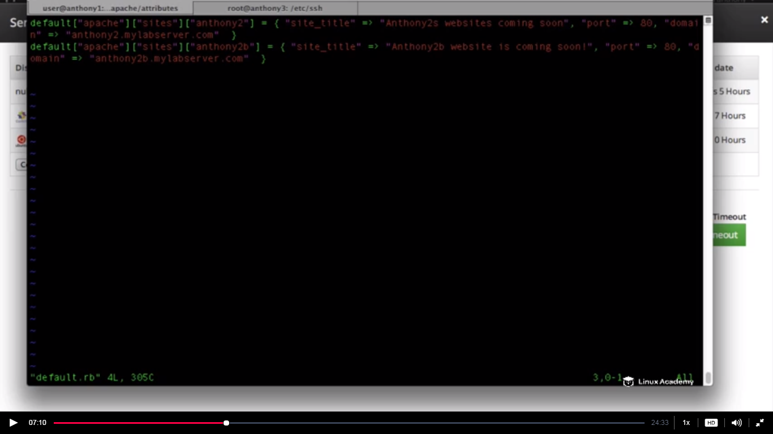

We have two sites here but they run in the centos machine.

We need to add an attribute i.e a site for Ubuntu and a index.html file as we did for our centos machine

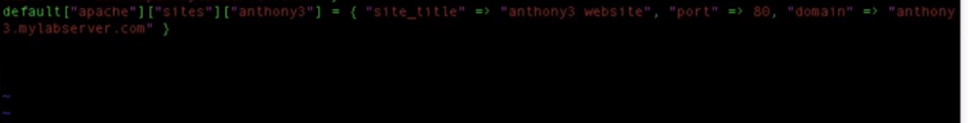

Now we need to put some information about the node and which package to install. So I need to use attribute and I will use a case statement . We are referencing our node and there is a platform attribute .This platform says the distributions centos or Ubuntu and this platform is populated when the node ohai object runs at the beginning of our chef-client run and also at the end of the chef-client run. That’s why we can use the platform attribute as

We can even go to the chef interface and see the attributes there especially platform attribute as

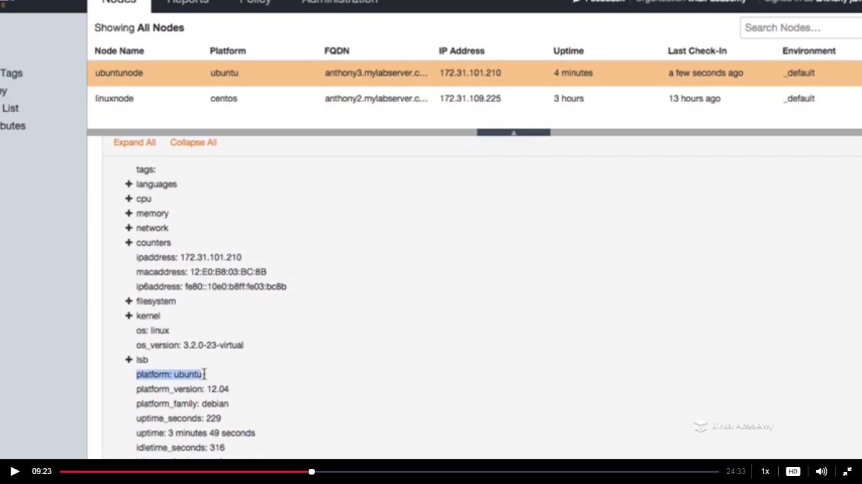

Attributes can be created inside roles,environments,cookbooks,recipes but here we are doing this inside our cookbooks.

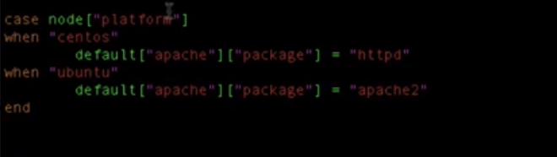

All we are saying here is when the value of our node platform attribute is centos then set the value of the attribute(default[apache][package[]) to httpd and if Ubuntu then the value defined for that platform.

The value of the platform attribute is populated when the node ohai object runs and it runs at the start of the chef-client run.

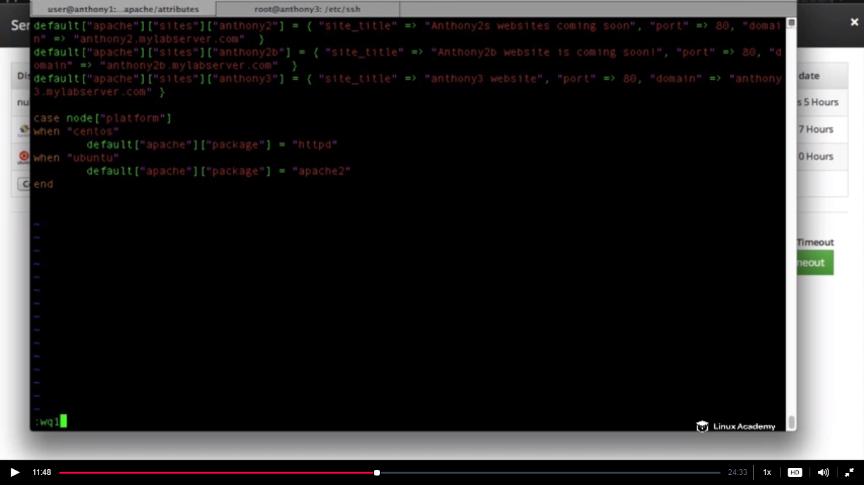

Now we need to change the recipe for the Ubuntu

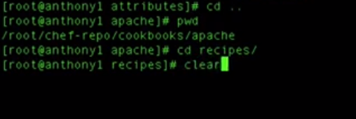

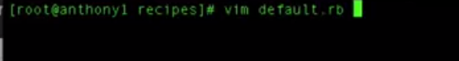

We have here package httpd here and we need to change this a bit

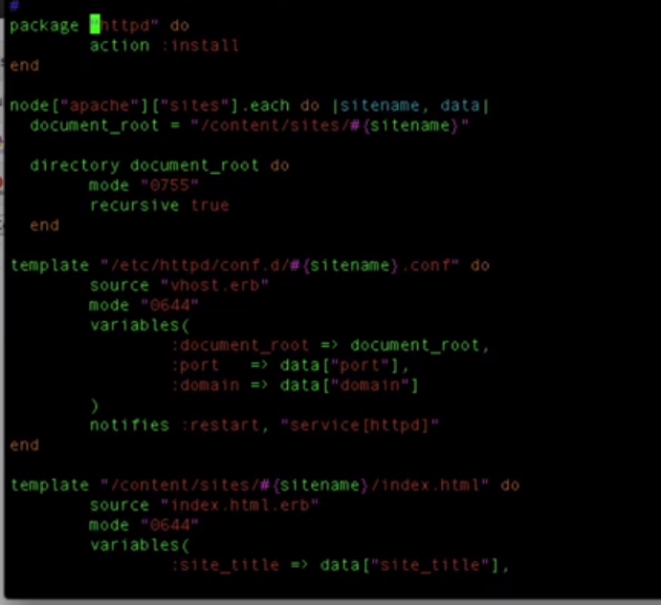

And the changes will be like

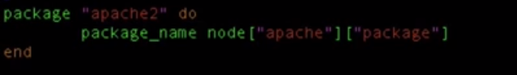

We changed the package name as apache2 however it could be httpd because its just the resource name. The changes we need to do is to change the action. And we change the action based on our attribute we defined inside our attributes file. We defined here a variable package_name and gave it the value as the attribute node[‘apache][package] and this attribute value would be populated based on the case we defined inside our attributes default.rb file.

Also we know the template location for Ubuntu is different hence we need to make the below changes to the same recipe file as

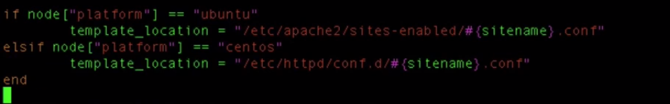

The whole file looks like this

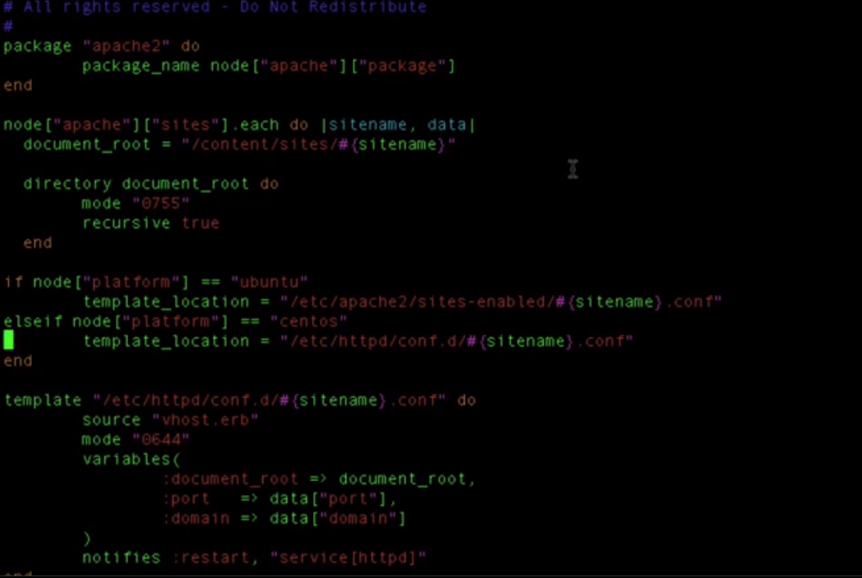

Now we set the variable and now we need to make changes to the template resource to choose the location based on the distribution as



Replace this with the



Last thing which we need to change is the service resource. We have a service httpd and we have a service resource httpd. As of now it is going to restart the service httpd which doesn’t exist in the Ubuntu machine. We need to make sure it starts the httpd service for centos and apache2 service for Ubuntu.

We just need to add an attribute inside the resource service as

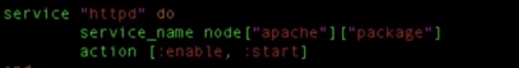

We just defined a variable **service_name** and gave the value of the attribute as defined in the attribute file. When gets the notification it comes here in the service resource and bydefault it takes httpd(its just the resource name) and would restart httpd but here we have declared a variable and hence it will start the service whose name gets populated here based on the distribution. So if its Ubuntu the variable service_name gets the value as apache2 and hence apache2 service will restart and if centos then service_name would be httpd.

Now come to the top of the file in which we are editing and do a if as

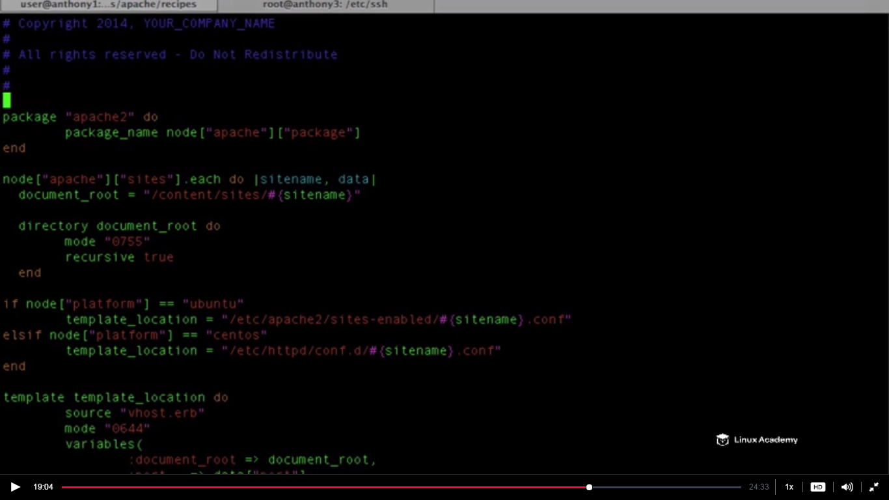

At the cursor we need to make some changes.One thing we know about Ubuntu is that we need to refresh our package information on a regular basis because the repository information for apt-get is stored inside of a cache on our local system. We need to make sure it is uptodate whenever we run our recipe its just install the packages and do not fail.

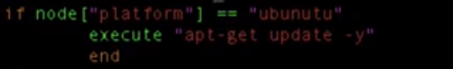

**The final file should look like this but correct the Ubuntu name above else it would an error later**

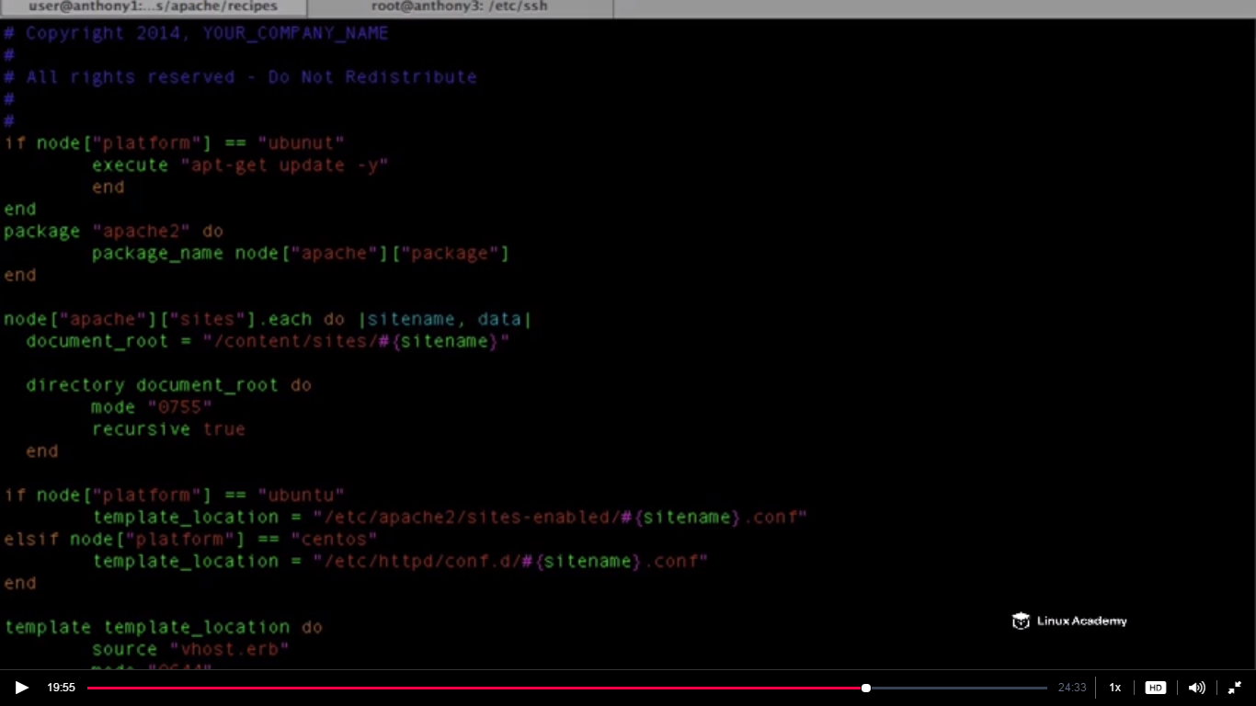

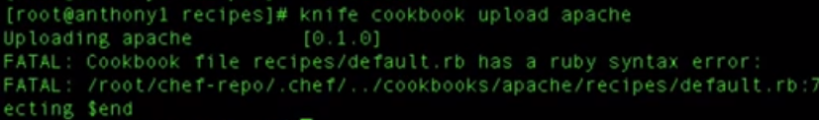



Here we are not attempting to run php so lets comment it as



**Also we need to have a do in the execute statement as below in the first line**

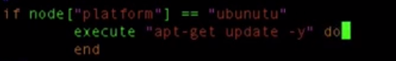

Spell Ubuntu correctly mentioned as earlier already

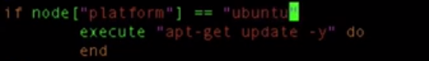

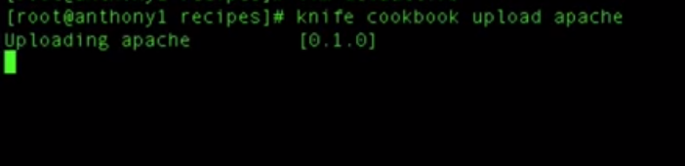

Run our chef-client on the Ubuntu node.



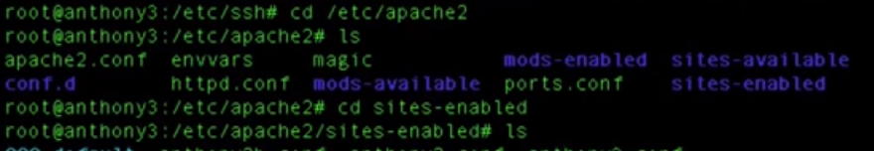

Inside our sites-enabled we have now three websites

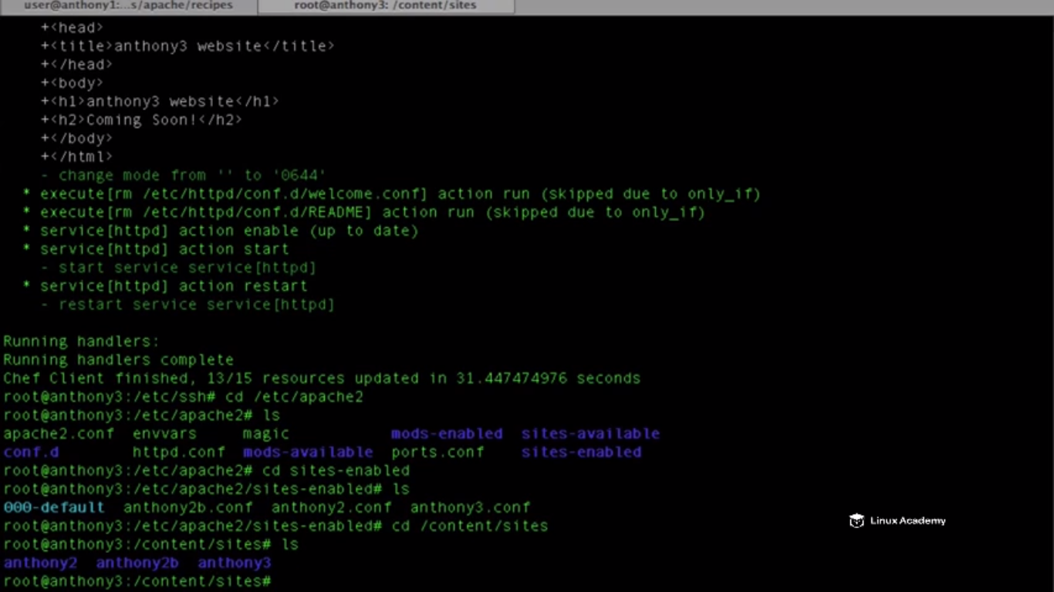

So we see above at the last line 3 sites are there now. So if we go to the anthony3.labserver.com

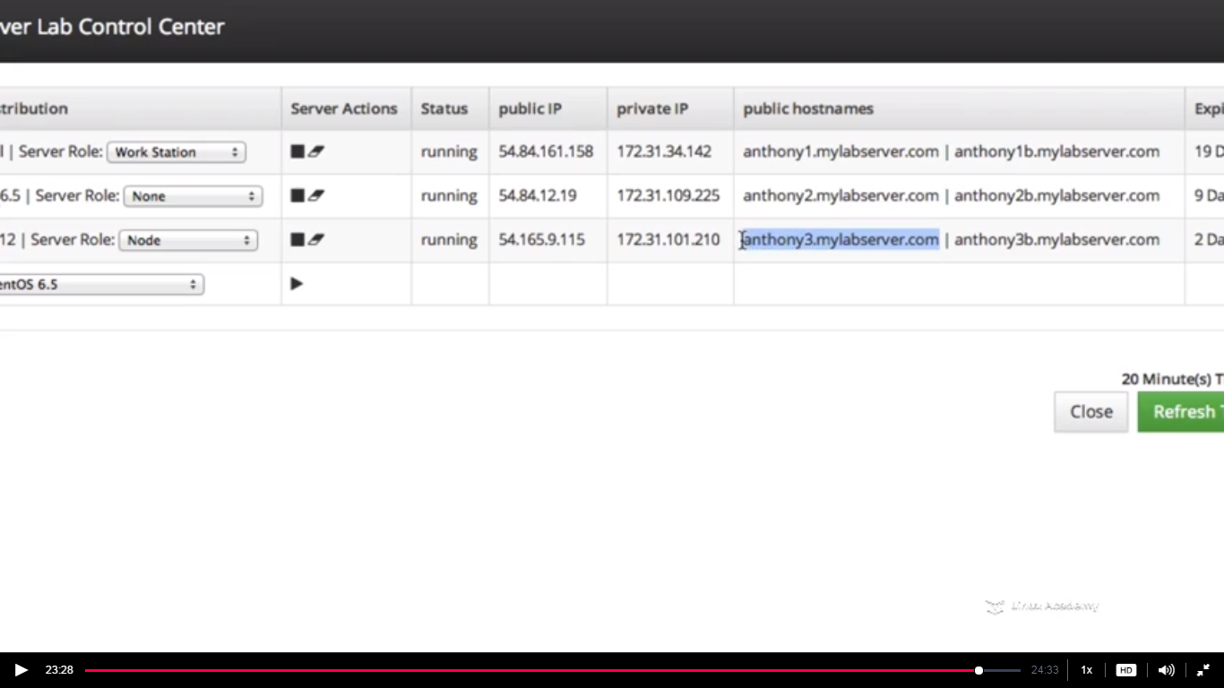

Copy the url from here and paste in the browser

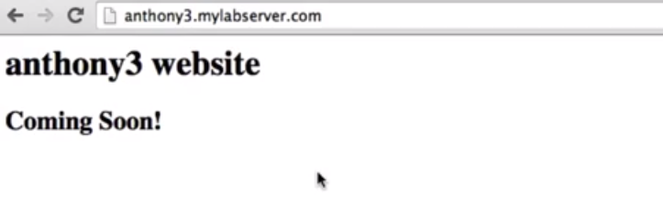

Lets check our original node if its running correctly so lets do a chef client to our centos node as

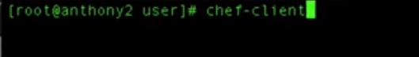

Copy the url and paste in the browser for the centos server and will see its functional .The same way you can create recipes for other platforms as redhat,cusi etc.

**Lecture: Adding The Local Chef-Repo To Github**

In this lesson we are going to learn how to set up a git repo using GitHub. We will use GitHub to maintain the source for our local chef-repo.

**We are doing this because if we are working on a team and our team need to access this then it should be inside a source control .**

**This is the best way because we do have a backup here and we need not to download this multiple times from the chef server if we need to provide others in the team the updated code. So source control is the best option. So just go and create an account and create a repository.**

**WE have created a repository as linux-academy-chef**

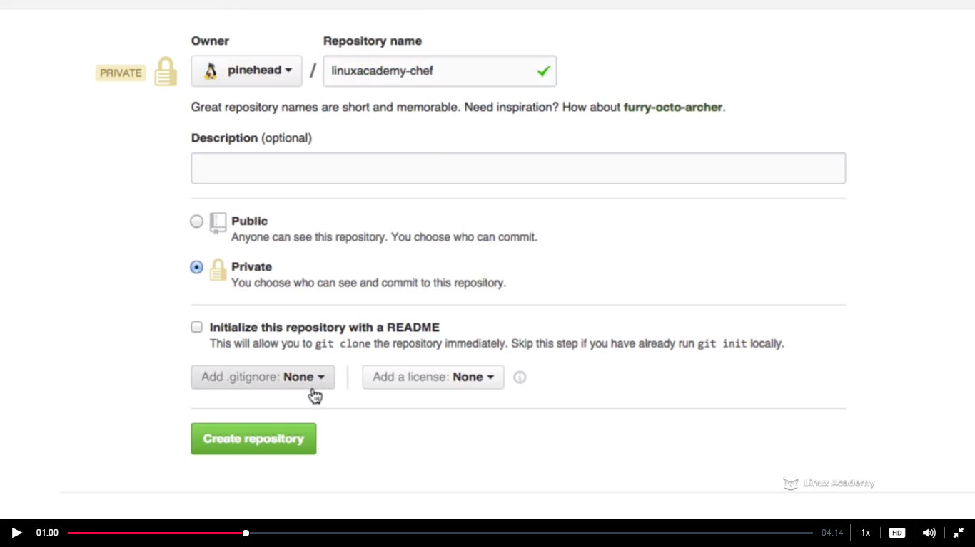

You need to have a username and password in the github because we are not going to set a ssl here we just gonna keep it simple for the purpose of this lecture.

Make sure you are below

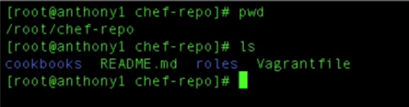

Do a

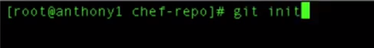

IT creates a .git directory

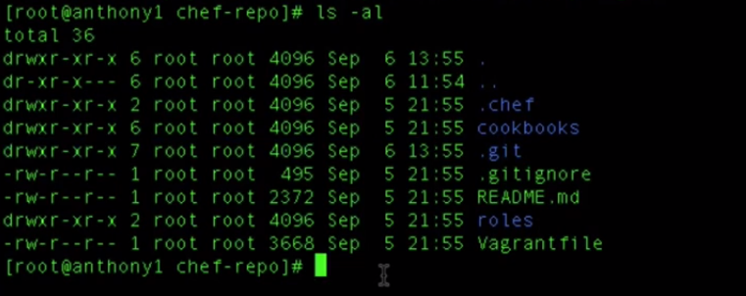

Now we need to add all the files and directories that are within our chef repo as

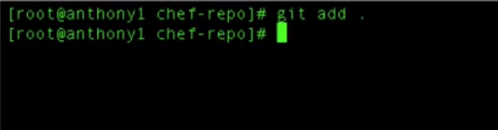

Then do a git commit as

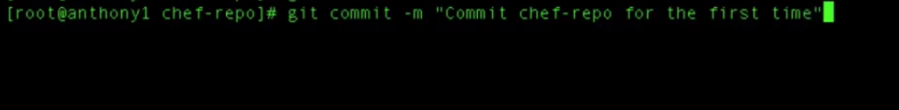

Now copy from git interface the url as

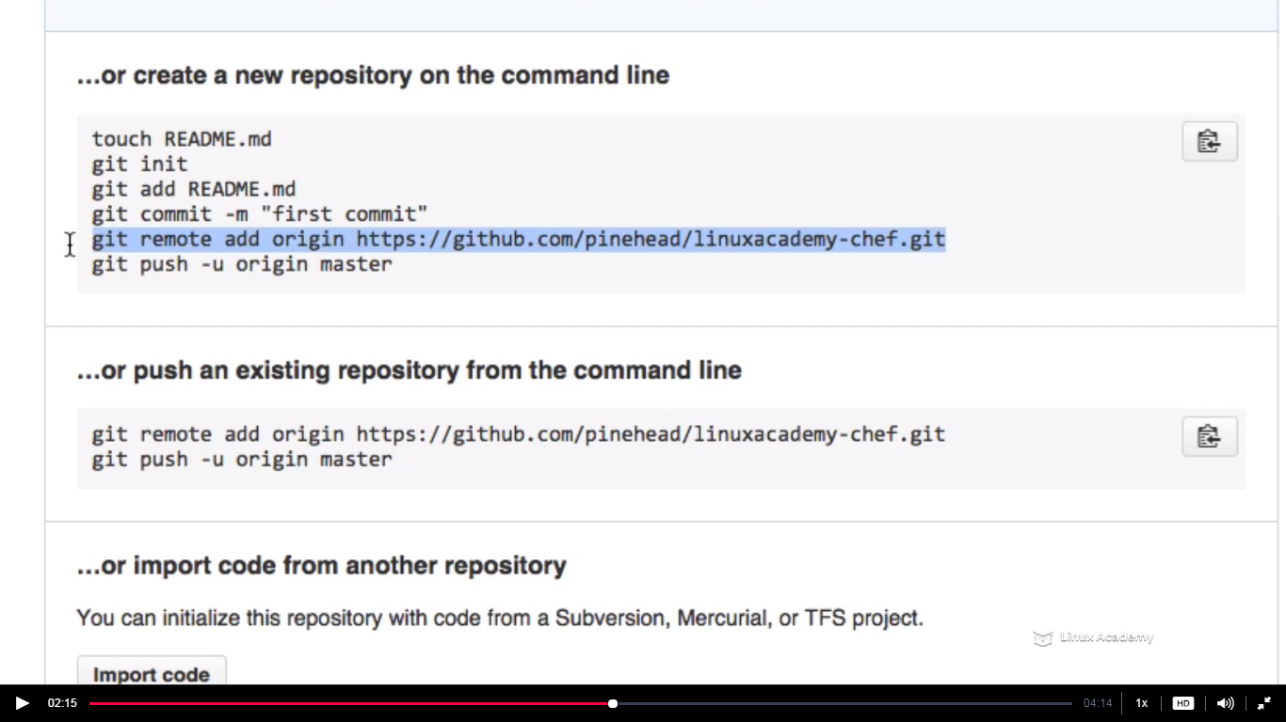

Add your username here at the blurre space as



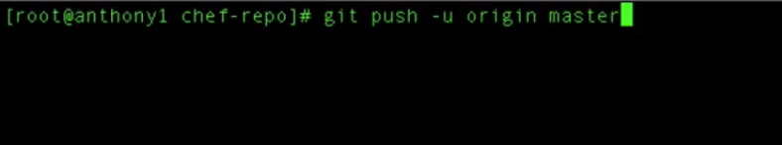

The above would push our code that we have just added to our repository to our master branch. We could have developer, production, QA branch etc.

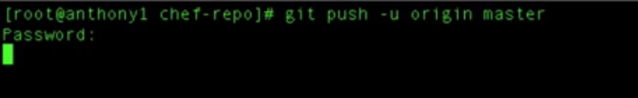

Give the password.

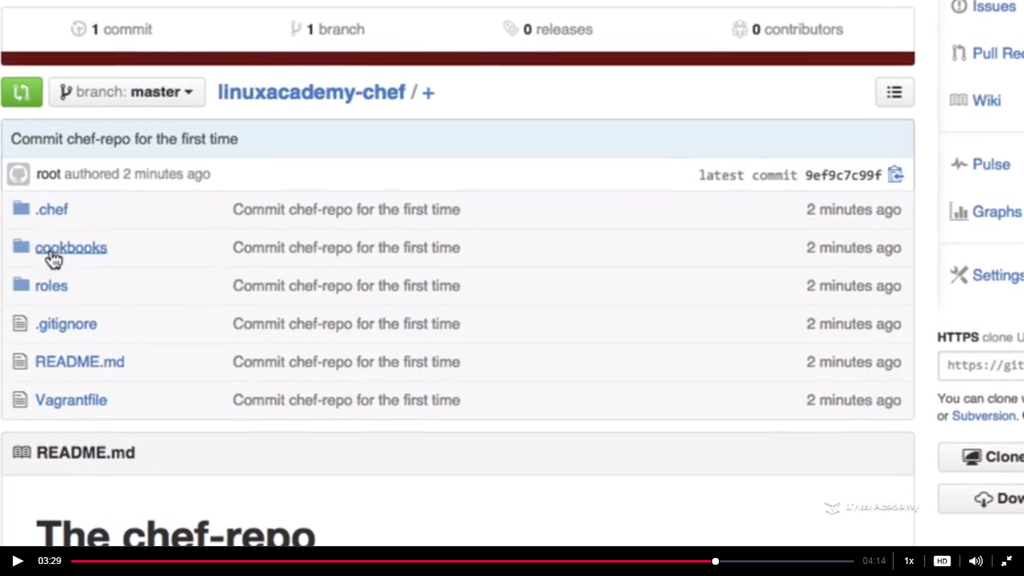

We can see the recipes here

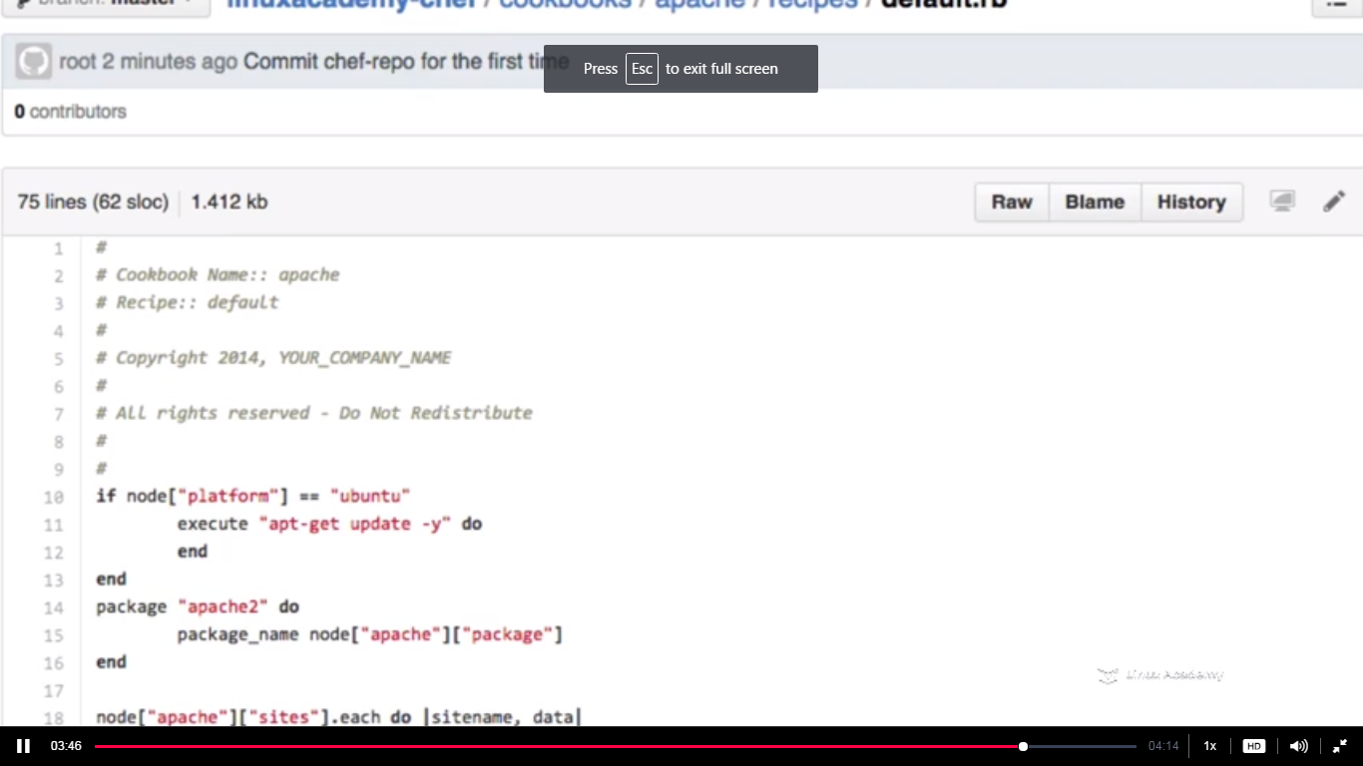

WE can share the recipes with our team members from here.